**Project Report On**

**POWER HOUSE GYM MANAGEMENT SYSYTEM**

Through PHP and MYSQL

Submitted in Partial Fulfillment of the Requirement for the Award of the Degree of

**MASTER OF COMPUTER APPLICATION**

TO



**UNIVERSITY OF PERTOLEUM AND ENERGY STUDIES**

BY

**ANKESH MOBAR**

**SAP ID: 500100953**

**Enroll no.: R271222025**

UNDER THE GUIDENCE OF

**PROF. DHIVIYA ROSE**

**SCHOOL OF COMPUTER SCIENCE**

**UNIVERSITY OF PERTOLEUM AND ENERGY STUDIES**

**2022-2023**

## ACKNOWLEDGEMENTS

It is indeed a great pleasure to express our sincere thanks to our august supervisor, **PROF. DHIVIYA ROSE** school of computer science of UNIVERSITY OF PETROLEUM AND ENERGY STUIDIES, Dehradun for his continuous support in this project. He was always there to listen and to give advice. He showed us different ways to approach a research problem and the need to be persistent to accomplish any goal. He taught us how to write academic paper, had confidence in us when we doubted ourselves, and brought out the good ideas in us. He was always there to meet and talk about our ideas, to proofread and mark up our paper, and to ask us good questions to help us think through our problems. Without his encouragement and constant guidance, we could not have finished this project.

We are thankful to our family whose unfailing love, affection, sincere prayers and best wishes had been a constant source of strength and encouragement.

Last, but not least, we thank our parents, for giving us life in the first place, for educating us with aspects from both arts and sciences, for unconditional support and encouragement to pursue our interests. We dedicate this work to our parents who will feel very proud of us. They deserve real credit for getting us this far, and no words can ever repay for them.

**ANKESH MOBAR**

**MCA**

**SAPID: 500100953**

**Enroll no.: R271222025**

## SCHOOL OF COMPUTER SCIENCE

## CERTIFICATE

This is to certify that Mr. ANKESH MOBAR of UNIVERSITY OF PETROLEUM AND ENERGY STUIDIES, Dehradun is a regular student of **MCA 1ST SEM**, session **2022-2023** and has worked on the project entitled **POWER HOUSE GYM MANAGEMENT SYSYTEM** Through PHP and MUSQL.

## This is a record of student’s own work carried out by his, under my guidance and supervision.

**PROF. Dhiviya Rose**

**Sign. Of Student** School of Computer Science  UPES

DEHRADUN

**CONTENT**

1. **Introduction**
2. **Literature Review**
   1. **HTML**
   2. **CSS**
   3. **Java script**
   4. **Php**
   5. **MySQL**
3. **Requirements**
4. **Coding**
5. **Read me (Username or Password)**
6. **Frontend Output Screenshot**
7. **Backend Output Screenshot**
8. **Conclusion**
9. **Introduction:**

Our Power House Gym Management System is a Gym and health Club Membership Management System. You can keep record on your members, their memberships, and have quick and easy communication between you and your members, Gym management also includes a booking system, point of sale, banking, accounting, concessions and has a range of reports that help in the management of your club.

Our Power house Gym Management Website is a complete gym and recreation facility system program which looks after all of your members, memberships and activities, It is designed for Gyms, recreation centers, and health Clubs.

Our Power house Gym Management Website provides lots of functions such data entry of customer, keeping records of all the things about customers fees, plan and physical fitness which help to provides good quality of services to customer from Gym managers.

1. Our Gym Management Software is a gym and health club membership
2. management system. You can keep records on your members, their memberships,
3. and have quick and easy communication between you and your members. Gym
4. Management also includes a booking system, point of sale, banking, accounting,
5. concessions and has a range of reports that help in the management of your club.

Our Gym Management Software is a gym and health club membership

management system. You can keep records on your members, their memberships,

and have quick and easy communication between you and your members. Gym

Management also includes a booking system, point of sale, banking, accounting,

concessions and has a range of reports that help in the management of your club.

Our Gym Management Software is a gym and health club membership

management system. You can keep records on your members, their memberships,

and have quick and easy communication between you and your members. Gym

Management also includes a booking system, point of sale, banking, accounting,

concessions and has a range of reports that help in the management of your club.

Our Gym Management Software is a gym and health club membership

management system. You can keep records on your members, their memberships,

and have quick and easy communication between you and your members. Gym

Management also includes a booking system, point of sale, banking, accounting,

concessions and has a range of reports that help in the management of your club.

Our Gym Management Software is a gym and health club membership

management system. You can keep records on your members, their memberships,

and have quick and easy communication between you and your members. Gym

Management also includes a booking system, point of sale, banking, accounting,

concessions and has a range of reports that help in the management of your club.

Our Gym Management Software is a gym and health club membership

management system. You can keep records on your members, their memberships,

and have quick and easy communication between you and your members. Gym

Management also includes a booking system, point of sale, banking, accounting,

concessions and has a range of reports that help in the management of your club.

Our Gym Management Software is a gym and health club membership

management system. You can keep records on your members, their memberships,

and have quick and easy communication between you and your members. Gym

Management also includes a booking system, point of sale, banking, accounting,

concessions and has a range of reports that help in the management of your club

1. **Literature Review:**

**HTML:**

HTML is an acronym which stands for **Hyper Text Markup Language** which is used for creating web pages and web applications. Let's see what is meant by Hypertext Markup Language, and Web page. HyperText simply means "Text within Text." A text has a link within it, is a hypertext. Whenever you click on a link which brings you to a new webpage, you have clicked on a hypertext. HyperText is a way to link two or more web pages (HTML documents) with each other.  A markup language is a computer language that is used to apply layout and formatting conventions to a text document. Markup language makes text more interactive and dynamic. It can turn text into images, tables, links, etc. A web page is a document which is commonly written in HTML and translated by a web browser. A web page can be identified by entering an URL. A Web page can be of the static or dynamic type. **With the help of HTML only, we can create static web pages**.

**CSS:**

CSS stands for Cascading Style Sheets. It is a style sheet language which is used to describe the look and formatting of a document written in markup language. It provides an additional feature to HTML. It is generally used with HTML to change the style of web pages and user interfaces. It can also be used with any kind of XML documents including plain XML, SVG and XUL.

CSS is used along with HTML and JavaScript in most websites to create user interfaces for web applications and user interfaces for many mobile applications.

**Types of CSS:**

1. **Inline CSS:**

We can apply CSS in a single element by inline CSS technique. The inline CSS is also a method to insert style sheets in HTML document. This method mitigates some advantages of style sheets so it is advised to use this method sparingly. If you want to use inline CSS, you should use the style attribute to the relevant tag.

1. **Internal CSS:**

The internal style sheet is used to add a unique style for a single document. It is defined in <head> section of the HTML page inside the <style> tag.

1. **External CSS:**

The external style sheet is generally used when you want to make changes on multiple pages. It is ideal for this condition because it facilitates you to change the look of the entire web site by changing just one file. It uses the <link> tag on every pages and the <link> tag should be put inside the head section.

**JAVA SCRIPT:**

JavaScript (js) is a light-weight object-oriented programming language which is used by several websites for scripting the webpages. It is an interpreted, full-fledged programming language that enables dynamic interactivity on websites when applied to an HTML document. It was introduced in the year 1995 for adding programs to the webpages in the Netscape Navigator browser. Since then, it has been adopted by all other graphical web browsers. With JavaScript, users can build modern web applications to interact directly without reloading the page every time. The traditional website uses js to provide several forms of interactivity and simplicity.

Although, JavaScript has no connectivity with Java programming language. The name was suggested and provided in the times when Java was gaining popularity in the market. In addition to web browsers, databases such as CouchDB and MongoDB uses JavaScript as their scripting and query language.

**PHP:**

PHP is an open-source, interpreted, and object-oriented scripting language that can be executed at the server-side. PHP is well suited for web development. Therefore, it is used to develop web applications (an application that executes on the server and generates the dynamic page.).

PHP was created by **Rasmus Lerdorf in 1994** but appeared in the market in 1995. **PHP 7.4.0** is the latest version of PHP, which was released on **28 November**. Some important points need to be noticed about PHP are as followed:

* PHP stands for Hypertext Preprocessor.
* PHP is an interpreted language, i.e., there is no need for compilation.
* PHP is faster than other scripting languages, for example, ASP and JSP.
* PHP is a server-side scripting language, which is used to manage the dynamic content of the website.
* PHP can be embedded into HTML.
* PHP is an object-oriented language.
* PHP is an open-source scripting language.
* PHP is simple and easy to learn language.

**MYSQL:**

MySQL is currently the most popular database management system software used for managing the relational database. It is open-source database software, which is supported by Oracle Company. It is fast, scalable, and easy to use database management system in comparison with Microsoft SQL Server and Oracle Database. It is commonly used in conjunction with [PHP](https://www.javatpoint.com/php-tutorial) scripts for creating powerful and dynamic server-side or web-based enterprise applications.

1. **Requirements:**

**System Requirements**

For our project, the following Hardware and software are required:

**Software configuration**

Operating system: Windows 7,

Windows 8,

Windows 10,

Windows 11

Language: HTML, CSS, Js and PHP

Software requirement: XMAPP, VS Code,

**Hardware Configuration**

Processor: x86 64-bit CPU (Intel / AMD architecture)

RAM: 4GB

Hard disk: 20 GB

1. **Coding:**

Index.php Page:

<?php

session_start();

error_reporting(0);

include 'include/config.php';

$uid=$_SESSION['uid'];

if(isset($_POST['submit']))

{

$pid=$_POST['pid'];

$sql="INSERT INTO tblbooking (package_id,userid) Values(:pid,:uid)";

$query = $dbh -> prepare($sql);

$query->bindParam(':pid',$pid,PDO::PARAM_STR);

$query->bindParam(':uid',$uid,PDO::PARAM_STR);

$query -> execute();

echo "<script>alert('Package has been booked.');</script>";

echo "<script>window.location.href='booking-history.php'</script>";

}

?>

<!DOCTYPE html>

<html lang="zxx">

<head>

    <title>POWER HOUSE GYM</title>

    <!-- Stylesheets -->

    <link rel="stylesheet" href="css/font-awesome.min.css"/>

    <link rel="stylesheet" href="css/animate.css"/>

    <!-- Main Stylesheets -->

    <link rel="stylesheet" href="css/style.css"/>

</head>

<body>

    <!-- Page Preloder -->

    <!-- Header Section -->

    <?php include 'include/header.php';?>

    <!-- Header Section end -->

    <!-- Page top Section -->

    <section class="page-top-section set-bg" data-setbg="img/front.jpg">

        <div class="container">

            <div class="row">

                <div class="col-lg-7 m-auto text-white">

                <h1>

                <font size="30">

                <center>

                POWER HOUSE UNISEX GYM

                </center>

                </font>

                </h1>

                    <p>Physical Activity Or Can Improve Your Health</p>

                </div>

            </div>

        </div>

    </section>

    <!-- Pricing Section -->

    <section class="pricing-section spad">

        <div class="container">

            <div class="section-title text-center">

                <h2>Pricing plans</h2>

                <p>Regular Workout to perfect physical beauty, take care of your soul and enjoy life more fully!</p>

            </div>

            <div class="row">

                        <?php

$sql ="SELECT id, category, titlename, PackageType, PackageDuratiobn, Price, uploadphoto, Description, create_date from tbladdpackage";

$query= $dbh -> prepare($sql);

$query-> execute();

$results = $query -> fetchAll(PDO::FETCH_OBJ);

$cnt=1;

if($query -> rowCount() > 0)

{

foreach($results as $result)

{

?>

                <div class="col-lg-3 col-sm-6">

                    <div class="pricing-item begginer">

                        <div class="pi-top">

                            <h4><?php echo $result->titlename;?></h4>

                        </div>

                        <div class="pi-price">

                            <h3><?php echo htmlentities($result->Price);?></h3>

                            <p> <?php echo $result->PackageDuratiobn;?></p>

                        </div>

                        <ul>

                            <?php echo $result->Description;?>

                        </ul>

                        <?php if(strlen($_SESSION['uid'])==0): ?>

                        <a href="login.php" class="site-btn sb-line-gradient">Booking Now</a>

                        <?php else :?>

                            <!-- <a href="#" class="site-btn sb-line-gradient">Booking Now</a> -->

                             <form method='post'>

                            <input type='hidden' name='pid' value='<?php echo htmlentities($result->id);?>'>

                        <input class='site-btn sb-line-gradient' type='submit' name='submit' value='Booking Now' onclick="return confirm('Do you really want to book this package.');">

                        </form>

                             <?php endif;?>

                    </div>

                </div>

                <?php  $cnt=$cnt+1; } } ?>

            </div>

        </div>

    </section>

    <!-- Footer Section -->

    <?php include 'include/footer.php'; ?>

    <!-- Footer Section end -->

    <div class="back-to-top"><img src="img/icons/up-arrow.png" alt=""></div>

    <!--====== Javascripts &  ======-->

    <script src="js/main.js"></script>

    </body>

</html>

Contact.php file:

<?php

session_start();

error_reporting(0);

include 'include/config.php';

$uid=$_SESSION['uid'];

if(isset($_POST['submit']))

{

$pid=$_POST['pid'];

$sql="INSERT INTO tblbooking (package_id,userid) Values(:pid,:uid)";

$query = $dbh -> prepare($sql);

$query->bindParam(':pid',$pid,PDO::PARAM_STR);

$query->bindParam(':uid',$uid,PDO::PARAM_STR);

$query -> execute();

echo "<script>alert('Package has been booked.');</script>";

echo "<script>window.location.href='booking-history.php'</script>";

}

?>

<!DOCTYPE html>

<html lang="zxx">

<head>

    <title>POWER HOUSE GYM</title>

    <!-- Stylesheets -->

    <link rel="stylesheet" href="css/font-awesome.min.css"/>

    <link rel="stylesheet" href="css/animate.css"/>

    <!-- Main Stylesheets -->

    <link rel="stylesheet" href="css/style.css"/>

</head>

<body>

    <!-- Page Preloder -->

    <!-- Header Section -->

    <?php include 'include/header.php';?>

    <!-- Header Section end -->

    <!-- Page top Section -->

    <section class="page-top-section set-bg" data-setbg="img/front.jpg">

        <div class="container">

            <div class="row">

                <div class="col-lg-7 m-auto text-white">

                    <h2>Contact US</h2>

                </div>

            </div>

        </div>

    </section>

    <!-- Pricing Section -->

    <section class="pricing-section spad">

        <div class="container">

            <div class="row">

                <div class="col-lg-12 col-sm-6">

<p><strong>Email:</strong> a*****ar@gmail.com</p>

<p><strong>Contact No:</strong> 63******77</p>

<p><strong>Address:</strong> Vikas nagar PDA colony Naini Prayagraj, Uttar pradesh</p>

<p><strong>Owner:</strong> Ankesh Mobar</p>

                </div>

            </div>

            <div class="row">

            <div>

                <img src="img/contact.jpg"width="300px" height="400px">

            </div>

</div>

        </div>

    </section>

    <!-- Footer Section -->

    <?php include 'include/footer.php'; ?>

    <!-- Footer Section end -->

    <div class="back-to-top"><img src="img/icons/up-arrow.png" alt=""></div>

    <!-- Search model end -->

    <!--====== Javascripts ======-->

    <script src="js/main.js"></script>

    </body>

</html>

Profile.php Page:

<?php

session_start();

error_reporting(0);

require_once('include/config.php');

if(strlen( $_SESSION["uid"])==0)

    {

header('location:login.php');

}

else{

if(isset($_POST['submit']))

{

$uid=$_SESSION['uid'];

$fname=$_POST['fname'];

$lname=$_POST['lname'];

$email=$_POST['email'];

$mobile=$_POST['mobile'];

$city=$_POST['city'];

$state=$_POST['state'];

$address=$_POST['address'];

$sql="update tbluser set fname=:fname,lname=:lname,mobile=:mobile,city=:city,state=:state,address=:Address where id=:uid";

$query = $dbh->prepare($sql);

$query->bindParam(':fname',$fname,PDO::PARAM_STR);

$query->bindParam(':lname',$lname,PDO::PARAM_STR);

$query->bindParam(':mobile',$mobile,PDO::PARAM_STR);

$query->bindParam(':city',$city,PDO::PARAM_STR);

$query->bindParam(':state',$state,PDO::PARAM_STR);

$query->bindParam(':Address',$address,PDO::PARAM_STR);

$query->bindParam(':uid',$uid,PDO::PARAM_STR);

$query->execute();

//$msg="<script>toastr.success('Mobile info updated Successfully', {timeOut: 5000})</script>";

echo "<script>alert('Profile has been updated.');</script>";

echo "<script> window.location.href =profile.php;</script>";

}

 ?>

<!DOCTYPE html>

<html lang="zxx">

<head>

    <title>POWER HOUSE GYM | User Profile</title>

    <!-- Stylesheets -->

    <link rel="stylesheet" href="css/font-awesome.min.css"/>

    <!-- Main Stylesheets -->

    <link rel="stylesheet" href="css/style.css"/>

</head>

<body>

    <!-- Page Preloder -->

    <!-- Header Section -->

    <?php include 'include/header.php';?>

    <!-- Header Section end -->

    <!-- Page top Section -->

    <section class="page-top-section set-bg" data-setbg="img/page-top-bg.jpg">

        <div class="container">

            <div class="row">

                <div class="col-lg-7 m-auto text-white">

                    <h2>Profile</h2>

                </div>

            </div>

        </div>

    </section>

    <!-- Page top Section end -->

    <!-- Contact Section -->

    <section class="contact-page-section spad overflow-hidden">

        <div class="container">

            <div class="row">

                <div class="col-lg-2">

                </div>

                <div class="col-lg-8">

                    <form class="singup-form contact-form" method="post">

                        <div class="row">

                            <?php

                            $uid=$_SESSION['uid'];

                            $sql ="SELECT id, fname, lname, email, mobile, password, address,state,city, create_date from tbluser where id=:uid ";

                            $query= $dbh -> prepare($sql);

                            $query->bindParam(':uid',$uid, PDO::PARAM_STR);

                            $query-> execute();

                            $results = $query -> fetchAll(PDO::FETCH_OBJ);

                            $cnt=1;

                            if($query->rowCount() > 0)

                            {

                            foreach($results as $result)

                            {               ?>

                            <div class="col-md-6">

                                <input type="text" name="fname" id="fname" placeholder="First Name" autocomplete="off" value="<?php echo $result->fname;?>">

                            </div>

                            <div class="col-md-6">

                                <input type="text" name="lname" id="lname" placeholder="Last Name" autocomplete="off" value="<?php echo $result->lname;?>">

                            </div>

                            <div class="col-md-6">

                                <input type="text" name="email" id="email" placeholder="Your Email" autocomplete="off" value="<?php echo $result->email;?>" readonly>

                            </div>

                            <div class="col-md-6">

                                <input type="text" name="mobile" id="mobile" placeholder="Mobile Number" autocomplete="off" value="<?php echo $result->mobile;?>">

                            </div>

                            <div class="col-md-6">

                                <input type="text" name="state" id="state" placeholder="State" autocomplete="off" value="<?php echo $result->state;?>">

                            </div>

                            <div class="col-md-6">

                                <input type="text" name="city" id="city" placeholder="City" autocomplete="off" value="<?php echo $result->city;?>">

                            </div>

                            <div class="col-md-12">

                                <input type="text" name="address" id="address" placeholder="Address" autocomplete="off" value="<?php echo $result->address;?>">

                            </div>

                            <div class="col-md-12">

                        <input type="submit" id="submit" name="submit" value="Update" class="site-btn sb-gradient">

                            </div>

                            <?php }} ?>

                        </div>

                    </form>

                </div>

                <div class="col-lg-2">

                </div>

            </div>

        </div>

    </section>

    <!-- Trainers Section end -->

<?php include 'include/footer.php'; ?>

    <!-- Footer Section end -->

    <div class="back-to-top"><img src="img/icons/up-arrow.png" alt=""></div>

    <!-- Search model -->

    <!-- Search model end -->

    <!--====== Javascripts ======-->

    <script src="js/main.js"></script>

    </body>

</html>

 <?php } ?>

  <style>

.errorWrap {

    padding: 10px;

    margin: 0 0 20px 0;

    background: #dd3d36;

    color:#fff;

    -webkit-box-shadow: 0 1px 1px 0 rgba(0,0,0,.1);

    box-shadow: 0 1px 1px 0 rgba(0,0,0,.1);

}

.succWrap{

    padding: 10px;

    margin: 0 0 20px 0;

    background: #5cb85c;

    color:#fff;

    -webkit-box-shadow: 0 1px 1px 0 rgba(0,0,0,.1);

    box-shadow: 0 1px 1px 0 rgba(0,0,0,.1);

}

        </style>

Booking_details.php Page:

<?php session_start();

error_reporting(0);

require_once('include/config.php');

if(strlen( $_SESSION["uid"])==0)

    {

header('location:login.php');

}

else{

$uid=$_SESSION['uid'];

?>

<!DOCTYPE html>

<html lang="zxx">

<head>

  <title>User | Booking History</title>

  <!-- Stylesheets -->

  <link rel="stylesheet" href="css/font-awesome.min.css"/>

  <!-- Main Stylesheets -->

  <link rel="stylesheet" href="css/style.css"/>

</head>

<body>

  <!-- Page Preloder -->

  <!-- Header Section -->

  <?php include 'include/header.php';?>

  <!-- Header Section end -->

  <!-- Page top Section -->

  <section class="page-top-section set-bg" data-setbg="img/page-top-bg.jpg">

    <div class="container">

      <div class="row">

        <div class="col-lg-7 m-auto text-white">

          <h2>Booking History</h2>

        </div>

      </div>

    </div>

  </section>

  <!-- Page top Section end -->

  <!-- Contact Section -->

  <section class="contact-page-section spad overflow-hidden">

    <div class="container">

      <div class="row">

        <div class="col-lg-12">

             <table class="table table-hover table-bordered">

                <thead>

                   <?php $bookindid=$_GET['bookingid'];

                  $sql="SELECT t1.id as bookingid,t3.fname as Name, t3.email as email,t1.booking_date as bookingdate,t2.titlename as title,t2.PackageDuratiobn as PackageDuratiobn,

t2.Price as Price,t2.Description as Description,t4.category_name as category_name,t5.PackageName as PackageName,payment,paymentType FROM tblbooking as t1

 join tbladdpackage as t2

on t1.package_id =t2.id

join tbluser as t3

on t1.userid=t3.id

join tblcategory as t4

on t2.category=t4.id

join tblpackage as t5

on t2.PackageType=t5.id

 where t1.id=:bookindid";

                  $query= $dbh->prepare($sql);

                  $query->bindParam(':bookindid',$bookindid, PDO::PARAM_STR);

                  $query-> execute();

                  $results = $query -> fetchAll(PDO::FETCH_OBJ);

                  $cnt=1;

                  if($query -> rowCount() > 0)

                  {

                  foreach($results as $result)

                  {

                  ?>

                  <tr>

                   <th>Booking Date</th>

                   <td><?php echo $result->bookingdate; ?></td>

                    <th>Name</th>

                    <td><?php echo $result->Name; ?></td>

                  </tr>

                  <tr>

                   <th>Email</th>

                   <td><?php echo $result->email; ?></td>

                    <th>Category</th>

                    <td><?php echo $result->category_name; ?></td>

                  </tr>

                  <tr>

                   <th>Package Name:</th>

                   <td><?php echo $result->PackageName; ?></td>

                    <th>Title</th>

                    <td><?php echo $result->title; ?></td>

                  </tr>

                  <tr>

                   <th>Package Duratiobn</th>

                   <td><?php echo $result->PackageDuratiobn; ?></td>

                    <th>Price</th>

                    <td><?php echo $result->Price; ?></td>

                    <?php $pricess=$result->Price; ?>

                  </tr>

                  <tr>

                   <th>Description</th>

                   <td colspan="3"><?php echo $result->Description; ?></td>

                  </tr>

                  <tr>

                   <th>PaymentType</th>

                   <td colspan="3"><?php  $ptype=$result->paymentType;

if($ptype==''):

  echo "Payment not made yet";

else:

  echo $ptype;

endif;

                 ?></td>

                  </tr>

                  <?php  $cnt=$cnt+1; } } ?>

                </thead>

              </table>

            <?php   $sql="SELECT * from tblpayment

 where bookingID=:bookindid";

                  $query= $dbh->prepare($sql);

                  $query->bindParam(':bookindid',$bookindid, PDO::PARAM_STR);

                  $query-> execute();

                  $results = $query -> fetchAll(PDO::FETCH_OBJ);

                  $cnt=1;

                  if($query -> rowCount() > 0)

                  { ?>

                       <table class="table table-hover table-bordered">

                        <tr>

                          <th colspan="3" style="text-align:center;font-size:20px;">Payment History</th>

                        </tr>

                        <tr>

                          <th>Payment Type</th>

                          <th>Amount Paid</th>

                          <th>Payment Date</th>

                        </tr>

 <?php foreach($results as $result)

                  { ?>

<tr>

  <td><?php echo $result->paymentType; ?></td>

  <td><?php echo $tpayment=$result->payment; ?></td>

  <td><?php echo $result->payment_date; ?></td>

</tr>

<?php

$gpayment+=$tpayment;

}  ?>

<tr>

  <th>Total</th>

  <th><?php echo $gpayment;?></th>

</tr>

                       </table>

                     <?php } ?>

        </div>

      </div>

    </div>

  </section>

  <!-- Trainers Section end -->

  <!-- Footer Section -->

<?php include 'include/footer.php'; ?>

  <!-- Footer Section end -->

  <div class="back-to-top"><img src="img/icons/up-arrow.png" alt=""></div>

  <!--====== Javascripts  ======-->

  <script src="js/main.js"></script>

  </body>

</html>

 <style>

.errorWrap {

    padding: 10px;

    margin: 0 0 20px 0;

    background: #dd3d36;

    color:#fff;

    -webkit-box-shadow: 0 1px 1px 0 rgba(0,0,0,.1);

    box-shadow: 0 1px 1px 0 rgba(0,0,0,.1);

}

.succWrap{

    padding: 10px;

    margin: 0 0 20px 0;

    background: #5cb85c;

    color:#fff;

    -webkit-box-shadow: 0 1px 1px 0 rgba(0,0,0,.1);

    box-shadow: 0 1px 1px 0 rgba(0,0,0,.1);

}

        </style>

        <?php } ?>

Booking_history.php Page:

<?php session_start();

error_reporting(0);

require_once('include/config.php');

if(strlen( $_SESSION["uid"])==0)

    {

header('location:login.php');

}

else{

$uid=$_SESSION['uid'];

?>

<!DOCTYPE html>

<html lang="zxx">

<head>

  <title>User | Booking History</title>

  <!-- Stylesheets -->

  <link rel="stylesheet" href="css/font-awesome.min.css"/>

  <!-- Main Stylesheets -->

  <link rel="stylesheet" href="css/style.css"/>

</head>

<body>

  <!-- Page Preloder -->

  <!-- Header Section -->

  <?php include 'include/header.php';?>

  <!-- Header Section end -->

  <!-- Page top Section -->

  <section class="page-top-section set-bg" data-setbg="img/page-top-bg.jpg">

    <div class="container">

      <div class="row">

        <div class="col-lg-7 m-auto text-white">

          <h2>Booking History</h2>

        </div>

      </div>

    </div>

  </section>

  <!-- Page top Section end -->

  <!-- Contact Section -->

  <section class="contact-page-section spad overflow-hidden">

    <div class="container">

      <div class="row">

        <div class="col-lg-12">

          <table class="table table-bordered">

    <thead>

      <tr>

        <th>Sr.No</th>

        <th hidden>bookingid</th>

        <th hidden>Name</th>

        <th hidden>email</th>

        <th>bookingdate</th>

        <th>title</th>

        <th>PackageDuratiobn</th>

        <th>price</th>

        <th>Description</th>

        <th>category_name</th>

        <th>PackageName</th>

        <th>Action</th>

      </tr>

    </thead>

          <?php

          $uid=$_SESSION['uid'];

                  /*$sql="select id, product_id, userid, product_title, packages, category, PackageDuratiobn, price, descripation, booking_date from tblbooking where userid=:uid";*/

                  $sql="SELECT t1.id as bookingid,t3.fname as Name, t3.email as email,t1.booking_date as bookingdate,t2.titlename as title,t2.PackageDuratiobn as PackageDuratiobn,

t2.Price as Price,t2.Description as Description,t4.category_name as category_name,t5.PackageName as PackageName FROM tblbooking as t1

 join tbladdpackage as t2

on t1.package_id =t2.id

join tbluser as t3

on t1.userid=t3.id

join tblcategory as t4

on t2.category=t4.id

join tblpackage as t5

on t2.PackageType=t5.id

where t1.userid=:uid";

                  $query= $dbh->prepare($sql);

                  $query->bindParam(':uid',$uid, PDO::PARAM_STR);

                  $query-> execute();

                  $results = $query -> fetchAll(PDO::FETCH_OBJ);

                  $cnt=1;

                  if($query -> rowCount() > 0)

                  {

                  foreach($results as $result)

                  {

                  ?>

                <tbody>

                  <tr>

                    <td><?php echo($cnt);?></td>

                    <td hidden><?php echo htmlentities($result->bookingid);?></td>

                    <td hidden><?php echo htmlentities($result->Name);?></td>

                    <td hidden><?php echo htmlentities($result->email);?></td>

                    <td><?php echo htmlentities($result->bookingdate);?></td>

                    <td><?php echo htmlentities($result->title);?></td>

                    <td><?php echo htmlentities($result->PackageDuratiobn);?></td>

                    <td><?php echo $result->Price;?></td>

                    <td><?php echo $result->Description;?></td>

                    <td><?php echo htmlentities($result->category_name);?></td>

                    <td><?php echo htmlentities($result->PackageName);?></td>

                    <td><a href="booking-details.php?bookingid=<?php echo htmlentities($result->bookingid);?>"><button class="btn btn-primary" type="button">View</button></td>

                  </tr>

                    <?php  $cnt=$cnt+1; } } ?>

                </tbody>

  </table>

        </div>

      </div>

    </div>

  </section>

  <!-- Trainers Section end -->

  <!-- Footer Section -->

<?php include 'include/footer.php'; ?>

  <!-- Footer Section end -->

  <div class="back-to-top"><img src="img/icons/up-arrow.png" alt=""></div>

  <!--====== Javascripts  ======-->

  <script src="js/main.js"></script>

  </body>

</html>

 <style>

.errorWrap {

    padding: 10px;

    margin: 0 0 20px 0;

    background: #dd3d36;

    color:#fff;

    -webkit-box-shadow: 0 1px 1px 0 rgba(0,0,0,.1);

    box-shadow: 0 1px 1px 0 rgba(0,0,0,.1);

}

.succWrap{

    padding: 10px;

    margin: 0 0 20px 0;

    background: #5cb85c;

    color:#fff;

    -webkit-box-shadow: 0 1px 1px 0 rgba(0,0,0,.1);

    box-shadow: 0 1px 1px 0 rgba(0,0,0,.1);

}

        </style>

        <?php } ?>

About.php Page:

<?php

session_start();

error_reporting(0);

include 'include/config.php';

$uid=$_SESSION['uid'];

if(isset($_POST['submit']))

{

$pid=$_POST['pid'];

$sql="INSERT INTO tblbooking (package_id,userid) Values(:pid,:uid)";

$query = $dbh -> prepare($sql);

$query->bindParam(':pid',$pid,PDO::PARAM_STR);

$query->bindParam(':uid',$uid,PDO::PARAM_STR);

$query -> execute();

echo "<script>alert('Package has been booked.');</script>";

echo "<script>window.location.href='booking-history.php'</script>";

}

?>

<!DOCTYPE html>

<html lang="zxx">

<head>

    <title>POWER HOUSE GYM</title>

    <!-- Stylesheets -->

    <link rel="stylesheet" href="css/font-awesome.min.css"/>

    <link rel="stylesheet" href="css/animate.css"/>

    <!-- Main Stylesheets -->

    <link rel="stylesheet" href="css/style.css"/>

</head>

<body>

    <!-- Page Preloder -->

    <!-- Header Section -->

    <?php include 'include/header.php';?>

    <!-- Header Section end -->

    <!-- Page top Section -->

    <section class="page-top-section set-bg" data-setbg="img/front.jpg">

        <div class="container">

            <div class="row">

                <div class="col-lg-7 m-auto text-white">

                    <h2>About POWER HOUSE GYM</h2>

                </div>

            </div>

        </div>

    </section>

    <!-- Pricing Section -->

    <section class="pricing-section spad">

        <div class="container">

            <div class="section-title text-center">

                <img src="img/icons/logo-icon.png" alt="">

                <h2>About Us</h2>

            </div>

            <div class="row">

                <div class="col-lg-12 col-sm-6">

                <h3> * The first Biggest and Luxurious Gym in Prayagraj.</h3>

                <h3> * GYM CAFE, Healthy meals, Juice, Shake, Salad.</h3>

                <h3> * Wellmess, Body Spa, Saune, Jacuzzi, Physiotheraphy.</h3>

                <h3> * Certified Premimum Trainers (Male &amp; Female)</h3>

                <h3> * Modern Gym Equipments.</h3>

                <h3> * Dietition.</h3>

                <h3> * CrossFit.</h3>

                <h3> * Yoga. </h3>

                </div>

            </div>

        </div>

    </section>

    <!-- Footer Section -->

    <?php include 'include/footer.php'; ?>

    <!-- Footer Section end -->

    <div class="back-to-top"><img src="img/icons/up-arrow.png" alt=""></div>

    <!-- Search model end -->

    <!--====== Javascripts  ======-->

    <script src="js/main.js"></script>

    </body>

</html>

Login.php Page:

<?php

session_start();

error_reporting(0);

require_once('include/config.php');

$msg = "";

if(isset($_POST['submit'])) {

  $email = trim($_POST['email']);

  $password = md5(($_POST['password']));

  if($email != "" && $password != "") {

    try {

      $query = "select id, fname, lname, email, mobile, password, address, create_date from tbluser where email=:email and password=:password";

      $stmt = $dbh->prepare($query);

      $stmt->bindParam('email', $email, PDO::PARAM_STR);

      $stmt->bindValue('password', $password, PDO::PARAM_STR);

      $stmt->execute();

      $count = $stmt->rowCount();

      $row   = $stmt->fetch(PDO::FETCH_ASSOC);

      if($count == 1 && !empty($row)) {

        /******************** Your code ***********************/

        $_SESSION['uid']   = $row['id'];

        $_SESSION['email'] = $row['email'];

        $_SESSION['name'] = $row['fname'];

       header("location: index.php");

      } else {

        $msg = "Invalid username and password!";

      }

    } catch (PDOException $e) {

      echo "Error : ".$e->getMessage();

    }

  } else {

    $msg = "Both fields are required!";

  }

}

?>

<!DOCTYPE html>

<html lang="zxx">

<head>

    <title>POWER HOUSE GYM</title>

    <!-- Stylesheets -->

    <link rel="stylesheet" href="css/font-awesome.min.css"/>

    <link rel="stylesheet" href="css/animate.css"/>

    <!-- Main Stylesheets -->

    <link rel="stylesheet" href="css/style.css"/>

</head>

<body>

    <!-- Page Preloder -->

    <!-- Header Section -->

    <?php include 'include/header.php';?>

    <!-- Header Section end -->

    <!-- Page top Section -->

    <section class="page-top-section set-bg" data-setbg="img/page-top-bg.jpg">

        <div class="container">

            <div class="row">

                <div class="col-lg-7 m-auto text-white">

                    <h2>Login</h2>

                </div>

            </div>

        </div>

    </section>

    <!-- Pricing Section -->

    <section class="pricing-section spad">

        <div class="container">

            <div class="row">

                <div class="col-lg-3 col-sm-6">

                </div>

                <div class="col-lg-6 col-sm-6">

                    <div class="pricing-item entermediate">

                        <div class="pi-top">

                        </div>

                        <div class="pi-price">

                            <h3>User</h3>

                            <p>Login</p>

                        </div>

                         <?php if($error){?><div class="errorWrap" style="color:red;"><strong>ERROR</strong>:<?php echo htmlentities($error); ?> </div><?php }

                else if($msg){?><div class="succWrap" style="color:red;"><strong>Error</strong>:<?php echo htmlentities($msg); ?> </div><?php }?>

                        <form class="singup-form contact-form" method="post">

                        <div class="row">

                            <div class="col-md-12">

                                <input type="text" name="email" id="email" placeholder="Your Email" autocomplete="off" required>

                            </div>

                            <div class="col-md-12">

                                <input type="password" name="password" id="password" placeholder="Password" autocomplete="off" required>

                            </div>

                        </div>

                        <div class="row">

                    <div class="col-md-6">

                    <input type="submit" id="submit" name="submit" value="Login" class="site-btn sb-gradient">

                    </div>

<div class="col-md-6">

<a href="registration.php" class="site-btn sb-gradient">Registration</a>

                    </div>

                </div>

                </form>

                    </div>

                </div>

                <div class="col-lg-3 col-sm-6">

                </div>

            </div>

        </div>

    </section>

    <?php include 'include/footer.php'; ?>

    <!-- Footer Section end -->

    <div class="back-to-top"><img src="img/icons/up-arrow.png" alt=""></div>

    <!-- Search model end -->

    <!--====== Javascripts ======-->

    <script src="js/main.js"></script>

    </body>

</html>

Logout.php Page:

<?php

session_start();

require_once('include/config.php');

session_destroy();

header("location: login.php");

exit();

?>

Changepassword.php Page:

<?php

session_start();

error_reporting(0);

require_once('include/config.php');

if(strlen( $_SESSION["uid"])==0)

    {

header('location:login.php');

}

else{

// Code for change password

if(isset($_POST['submit']))

    {

$password=md5($_POST['password']);

$newpassword=md5($_POST['newpassword']);

$email=$_SESSION['email'];

$sql ="SELECT password FROM tbluser WHERE email=:email and password=:password";

$query= $dbh -> prepare($sql);

$query-> bindParam(':email', $email, PDO::PARAM_STR);

$query-> bindParam(':password', $password, PDO::PARAM_STR);

$query-> execute();

$results = $query -> fetchAll(PDO::FETCH_OBJ);

if($query -> rowCount() > 0)

{

$con="update tbluser set password=:newpassword where email=:email";

$chngpwd1 = $dbh->prepare($con);

$chngpwd1-> bindParam(':email', $email, PDO::PARAM_STR);

$chngpwd1-> bindParam(':newpassword', $newpassword, PDO::PARAM_STR);

$chngpwd1->execute();

$msg="Your Password succesfully changed";

}

else {

$error="Your current password is not valid.";

}

}

?>

<!DOCTYPE html>

<html lang="zxx">

<head>

    <title>POWER HOUSE GYM</title>

    <!-- Stylesheets -->

    <link rel="stylesheet" href="css/font-awesome.min.css"/>

    <link rel="stylesheet" href="css/animate.css"/>

    <!-- Main Stylesheets -->

    <link rel="stylesheet" href="css/style.css"/>

    <script type="text/javascript">

    function valid()

    {

    if(document.chngpwd.newpassword.value!= document.chngpwd.confirmpassword.value)

    {

    alert("New Password and Confirm Password Field do not match  !!");

    document.chngpwd.confirmpassword.focus();

    return false;

    }

    return true;

    }

    </script>

    <style>

        .errorWrap {

    padding: 10px;

    margin: 0 0 20px 0;

    background: #fff;

    border-left: 4px solid #dd3d36;

    -webkit-box-shadow: 0 1px 1px 0 rgba(0,0,0,.1);

    box-shadow: 0 1px 1px 0 rgba(0,0,0,.1);

}

.succWrap{

    padding: 10px;

    margin: 0 0 20px 0;

    background: #fff;

    border-left: 4px solid #5cb85c;

    -webkit-box-shadow: 0 1px 1px 0 rgba(0,0,0,.1);

    box-shadow: 0 1px 1px 0 rgba(0,0,0,.1);

}

        </style>

</head>

<body>

    <!-- Page Preloder -->

    <!-- Header Section -->

    <?php include 'include/header.php';?>

    <!-- Header Section end -->

    <!-- Page top Section -->

    <section class="page-top-section set-bg" data-setbg="img/page-top-bg.jpg">

        <div class="container">

            <div class="row">

                <div class="col-lg-7 m-auto text-white">

                    <h2>changepassword</h2>

                </div>

            </div>

        </div>

    </section>

    <!-- Pricing Section -->

    <section class="pricing-section spad">

        <div class="container">

            <div class="row">

                <div class="col-lg-4 col-sm-6">

                </div>

                <div class="col-lg-4 col-sm-6">

                    <div class="pricing-item entermediate">

                        <div class="pi-top">

                            <h4>changepassword</h4>

                        </div>

                          <?php if($error){?><div class="errorWrap"><strong>ERROR</strong>:<?php echo htmlentities($error); ?> </div><?php }

                else if($msg){?><div class="succWrap"><strong>SUCCESS</strong>:<?php echo htmlentities($msg); ?> </div><?php }?>

                        <form class="singup-form contact-form" method="post" onSubmit="return valid();">

                        <div class="row">

                            <div class="col-md-12">

                                <input type="password" name="password" id="password" placeholder="Old Password" autocomplete="off">

                            </div>

                            <div class="col-md-12">

                                <input type="password" name="newpassword" id="newpassword" placeholder="New Password" autocomplete="off">

                            </div>

                            <div class="col-md-12">

                                <input type="password" name="confirmpassword" id="confirmpassword" placeholder="Confirm Password" autocomplete="off">

                            </div>

                        </div>

                    <input type="submit" id="submit" name="submit" value="Submit" class="site-btn sb-gradient">

</form>

                    </div>

                </div>

                <div class="col-lg-4 col-sm-6">

                </div>

            </div>

        </div>

    </section>

    <!-- Footer Section -->

    <?php include 'include/footer.php'; ?>

    <!-- Footer Section end -->

    <div class="back-to-top"><img src="img/icons/up-arrow.png" alt=""></div>

    <!-- Search model end -->

    <!--====== Javascripts ======-->

    <script src="js/main.js"></script>

    </body>

</html>

<?php } ?>

Registration.php Page:

<?php

error_reporting(0);

require_once('include/config.php');

if(isset($_POST['submit']))

{

$fname=$_POST['fname'];

$lname=$_POST['lname'];

$mobile=$_POST['mobile'];

$email=$_POST['email'];

$state=$_POST['state'];

$city=$_POST['city'];

$Password=$_POST['password'];

$pass=md5($Password);

$RepeatPassword = $_POST['RepeatPassword'];

// Email id Already Exit

$usermatch=$dbh->prepare("SELECT mobile,email FROM tbluser WHERE (email=:usreml || mobile=:mblenmbr)");

$usermatch->execute(array(':usreml'=>$email,':mblenmbr'=>$mobile));

while($row=$usermatch->fetch(PDO::FETCH_ASSOC))

{

$usrdbeml= $row['email'];

$usrdbmble=$row['mobile'];

}

if(empty($fname))

{

  $nameerror="Please Enter First Name";

}

 else if(empty($mobile))

 {

 $mobileerror="Please Enter Mobile No";

 }

 else if(empty($email))

 {

 $emailerror="Please Enter Email";

 }

else if($email==$usrdbeml || $mobile==$usrdbmble)

 {

  $error="Email Id or Mobile Number Already Exists!";

 }

  else if($Password=="" || $RepeatPassword=="")

 {

   $error="Password And Confirm Password Not Empty!";

 }

 else if($_POST['password'] != $_POST['RepeatPassword'])

 {

   $error="Password And Confirm Password Not Matched";

 }

else{

$sql="INSERT INTO tbluser (fname,lname,email,mobile,state,city,password) Values(:fname,:lname,:email,:mobile,:state,:city,:Password)";

$query = $dbh -> prepare($sql);

$query->bindParam(':fname',$fname,PDO::PARAM_STR);

$query->bindParam(':lname',$lname,PDO::PARAM_STR);

$query->bindParam(':email',$email,PDO::PARAM_STR);

$query->bindParam(':mobile',$mobile,PDO::PARAM_STR);

$query->bindParam(':state',$state,PDO::PARAM_STR);

$query->bindParam(':city',$city,PDO::PARAM_STR);

$query->bindParam(':Password',$pass,PDO::PARAM_STR);

$query -> execute();

$lastInsertId = $dbh->lastInsertId();

if($lastInsertId>0)

{

echo "<script>alert('Registration successfull. Please login');</script>";

echo "<script> window.location.href='login.php';</script>";

}

else

{

$error ="Registration Not successfully";

 }

}

 }

 ?>

<!DOCTYPE html>

<html lang="zxx">

<head>

    <title>POWER HOUSE GYM</title>

    <link rel="stylesheet" href="css/font-awesome.min.css"/>

    <!-- Main Stylesheets -->

    <link rel="stylesheet" href="css/style.css"/>

</head>

<body>

    <!-- Page Preloder -->

    <!-- Header Section -->

    <?php include 'include/header.php';?>

    <!-- Header Section end -->

    <!-- Page top Section -->

    <section class="page-top-section set-bg" data-setbg="img/page-top-bg.jpg">

        <div class="container">

            <div class="row">

                <div class="col-lg-7 m-auto text-white">

                    <h2>Registration</h2>

                </div>

            </div>

        </div>

    </section>

    <!-- Page top Section end -->

    <!-- Contact Section -->

    <section class="contact-page-section spad overflow-hidden">

        <div class="container">

            <div class="row">

                <div class="col-lg-2">

                </div>

                <div class="col-lg-8">

                    <?php if($error){?><div class="errorWrap"><strong>ERROR</strong>:<?php echo htmlentities($error); ?> </div><?php }

                else if($succmsg){?><div class="succWrap"><strong>SUCCESS</strong>:<?php echo htmlentities($succmsg); ?> </div><?php }?><br><br>

                    <form class="singup-form contact-form" method="post">

                        <div class="row">

                            <div class="col-md-6">

                                <input type="text" name="fname" id="fname" placeholder="First Name" autocomplete="off" value="<?php echo $fname;?>" required>

                            </div>

                            <div class="col-md-6">

                                <input type="text" name="lname" id="lname" placeholder="Last Name" autocomplete="off" value="<?php echo $lname;?>" required>

                            </div>

                            <div class="col-md-6">

                                <input type="text" name="email" id="email" placeholder="Your Email" autocomplete="off" value="<?php echo $email;?>" required>

                            </div>

                            <div class="col-md-6">

                                <input type="text" name="mobile" id="mobile" maxlength="10" placeholder="Mobile Number" autocomplete="off" value="<?php echo $mobile;?>" required>

                            </div>

                            <div class="col-md-6">

                                <input type="text" name="state" id="state" placeholder="Your State" autocomplete="off" value="<?php echo $state;?>" required>

                            </div>

                            <div class="col-md-6">

                                <input type="text" name="city" id="city" placeholder="Your City" autocomplete="off" value="<?php echo $city;?>" required>

                            </div>

                            <div class="col-md-6">

                                <input type="password" name="password" id="password" placeholder="Password" autocomplete="off">

                            </div>

                            <div class="col-md-6">

                                <input type="password" name="RepeatPassword" id="RepeatPassword" placeholder="Confirm Password" autocomplete="off" required>

                            </div>

                            <div class="col-md-4">

                        <input type="submit" id="submit" name="submit" value="Register Now" class="site-btn sb-gradient">

                            </div>

                        </div>

                    </form>

                </div>

                <div class="col-lg-2">

                </div>

            </div>

        </div>

    </section>

    <!-- Footer Section -->

<?php include 'include/footer.php'; ?>

    <!-- Footer Section end -->

    <div class="back-to-top"><img src="img/icons/up-arrow.png" alt=""></div>

    <!--====== Javascripts ======-->

    <script src="js/main.js"></script>

    </body>

</html>

 <style>

.errorWrap {

    padding: 10px;

    margin: 0 0 20px 0;

    background: #dd3d36;

    color:#fff;

    -webkit-box-shadow: 0 1px 1px 0 rgba(0,0,0,.1);

    box-shadow: 0 1px 1px 0 rgba(0,0,0,.1);

}

.succWrap{

    padding: 10px;

    margin: 0 0 20px 0;

    background: #5cb85c;

    color:#fff;

    -webkit-box-shadow: 0 1px 1px 0 rgba(0,0,0,.1);

    box-shadow: 0 1px 1px 0 rgba(0,0,0,.1);

}

        </style>

Config.Php:

<?php

ob_start();

//DB Connection

define('DB_HOST','localhost');

define('DB_USER','root');

define('DB_PASS','');

define('DB_NAME','gymdb');

// Establish database connection.

try

{

$dbh = new PDO("mysql:host=".DB_HOST.";dbname=".DB_NAME,DB_USER, DB_PASS,array(PDO::MYSQL_ATTR_INIT_COMMAND => "SET NAMES 'utf8'"));

}

catch (PDOException $e)

{

exit("Error: " . $e->getMessage());

}

Footer.php:

<footer class="">

        <div class="container">

            <div class="footer-bottom">

                <div class="row">

                    <div class="col-md-8 text-md-right">

                        <div class="copyright">

                        POWER HOUSE GYM</div>

                    </div>

                </div>

            </div>

        </div>

    </footer>

Header.php:

    <header class="header-section">

        <div class="header-top">

            <div class="row m-0">

                <div class="col-md-6 d-none d-md-block p-0">

                </div>

                <div class="col-md-6 text-left text-md-right p-0">

                 <?php if(strlen($_SESSION['uid'])==0): ?>

                    <div class="header-info d-none d-md-inline-flex">

                        <i class="material-icons">account_circle</i>

                        <a href="login.php"><p>Login</p></a>

                    </div>

                    <?php else :?>

                    <div class="header-info d-none d-md-inline-flex">

                        <i class="material-icons">account_circle</i>

                        <a href="profile.php"><p>My Profile</p></a>

                    </div>

                    <div class="header-info d-none d-md-inline-flex">

                        <i class="material-icons">brightness_7</i>

                        <a href="changepassword.php"><p>Change Password</p></a>

                    </div>

                    <div class="header-info d-none d-md-inline-flex">

                        <i class="material-icons">logout</i>

                        <a href="logout.php"><p>Logout</p></a>

                    </div>

                    <?php endif;?>

                </div>

            </div>

        </div>

        <div class="header-bottom">

            <a href="index.php" class="site-logo" style="color:#fff; font-weight:bold; font-size:26px;">

            POWER HOUSE GYM<br />

                <small style="margin-top:-4%;">POWER HOUSE GYM</small>

            </a>

            <div class="container">

                <ul class="main-menu">

                    <li><a href="index.php" class="active">Home</a></li>

                    <li><a href="about.php">About</a></li>

                    <li><a href="contact.php">Contact</a></li>

                    <?php if(strlen($_SESSION['uid'])==0): ?>

            <li><a href="admin/">Admin</a></li>

                    <?php else :?>

                        <li><a href="booking-history.php">Booking History</a></li>

                        <?php endif;?>

                </ul>

            </div>

        </div>

    </header>

Sidebar.php:

<!DOCTYPE html>

<html lang="zxx">

<head>

    <title>POWER HOUSE GYM</title>

    <!-- Stylesheets -->

    <link rel="stylesheet" href="css/font-awesome.min.css"/>

    <link rel="stylesheet" href="css/animate.css"/>

    <!-- Main Stylesheets -->

    <link rel="stylesheet" href="css/style.css"/>

</head>

<body>

    <!-- Page Preloder -->

    <div id="preloder">

        <div class="loader"></div>

    </div>

    <!-- Header Section -->

    <header class="header-section">

        <div class="header-top">

            <div class="row m-0">

                <div class="col-md-6 d-none d-md-block p-0">

                    <div class="header-info">

                        <i class="material-icons">map</i>

                        <p>184 Main Collins Street</p>

                    </div>

                    <div class="header-info">

                        <i class="material-icons">phone</i>

                        <p>(965) 436 3274</p>

                    </div>

                </div>

                <div class="col-md-6 text-left text-md-right p-0">

                    <div class="header-info d-none d-md-inline-flex">

                        <i class="material-icons">alarm_on</i>

                        <p>Registratin</p>

                    </div>

                    <div class="header-info d-none d-md-inline-flex">

                        <i class="material-icons">alarm_on</i>

                        <p>Registratin</p>

                    </div>

                </div>

            </div>

        </div>

        <div class="header-bottom">

            <a href="index.html" class="site-logo">

                <img src="img/logo.png" alt="">

            </a>

            <div class="hb-right">

                <div class="hb-switch" id="search-switch">

                    <img src="img/icons/search.png" alt="">

                </div>

                <div class="hb-switch" id="infor-switch">

                    <img src="img/icons/bars.png" alt="">

                </div>

            </div>

            <div class="container">

                <ul class="main-menu">

                    <li><a href="index.html" class="active">Home</a></li>

                    <li><a href="about.html">About</a></li>

                    <li><a href="classes.html">Classes</a>

                        <ul class="sub-menu">

                            <li><a href="classes.html">Our Claasses</a></li>

                            <li><a href="classes-details.html">Claasses Details</a></li>

                        </ul>

                    </li>

                    <li><a href="trainer.html">trainers</a>

                        <ul class="sub-menu">

                            <li><a href="trainer.html">Our Trainers</a></li>

                            <li><a href="trainer-details.html">Trainers Details</a></li>

                        </ul>

                    </li>

                    <li><a href="events.html">events</a>

                        <ul class="sub-menu">

                            <li><a href="events.html">Our Events</a></li>

                            <li><a href="event-details.html">Events Details</a></li>

                        </ul>

                    </li>

                    <li><a href="blog.html">Blog</a>

                        <ul class="sub-menu">

                            <li><a href="blog.html">Our Blog</a></li>

                            <li><a href="single-blog.html">Blog Details</a></li>

                        </ul>

                    </li>

                    <li><a href="contact.html">Contact</a></li>

                </ul>

            </div>

        </div>

    </header>

    <!-- Header Section end -->

    <!-- Infor Model -->

    <div class="infor-model-warp">

        <div class="infor-model d-flex align-items-center">

            <div class="infor-close">

                <i class="material-icons">close</i>

            </div>

            <div class="infor-middle">

                <a href="#" class="infor-logo">

                    <img src="img/logo-2.png" alt="">

                </a>

                <p>How’d you like to go on a long romantic walk on the treadmill?</p>

            </div>

        </div>

    </div>

    <!--====== Javascripts ======-->

    <script src="js/main.js"></script>

    </body>

</html>

**ADMIN SECTION:**

Add_category.php:

<?php session_start();

error_reporting(0);

include  'include/config.php';

if (strlen($_SESSION['adminid']==0)) {

  header('location:logout.php');

  } else{

if(isset($_POST['submit'])){

$category = $_POST['category'];

$sql="INSERT INTO tblcategory (category_name) Values(:category)";

$query = $dbh -> prepare($sql);

$query->bindParam(':category',$category,PDO::PARAM_STR);

$query -> execute();

$lastInsertId = $dbh->lastInsertId();

if($lastInsertId>0)

{

$msg= "Category Add Successfully";

 }

else {

$errormsg= "Data not insert successfully";

 }

}

//Delete Record Data

if(isset($_REQUEST['del']))

{

$uid=intval($_GET['del']);

$sql = "delete from tblcategory WHERE  id=:id";

$query = $dbh->prepare($sql);

$query-> bindParam(':id',$uid, PDO::PARAM_STR);

$query -> execute();

echo "<script>alert('Record Delete successfully');</script>";

echo "<script>window.location.href='add-category.php'</script>";

}

?>

<!DOCTYPE html>

<html lang="en">

  <head>

   <title>Admin | Categories</title>

    <!-- Main CSS-->

    <link rel="stylesheet" type="text/css" href="css/main.css">

  </head>

  <body class="app sidebar-mini rtl">

    <!-- Navbar-->

   <?php include 'include/header.php'; ?>

    <!-- Sidebar menu-->

    <div class="app-sidebar__overlay" data-toggle="sidebar"></div>

    <?php include 'include/sidebar.php'; ?>

    <main class="app-content">

     <h3>Categories</h3>

     <hr />

      <div class="row">

        <div class="col-md-6">

          <div class="tile">

          <!---Success Message--->

          <?php if($msg){ ?>

          <div class="alert alert-success" role="alert">

          <strong>Well done!</strong> <?php echo htmlentities($msg);?>

          </div>

          <?php } ?>

          <!---Error Message--->

          <?php if($errormsg){ ?>

          <div class="alert alert-danger" role="alert">

          <strong>Oh snap!</strong> <?php echo htmlentities($errormsg);?></div>

          <?php } ?>

            <div class="tile-body">

              <form  method="post">

                <div class="form-group col-md-12">

                  <label class="control-label">Add Category</label>

                  <input class="form-control" name="category" id="category" type="text" placeholder="Enter Add Category">

                </div>

                <div class="form-group col-md-4 align-self-end">

                  <input type="submit" name="submit" id="submit" class="btn btn-primary" value=" Submit">

                </div>

              </form>

            </div>

          </div>

        </div>

      </div>

       <div class="row">

        <div class="col-md-12">

          <div class="tile">

            <div class="tile-body">

              <table class="table table-hover table-bordered" id="sampleTable">

                <thead>

                  <tr>

                    <th>Sr.No</th>

                    <th>Name</th>

                    <th>Action</th>

                  </tr>

                </thead>

                  <?php

                  $sql="select * from tblcategory";

                  $query= $dbh->prepare($sql);

                  $query-> execute();

                  $results = $query -> fetchAll(PDO::FETCH_OBJ);

                  $cnt=1;

                  if($query -> rowCount() > 0)

                  {

                  foreach($results as $result)

                  {

                  ?>

                <tbody>

                  <tr>

                    <td><?php echo($cnt);?></td>

                    <td><?php echo htmlentities($result->category_name);?></td>

                    <td>

                      <!-- <a href="add-category.php?cid=<?php echo htmlentities($result->id);?>"><button class="btn btn-primary" type="button">Edit</button></a>  -->

                      <a href="add-category.php?del=<?php echo htmlentities($result->id);?>"><button class="btn btn-danger" type="button">Delete</button></a></td>

                  </tr>

                    <?php  $cnt=$cnt+1; } } ?>

                </tbody>

              </table>

            </div>

          </div>

        </div>

      </div>

    </main>

  </body>

</html>

<?php } ?>

Add_package.php:

<?php session_start();

error_reporting(0);

include  'include/config.php';

if (strlen($_SESSION['adminid']==0)) {

  header('location:logout.php');

  } else{

if(isset($_POST['submit'])){

$AddPackage = $_POST['addPackage'];

$category = $_POST['category'];

$sql="INSERT INTO tblpackage (PackageName,cate_id) Values(:Package,:category)";

$query = $dbh -> prepare($sql);

$query->bindParam(':Package',$AddPackage,PDO::PARAM_STR);

$query->bindParam(':category',$category,PDO::PARAM_STR);

$query -> execute();

$lastInsertId = $dbh->lastInsertId();

if($lastInsertId>0)

{

$msg= "Package Add Successfully";

echo "<script>window.location.href='add-package.php'</script>";

 }

else {

$errormsg= "Data not insert successfully";

 }

}

//Delete Record Data

if(isset($_REQUEST['del']))

{

$uid=intval($_GET['del']);

$sql = "delete from tblpackage WHERE  id=:id";

$query = $dbh->prepare($sql);

$query-> bindParam(':id',$uid, PDO::PARAM_STR);

$query -> execute();

echo "<script>alert('Record Delete successfully');</script>";

echo "<script>window.location.href='add-package.php'</script>";

}

?>

<!DOCTYPE html>

<html lang="en">

  <head>

   <title>Admin | Add Package Type</title>

    <!-- Main CSS-->

    <link rel="stylesheet" type="text/css" href="css/main.css">

  </head>

  <body class="app sidebar-mini rtl">

    <!-- Navbar-->

   <?php include 'include/header.php'; ?>

    <!-- Sidebar menu-->

    <div class="app-sidebar__overlay" data-toggle="sidebar"></div>

    <?php include 'include/sidebar.php'; ?>

    <main class="app-content">

     <h3>Package Types</h3>

     <hr />

      <div class="row">

        <div class="col-md-6">

          <div class="tile">

          <!---Success Message--->

          <?php if($msg){ ?>

          <div class="alert alert-success" role="alert">

          <strong>Well done!</strong> <?php echo htmlentities($msg);?>

          </div>

          <?php } ?>

          <!---Error Message--->

          <?php if($errormsg){ ?>

          <div class="alert alert-danger" role="alert">

          <strong>Oh snap!</strong> <?php echo htmlentities($errormsg);?></div>

          <?php } ?>

              <form class="row" method="post">

                 <div class="form-group col-md-12">

                  <label class="control-label">Add Category</label>

                  <select class="form-control" name="category" id="category">

                  <option value="NA">--select--</option>

                  <?php

                  $stmt = $dbh->prepare("SELECT * FROM tblcategory ORDER BY category_name");

                  $stmt->execute();

                  $countriesList = $stmt->fetchAll();

                  foreach($countriesList as $country){

                  echo "<option value='".$country['id']."'>".$country['category_name']."</option>";

                  }

                  ?>

                  </select>

                </div>

                <div class="form-group col-md-12">

                  <label class="control-label">Add Package</label>

                  <input class="form-control" name="addPackage" id="addPackage" type="text" placeholder="Enter Add Package">

                </div>

                <div class="form-group col-md-4 align-self-end">

                  <input type="submit" name="submit" id="submit" class="btn btn-primary" value=" Submit">

                </div>

              </form>

            </div>

          </div>

        </div>

      </div>

       <div class="row">

        <div class="col-md-12">

          <div class="tile">

            <div class="tile-body">

              <table class="table table-hover table-bordered" id="sampleTable">

                <thead>

                  <tr>

                    <th>Sr.No</th>

                     <th>Category </th>

                    <th>Package</th>

                    <th>Action</th>

                  </tr>

                </thead>

               <?php

                  $sql="SELECT * FROM tblpackage

                  join tblcategory

                  on tblpackage.cate_id=tblcategory.id";

                  $query= $dbh->prepare($sql);

                  $query-> execute();

                  $results = $query -> fetchAll(PDO::FETCH_OBJ);

                  $cnt=1;

                  if($query -> rowCount() > 0)

                  {

                  foreach($results as $result)

                  {

                  ?>

                <tbody>

                  <tr>

                    <td><?php echo($cnt);?></td>

                    <td><?php echo htmlentities($result->category_name);?></td>

                    <td><?php echo htmlentities($result->PackageName);?></td>

                    <td>

<!--                       <a href="add-package.php?cid=<?php echo htmlentities($result->id);?>"><button class="btn btn-primary" type="button">Edit</button></a>

 -->                      <a href="add-package.php?del=<?php echo htmlentities($result->id);?>"><button class="btn btn-danger" type="button">Delete</button></a></td>

                  </tr>

                    <?php  $cnt=$cnt+1; } } ?>

                </tbody>

              </table>

            </div>

          </div>

        </div>

      </div>

    </main>

    <!-- Essential javascripts for application to work-->

    <script src="js/main.js"></script>

    <script type="text/javascript">$('#sampleTable').DataTable();</script>

  </body>

</html>

<?php } ?>

Booking_history.php:

<?php session_start();

error_reporting(0);

include  'include/config.php';

if (strlen($_SESSION['adminid']==0)) {

  header('location:logout.php');

  } else{

?>

<!DOCTYPE html>

<html lang="en">

  <head>

   <title>admin | All Bookings</title>

    <!-- Main CSS-->

    <link rel="stylesheet" type="text/css" href="css/main.css">

  </head>

  <body class="app sidebar-mini rtl">

    <!-- Navbar-->

   <?php include 'include/header.php'; ?>

    <!-- Sidebar menu-->

    <div class="app-sidebar__overlay" data-toggle="sidebar"></div>

    <?php include 'include/sidebar.php'; ?>

    <main class="app-content">

       <div class="row">

        <div class="col-md-12">

          <div class="tile">

            <div class="tile-body">

              <h3>All Bookings</h3>

              <hr />

              <table class="table table-hover table-bordered" id="sampleTable">

                <thead>

                  <tr>

                    <th>Sr.No</th>

        <th>bookingid</th>

        <th>Name</th>

        <th>Email</th>

        <th>bookingdate</th>

                <th>PackageName</th>

        <th>Title</th>

        <th>Action</th>

                  </tr>

                </thead>

               <?php

                  $sql="SELECT t1.id as bookingid,t3.fname as Name, t3.email as email,t1.booking_date as bookingdate,t2.titlename as title,t2.PackageDuratiobn as PackageDuratiobn,

t2.Price as Price,t2.Description as Description,t4.category_name as category_name,t5.PackageName as PackageName FROM tblbooking as t1

 join tbladdpackage as t2

on t1.package_id =t2.id

join tbluser as t3

on t1.userid=t3.id

join tblcategory as t4

on t2.category=t4.id

join tblpackage as t5

on t2.PackageType=t5.id";

                  $query= $dbh->prepare($sql);

                  $query-> execute();

                  $results = $query -> fetchAll(PDO::FETCH_OBJ);

                  $cnt=1;

                  if($query -> rowCount() > 0)

                  {

                  foreach($results as $result)

                  {

                  ?>

                <tbody>

                  <tr>

                    <td><?php echo($cnt);?></td>

                    <td ><?php echo htmlentities($result->bookingid);?></td>

                    <td><?php echo htmlentities($result->Name);?></td>

                    <td><?php echo htmlentities($result->email);?></td>

                    <td><?php echo htmlentities($result->bookingdate);?></td>

                      <td><?php echo htmlentities($result->PackageName);?></td>

                    <td ><?php echo htmlentities($result->title);?></td>

                     <td>

                      <a href="booking-history-details.php?bookingid=<?php echo htmlentities($result->bookingid);?>"><button class="btn btn-primary" type="button">View</button></a>

                     </td>

                  </tr>

                    <?php  $cnt=$cnt+1; } } ?>

                </tbody>

              </table>

            </div>

          </div>

        </div>

      </div>

    </main>

    <!-- Essential javascripts for application to work-->

    <script src="js/main.js"></script>

    <script type="text/javascript">$('#sampleTable').DataTable();</script>

  </body>

</html>

<?php } ?>

Booking_history_details.php:

<?php session_start();

error_reporting(0);

include  'include/config.php';

if (strlen($_SESSION['adminid']==0)) {

  header('location:logout.php');

  } else{

$bookindid=$_GET['bookingid'];

if(isset($_POST['submit']))

{

  $bookingiid=$_POST['bookingiid'];

 $Paymenttype=$_POST['Paymenttype'];

 if($Paymenttype=='Full Payment'):

$ParcialPayment=$_POST['fullamount'];

else:

$ParcialPayment=$_POST['ParcialPayment'];

endif;

$tpay=$_POST['totalpayment'];

// if($tpay==''):

//   $totalpay=$ParcialPayment;

// else:

//   $totalpay=$tpay;

// endif;

$sql="INSERT INTO tblpayment(bookingID,paymentType,payment) Values(:bookindid,:Paymenttype,:ParcialPayment);

update tblbooking set paymentType=:Paymenttype where id=:bookindid";

$query = $dbh -> prepare($sql);

$query->bindParam(':bookindid',$bookingiid,PDO::PARAM_STR);

$query->bindParam(':Paymenttype',$Paymenttype,PDO::PARAM_STR);

$query->bindParam(':ParcialPayment',$ParcialPayment,PDO::PARAM_STR);

$query -> execute();

echo "<script>alert('Payment Details has been updated.');</script>";

echo "<script> window.location.href='booking-history.php';</script>";

}

?>

<!DOCTYPE html>

<html lang="en">

  <head>

   <title>Booking Details</title>

    <!-- Main CSS-->

    <link rel="stylesheet" type="text/css" href="css/main.css">

  </head>

  <body class="app sidebar-mini rtl">

    <!-- Navbar-->

   <?php include 'include/header.php'; ?>

    <!-- Sidebar menu-->

    <div class="app-sidebar__overlay" data-toggle="sidebar"></div>

    <?php include 'include/sidebar.php'; ?>

    <main class="app-content">

       <div class="row">

        <div class="col-md-12">

          <div class="tile">

            <div class="tile-body">

              <table class="table table-hover table-bordered">

                <thead>

                   <?php

                  $sql="SELECT t1.id as bookingid,t3.fname as Name, t3.email as email,t1.booking_date as bookingdate,t2.titlename as title,t2.PackageDuratiobn as PackageDuratiobn,

t2.Price as Price,t2.Description as Description,t4.category_name as category_name,t5.PackageName as PackageName,payment,paymentType FROM tblbooking as t1

 join tbladdpackage as t2

on t1.package_id =t2.id

join tbluser as t3

on t1.userid=t3.id

join tblcategory as t4

on t2.category=t4.id

join tblpackage as t5

on t2.PackageType=t5.id

 where t1.id=:bookindid";

                  $query= $dbh->prepare($sql);

                  $query->bindParam(':bookindid',$bookindid, PDO::PARAM_STR);

                  $query-> execute();

                  $results = $query -> fetchAll(PDO::FETCH_OBJ);

                  $cnt=1;

                  if($query -> rowCount() > 0)

                  {

                  foreach($results as $result)

                  {

                  ?>

                  <tr>

                   <th>Booking Date</th>

                   <td><?php echo $result->bookingdate; ?></td>

                    <th>Name</th>

                    <td><?php echo $result->Name; ?></td>

                  </tr>

                  <tr>

                   <th>Email</th>

                   <td><?php echo $result->email; ?></td>

                    <th>Category</th>

                    <td><?php echo $result->category_name; ?></td>

                  </tr>

                  <tr>

                   <th>Package Name:</th>

                   <td><?php echo $result->PackageName; ?></td>

                    <th>Title</th>

                    <td><?php echo $result->title; ?></td>

                  </tr>

                  <tr>

                   <th>Package Duratiobn</th>

                   <td><?php echo $result->PackageDuratiobn; ?></td>

                    <th>Price</th>

                    <td><?php echo $result->Price; ?></td>

                    <?php $pricess=$result->Price; ?>

                  </tr>

                  <tr>

                   <th>Description</th>

                   <td colspan="3"><?php echo $result->Description; ?></td>

                  </tr>

                  <tr>

                   <th>PaymentType</th>

                   <td colspan="3"><?php echo $ptype=$result->paymentType; ?></td>

                  </tr>

                  <?php  $cnt=$cnt+1; } } ?>

                </thead>

              </table>

            <?php   $sql="SELECT * from tblpayment

 where bookingID=:bookindid";

                  $query= $dbh->prepare($sql);

                  $query->bindParam(':bookindid',$bookindid, PDO::PARAM_STR);

                  $query-> execute();

                  $results = $query -> fetchAll(PDO::FETCH_OBJ);

                  $cnt=1;

                  if($query -> rowCount() > 0)

                  { ?>

                       <table class="table table-hover table-bordered">

                        <tr>

                          <th colspan="3" style="text-align:center;font-size:20px;">Payment History</th>

                        </tr>

                        <tr>

                          <th>Payment Type</th>

                          <th>Amount Paid</th>

                          <th>Payment Date</th>

                        </tr>

 <?php foreach($results as $result)

                  { ?>

<tr>

  <td><?php echo $result->paymentType; ?></td>

  <td><?php echo $tpayment=$result->payment; ?></td>

  <td><?php echo $result->payment_date; ?></td>

</tr>

<?php

$gpayment+=$tpayment;

}  ?>

<tr>

  <th>Total</th>

  <th><?php echo $gpayment;?></th>

</tr>

                       </table>

                     <?php } ?>

               <td>

                <?php

                if($ptype=='Full Payment')

                {

                  echo ' <button type="button" class="btn btn-primary" disabled="" data-toggle="modal" data-target="#myModal">Tack Action</button>';

                }

                else{

echo ' <button type="button" class="btn btn-primary" data-toggle="modal" data-target="#myModal">Tack Action</button>';                }

               ?>

                     </td>

            </div>

          </div>

        </div>

      </div>

    </main>

    <!-- Essential javascripts for application to work-->

    <script src="js/main.js"></script>

    <script type="text/javascript">$('#sampleTable').DataTable();</script>

  </body>

</html>

 <!-- Modal -->

  <div class="modal fade" id="myModal" role="dialog">

    <div class="modal-dialog">

      <!-- Modal content-->

      <div class="modal-content">

        <div class="modal-body">

          <form method="post">

         <div class="row">

          <div class="col-md-12">

            <label>Payment Type</label>

            <select name="Paymenttype" id="Payment" class="form-control">

              <option value="">--select--</option>

              <option value="Partial Payment">Partial Payment</option>

              <option value="Full Payment">Full Payment</option>

            </select>

                <input type="hidden" name="bookingiid" id="bookingiid" value="<?php echo $bookindid; ?>">

            <br>

          </div>

           <div class="col-md-12" id="ParcialPay">

            <label>Partial Payment</label>

            <input type="text" name="ParcialPayment" id="ParcialPayment" class="form-control">

            <input type="hidden" name="totalpay" value="<?php echo $gpayment;?>">

              <br>

          </div>

             <input type="hidden" name="fullamount" value="<?php echo $pricess-$gpayment;?>">

         </div>

         <input type="submit" name="submit" id="submit" class="btn btn-primary" value="Submit">

       </form>

        </div>

        <div class="modal-footer">

          <button type="button" class="btn btn-default" data-dismiss="modal">Close</button>

        </div>

      </div>

    </div>

  </div>

  <script>

    $(document).ready(function(){

      $('#ParcialPay').hide();

      $('#Payment').change(function(){

        if($('#Payment').val()=='Partial Payment')

        {

          $('#ParcialPay').show();

        }

        else{

          $('#ParcialPay').hide();

        }

      });

    });

  </script>

  <?php } ?>

Change_password.php:

<?php session_start();

error_reporting(0);

include  'include/config.php';

if (strlen($_SESSION['adminid']==0)) {

  header('location:logout.php');

  } else{

// Code for change password

if(isset($_POST['submit']))

  {

$password=md5($_POST['password']);

$newpassword=md5($_POST['newpassword']);

$email=$_SESSION['email'];

$sql ="SELECT password FROM tbladmin WHERE email=:email and password=:password";

$query= $dbh -> prepare($sql);

$query-> bindParam(':email', $email, PDO::PARAM_STR);

$query-> bindParam(':password', $password, PDO::PARAM_STR);

$query-> execute();

$results = $query -> fetchAll(PDO::FETCH_OBJ);

if($query -> rowCount() > 0)

{

$con="update tbladmin set password=:newpassword where email=:email";

$chngpwd1 = $dbh->prepare($con);

$chngpwd1-> bindParam(':email', $email, PDO::PARAM_STR);

$chngpwd1-> bindParam(':newpassword', $newpassword, PDO::PARAM_STR);

$chngpwd1->execute();

$msg="Your Password succesfully changed";

}

else {

$error="Your current password is not valid.";

}

}

?>

<!DOCTYPE html>

<html lang="en">

  <head>

   <title>Admin | Change Password</title>

    <!-- Main CSS-->

    <link rel="stylesheet" type="text/css" href="css/main.css">

  </head>

  <body class="app sidebar-mini rtl">

    <!-- Navbar-->

   <?php include 'include/header.php'; ?>

    <!-- Sidebar menu-->

    <div class="app-sidebar__overlay" data-toggle="sidebar"></div>

    <?php include 'include/sidebar.php'; ?>

    <main class="app-content">

      <div class="row">

        <div class="col-md-6">

          <div class="tile">

            <h3 class="tile-title">Change Password</h3>

             <?php if($error){?><div class="errorWrap"><strong>ERROR</strong>:<?php echo htmlentities($error); ?> </div><?php }

        else if($msg){?><div class="succWrap"><strong>SUCCESS</strong>:<?php echo htmlentities($msg); ?> </div><?php }?>

            <div class="tile-body">

              <form class="row" method="post">

                <div class="form-group col-md-12">

                  <label class="control-label">Old Password</label>

                <input type="password" name="password" id="password" placeholder="Old Password" class="form-control" autocomplete="off">

                </div>

                <div class="form-group col-md-12">

                  <label class="control-label">New Password</label>

                <input type="password" name="newpassword" id="newpassword" class="form-control" placeholder="New Password" autocomplete="off">

                </div>

                 <div class="form-group col-md-12">

                  <label class="control-label">Confirm Password</label>

                  <input type="password" name="confirmpassword" id="confirmpassword" placeholder="Confirm Password" autocomplete="off" class="form-control">

                </div>

                <div class="form-group col-md-4 align-self-end">

                  <input type="Submit" name="submit" id="submit" class="btn btn-primary" value="Submit">

                </div>

              </form>

            </div>

          </div>

        </div>

      </div>

    </main>

    <!-- Essential javascripts for application to work-->

    <script src="js/main.js"></script>

  <script type="text/javascript">

function valid()

{

if(document.chngpwd.newpassword.value!= document.chngpwd.confirmpassword.value)

{

alert("New Password and Confirm Password Field do not match  !!");

document.chngpwd.confirmpassword.focus();

return false;

}

return true;

}

</script>

  <style>

    .errorWrap {

    padding: 10px;

    margin: 0 0 20px 0;

    background: #fff;

    border-left: 4px solid #dd3d36;

    -webkit-box-shadow: 0 1px 1px 0 rgba(0,0,0,.1);

    box-shadow: 0 1px 1px 0 rgba(0,0,0,.1);

}

.succWrap{

    padding: 10px;

    margin: 0 0 20px 0;

    background: #fff;

    border-left: 4px solid #5cb85c;

    -webkit-box-shadow: 0 1px 1px 0 rgba(0,0,0,.1);

    box-shadow: 0 1px 1px 0 rgba(0,0,0,.1);

}

    </style>

  </body>

</html>

<?php } ?>

Index.php:

<?php  session_start();

error_reporting(0);

include  'include/config.php';

if (strlen($_SESSION['adminid']==0)) {

  header('location:logout.php');

  } else{

?>

<!DOCTYPE html>

<html lang="en">

  <head>

    <title>Admin | Dashboard</title>

    <!-- Main CSS-->

    <link rel="stylesheet" type="text/css" href="css/main.css">

  </head>

  <body class="app sidebar-mini rtl">

    <!-- Navbar-->

    <?php include 'include/header.php'; ?>

    <!-- Sidebar menu-->

    <div class="app-sidebar__overlay" data-toggle="sidebar"></div>

    <?php include 'include/sidebar.php'; ?>

    <main class="app-content">

      <div class="app-title">

        <div>

          <h1><i class="fa fa-dashboard"></i> Dashboard</h1>

        </div>

        <ul class="app-breadcrumb breadcrumb">

          <li class="breadcrumb-item"><i class="fa fa-home fa-lg"></i></li>

          <li class="breadcrumb-item"><a href="#">Dashboard</a></li>

        </ul>

      </div>

      <div class="row">

        <div class="col-md-6 col-lg-6">

          <?php

                  $sql="SELECT count(id) as totalcat FROM tblcategory;";

                  $query= $dbh->prepare($sql);

                  $query-> execute();

                  $results = $query -> fetchAll(PDO::FETCH_OBJ);

                  foreach($results as $result)

                  {

                  ?>

                       <a href="add-category.php">

          <div class="widget-small info coloured-icon"><i class="icon fa fa-files-o fa-3x"></i>

            <div class="info">

              <h4>Listed Categories</h4>

              <p><b><?php echo $result->totalcat;?></b></p>

            </div>

          </div></a>

            <?php  } ?>

        </div>

  <div class="col-md-6 col-lg-6">

          <?php

                  $sql="SELECT count(id) as totalpackagetype FROM tblcategory;";

                  $query= $dbh->prepare($sql);

                  $query-> execute();

                  $results = $query -> fetchAll(PDO::FETCH_OBJ);

                  foreach($results as $result)

                  {

                  ?>

                       <a href="add-package.php">

          <div class="widget-small primary coloured-icon"><i class="icon fa fa-files-o fa-3x"></i>

            <div class="info">

              <h4>Listed Package Type</h4>

              <p><b><?php echo $result->totalpackagetype;?></b></p>

            </div>

          </div></a>

            <?php  } ?>

        </div>

        <div class="col-md-6 col-lg-6">

          <?php

                  $sql="SELECT count(id) as totalpost FROM tbladdpackage;";

                  $query= $dbh->prepare($sql);

                  $query-> execute();

                  $results = $query -> fetchAll(PDO::FETCH_OBJ);

                  $cnt=1;

                  if($query -> rowCount() > 0)

                  {

                  foreach($results as $result)

                  {

                  ?>

                   <a href="manage-post.php">

          <div class="widget-small primary coloured-icon"><i class="icon fa fa-file fa-3x"></i>

            <div class="info">

              <h4>Listed Packages</h4>

              <p><b><?php echo $result->totalpost;?></b></p>

            </div>

          </div>

        </a>

            <?php  $cnt=$cnt+1; } } ?>

        </div>

        <div class="col-md-6 col-lg-6">

          <?php

                  $sql="SELECT count(id) as totalbookings FROM tblbooking;";

                  $query= $dbh->prepare($sql);

                  $query-> execute();

                  $results = $query -> fetchAll(PDO::FETCH_OBJ);

                  foreach($results as $result)

                  {

                  ?>

                  <a href="booking-history.php">

          <div class="widget-small info coloured-icon"><i class="icon fa fa-users fa-3x"></i>

            <div class="info">

              <h4>Total Bookings</h4>

              <p><b><?php echo $result->totalbookings;?></b></p>

            </div>

          </div>

        </a>

            <?php  } ?>

        </div>

    <div class="col-md-6 col-lg-6">

          <?php

                  $sql="SELECT count(id) as totalbookings FROM tblbooking where  paymentType is null or paymentType=''";

                  $query= $dbh->prepare($sql);

                  $query-> execute();

                  $results = $query -> fetchAll(PDO::FETCH_OBJ);

                  foreach($results as $result)

                  {

                  ?>

                  <a href="new-bookings.php">

          <div class="widget-small danger coloured-icon"><i class="icon fa fa-user fa-3x"></i>

            <div class="info">

              <h4>New Bookings</h4>

              <p><b><?php echo $result->totalbookings;?></b></p>

            </div>

          </div>

        </a>

            <?php  } ?>

        </div>

    <div class="col-md-6 col-lg-6">

          <?php

                  $sql="SELECT count(id) as totalbookings FROM tblbooking where paymentType='Partial Payment'";

                  $query= $dbh->prepare($sql);

                  $query-> execute();

                  $results = $query -> fetchAll(PDO::FETCH_OBJ);

                  foreach($results as $result)

                  {

                  ?>

                  <a href="partial-payment-bookings.php">

          <div class="widget-small warning coloured-icon"><i class="icon fa fa-user fa-3x"></i>

            <div class="info">

              <h4>Partial Payment Bookings</h4>

              <p><b><?php echo $result->totalbookings;?></b></p>

            </div>

          </div>

        </a>

            <?php  } ?>

        </div>

         <div class="col-md-6 col-lg-6">

          <?php

                  $sql="SELECT count(id) as totalbookings FROM tblbooking where paymentType='Full Payment'";

                  $query= $dbh->prepare($sql);

                  $query-> execute();

                  $results = $query -> fetchAll(PDO::FETCH_OBJ);

                  foreach($results as $result)

                  {

                  ?>

                  <a href="full-payment-bookings.php">

          <div class="widget-small primary coloured-icon"><i class="icon fa fa-user fa-3x"></i>

            <div class="info">

              <h4>Full Payment Bookings</h4>

              <p><b><?php echo $result->totalbookings;?></b></p>

            </div>

          </div>

        </a>

            <?php  } ?>

        </div>

      </div>

    </main>

    <!-- Essential javascripts for application to work-->

    <script src="js/main.js"></script>

    <script type="text/javascript">$('#sampleTable').DataTable();</script>

  </body>

</html>

<?php } ?>

Login.php:

<?php

session_start();

error_reporting(0);

require_once('include/config.php');

$msg = "";

if(isset($_POST['submit'])) {

  $email = trim($_POST['email']);

  $password = md5(($_POST['password']));

  if($email != "" && $password != "") {

    try {

      $query = "select id, name, email, mobile, password, create_date from tbladmin where email=:email and password=:password";

      $stmt = $dbh->prepare($query);

      $stmt->bindParam('email', $email, PDO::PARAM_STR);

      $stmt->bindValue('password', $password, PDO::PARAM_STR);

      $stmt->execute();

      $count = $stmt->rowCount();

      $row   = $stmt->fetch(PDO::FETCH_ASSOC);

      if($count == 1 && !empty($row)) {

        /******************** Your code ***********************/

        $_SESSION['adminid']   = $row['id'];

        $_SESSION['email'] = $row['email'];

        $_SESSION['name'] = $row['fname'];

       header("location: index.php");

      } else {

        $msg = "Invalid username and password!";

      }

    } catch (PDOException $e) {

      echo "Error : ".$e->getMessage();

    }

  } else {

    $msg = "Both fields are required!";

  }

}

?>

<!DOCTYPE html>

<html>

  <head>

    <!-- Main CSS-->

    <link rel="stylesheet" type="text/css" href="css/main.css">

    <title>POWER HOUSE GYM | Admin login</title>

  </head>

  <body>

    <section class="material-half-bg">

      <div class="cover"></div>

    </section>

    <section class="login-content">

      <div class="logo">

        <h1>POWER HOUSE GYM | Admin login</h1>

      </div>

      <div class="login-box">

        <form class="login-form" method="post">

          <h3 class="login-head"><i class="fa fa-lg fa-fw fa-user"></i>SIGN IN</h3>

           <?php if($error){?><div class="errorWrap" style="color:red;"><strong>ERROR</strong>:<?php echo htmlentities($error); ?> </div><?php }

                else if($msg){?><div class="succWrap" style="color:red;"><strong>Error</strong>:<?php echo htmlentities($msg); ?> </div><?php }?>

          <div class="form-group">

            <label class="control-label">Emai </label>

            <input class="form-control" name="email" id="email" type="text" placeholder="Email" autofocus>

          </div>

          <div class="form-group">

            <label class="control-label">PASSWORD</label>

            <input class="form-control" name="password" id="password" type="password" placeholder="Password">

          </div>

          <div class="form-group">

            <div class="utility">

  <!--             <p class="semibold-text mb-2"><a href="#" data-toggle="flip">Forgot Password ?</a></p> -->

            </div>

          </div>

          <div class="form-group btn-container">

            <input type="submit" name="submit" id="submit" value="SIGN IN" class="btn btn-primary btn-block">

          </div>

          <hr />

          <a href="../index.php">Back to Home Page</a>

        </form>

        <form class="forget-form" action="index.html">

          <h3 class="login-head"><i class="fa fa-lg fa-fw fa-lock"></i>Forgot Password ?</h3>

          <div class="form-group">

            <label class="control-label">EMAIL</label>

            <input class="form-control" type="text" placeholder="Email">

          </div>

          <div class="form-group btn-container">

            <button class="btn btn-primary btn-block"><i class="fa fa-unlock fa-lg fa-fw"></i>RESET</button>

          </div>

          <div class="form-group mt-3">

            <p class="semibold-text mb-0"><a href="#" data-toggle="flip"><i class="fa fa-angle-left fa-fw"></i> Back to Login</a></p>

          </div>

        </form>

      </div>

    </section>

    <!-- Essential javascripts for application to work-->

    <script src="js/main.js"></script>

    <!-- The javascript plugin to display page loading on top-->

    <script src="js/plugins/pace.min.js"></script>

    <script type="text/javascript">

      // Login Page Flipbox control

      $('.login-content [data-toggle="flip"]').click(function() {

        $('.login-box').toggleClass('flipped');

        return false;

      });

    </script>

  </body>

</html>

Logout.php:

<?php

session_start();

require_once('include/config.php');

session_destroy();

header("location: login.php");

exit();

?>

New Booking.php:

<?php session_start();

error_reporting(0);

include  'include/config.php';

if (strlen($_SESSION['adminid']==0)) {

  header('location:logout.php');

  } else{

?>

<!DOCTYPE html>

<html lang="en">

  <head>

   <title>Admin | New Bookings</title>

    <!-- Main CSS-->

    <link rel="stylesheet" type="text/css" href="css/main.css">

  </head>

  <body class="app sidebar-mini rtl">

    <!-- Navbar-->

   <?php include 'include/header.php'; ?>

    <!-- Sidebar menu-->

    <div class="app-sidebar__overlay" data-toggle="sidebar"></div>

    <?php include 'include/sidebar.php'; ?>

    <main class="app-content">

       <div class="row">

        <div class="col-md-12">

          <div class="tile">

            <div class="tile-body">

              <h3>New Bookings</h3>

              <hr />

              <table class="table table-hover table-bordered" id="sampleTable">

                <thead>

                  <tr>

                    <th>Sr.No</th>

        <th>bookingid</th>

        <th>Name</th>

        <th>Email</th>

        <th>bookingdate</th>

                <th>PackageName</th>

        <th>Title</th>

        <th>Action</th>

                  </tr>

                </thead>

               <?php

                  $sql="SELECT t1.id as bookingid,t3.fname as Name, t3.email as email,t1.booking_date as bookingdate,t2.titlename as title,t2.PackageDuratiobn as PackageDuratiobn,

t2.Price as Price,t2.Description as Description,t4.category_name as category_name,t5.PackageName as PackageName FROM tblbooking as t1

 join tbladdpackage as t2

on t1.package_id =t2.id

join tbluser as t3

on t1.userid=t3.id

join tblcategory as t4

on t2.category=t4.id

join tblpackage as t5

on t2.PackageType=t5.id where t1.paymentType is null || t1.paymentType=''";

                  $query= $dbh->prepare($sql);

                  $query-> execute();

                  $results = $query -> fetchAll(PDO::FETCH_OBJ);

                  $cnt=1;

                  if($query -> rowCount() > 0)

                  {

                  foreach($results as $result)

                  {

                  ?>

                <tbody>

                  <tr>

                    <td><?php echo($cnt);?></td>

                    <td ><?php echo htmlentities($result->bookingid);?></td>

                    <td><?php echo htmlentities($result->Name);?></td>

                    <td><?php echo htmlentities($result->email);?></td>

                    <td><?php echo htmlentities($result->bookingdate);?></td>

                      <td><?php echo htmlentities($result->PackageName);?></td>

                    <td ><?php echo htmlentities($result->title);?></td>

                     <td>

                      <a href="booking-history-details.php?bookingid=<?php echo htmlentities($result->bookingid);?>"><button class="btn btn-primary" type="button">View</button></a>

                     </td>

                  </tr>

                    <?php  $cnt=$cnt+1; } } ?>

                </tbody>

              </table>

            </div>

          </div>

        </div>

      </div>

    </main>

    <!-- Essential javascripts for application to work-->

    <script src="js/main.js"></script>

    <script type="text/javascript">$('#sampleTable').DataTable();</script>

  </body>

</html>

<?php } ?>

Partial_payment.php:

<?php session_start();

error_reporting(0);

include  'include/config.php';

if (strlen($_SESSION['adminid']==0)) {

  header('location:logout.php');

  } else{

?>

<!DOCTYPE html>

<html lang="en">

  <head>

    <title>Admin | Partial Payment Bookings</title>

    <!-- Main CSS-->

    <link rel="stylesheet" type="text/css" href="css/main.css">

  </head>

  <body class="app sidebar-mini rtl">

    <!-- Navbar-->

   <?php include 'include/header.php'; ?>

    <!-- Sidebar menu-->

    <div class="app-sidebar__overlay" data-toggle="sidebar"></div>

    <?php include 'include/sidebar.php'; ?>

    <main class="app-content">

       <div class="row">

        <div class="col-md-12">

          <div class="tile">

            <div class="tile-body">

              <h3>Partial Payment Bookings</h3>

              <hr />

              <table class="table table-hover table-bordered" id="sampleTable">

                <thead>

                  <tr>

                    <th>Sr.No</th>

        <th>bookingid</th>

        <th>Name</th>

        <th>Email</th>

        <th>bookingdate</th>

                <th>PackageName</th>

        <th>Title</th>

        <th>Action</th>

                  </tr>

                </thead>

               <?php

                  $sql="SELECT t1.id as bookingid,t3.fname as Name, t3.email as email,t1.booking_date as bookingdate,t2.titlename as title,t2.PackageDuratiobn as PackageDuratiobn,

t2.Price as Price,t2.Description as Description,t4.category_name as category_name,t5.PackageName as PackageName FROM tblbooking as t1

 join tbladdpackage as t2

on t1.package_id =t2.id

join tbluser as t3

on t1.userid=t3.id

join tblcategory as t4

on t2.category=t4.id

join tblpackage as t5

on t2.PackageType=t5.id where t1.paymentType='Partial Payment'";

                  $query= $dbh->prepare($sql);

                  $query-> execute();

                  $results = $query -> fetchAll(PDO::FETCH_OBJ);

                  $cnt=1;

                  if($query -> rowCount() > 0)

                  {

                  foreach($results as $result)

                  {

                  ?>

                <tbody>

                  <tr>

                    <td><?php echo($cnt);?></td>

                    <td ><?php echo htmlentities($result->bookingid);?></td>

                    <td><?php echo htmlentities($result->Name);?></td>

                    <td><?php echo htmlentities($result->email);?></td>

                    <td><?php echo htmlentities($result->bookingdate);?></td>

                      <td><?php echo htmlentities($result->PackageName);?></td>

                    <td ><?php echo htmlentities($result->title);?></td>

                     <td>

                      <a href="booking-history-details.php?bookingid=<?php echo htmlentities($result->bookingid);?>"><button class="btn btn-primary" type="button">View</button></a>

                     </td>

                  </tr>

                    <?php  $cnt=$cnt+1; } } ?>

                </tbody>

              </table>

            </div>

          </div>

        </div>

      </div>

    </main>

    <!-- Essential javascripts for application to work-->

    <script src="js/main.js"></script>

    <script type="text/javascript">$('#sampleTable').DataTable();</script>

  </body>

</html>

<?php } ?>

Profile.php:

<?php

session_start();

error_reporting(0);

require_once('include/config.php');

if(strlen( $_SESSION["adminid"])==0)

    {

header('location:login.php');

}

else{

if(isset($_POST['submit']))

{

$adminid=$_SESSION['adminid'];

$name=$_POST['name'];

$email=$_POST['email'];

$mobile=$_POST['mobile'];

$sql="update tbladmin set name=:name,email=:email,mobile=:mobile where id=:adminid";

$query = $dbh->prepare($sql);

$query->bindParam(':name',$name,PDO::PARAM_STR);

$query->bindParam(':email',$email,PDO::PARAM_STR);

$query->bindParam(':mobile',$mobile,PDO::PARAM_STR);

$query->bindParam(':adminid',$adminid,PDO::PARAM_STR);

$query->execute();

//$msg="<script>toastr.success('Mobile info updated Successfully', {timeOut: 5000})</script>";

echo "<script>alert('Profile has been updated.');</script>";

echo "<script> window.location.href =profile.php;</script>";

}

 ?>

<!DOCTYPE html>

<html lang="en">

  <head>

   <title>Admin Profile</title>

    <!-- Main CSS-->

    <link rel="stylesheet" type="text/css" href="css/main.css">

  </head>

  <body class="app sidebar-mini rtl">

    <!-- Navbar-->

   <?php include 'include/header.php'; ?>

    <!-- Sidebar menu-->

    <div class="app-sidebar__overlay" data-toggle="sidebar"></div>

    <?php include 'include/sidebar.php'; ?>

    <main class="app-content">

      <div class="row">

        <div class="col-md-12">

          <div class="tile">

            <h3 class="tile-title">Profile</h3>

            <div class="tile-body">

              <form class="row" method="post">

                  <?php

              $adminid=$_SESSION['adminid'];

              $sql ="SELECT id, name,email,mobile,create_date from tbladmin where id=:adminid ";

              $query= $dbh -> prepare($sql);

              $query->bindParam(':adminid',$adminid, PDO::PARAM_STR);

              $query-> execute();

              $results = $query -> fetchAll(PDO::FETCH_OBJ);

              $cnt=1;

              if($query->rowCount() > 0)

              {

              foreach($results as $result)

              { ?>

                <div class="form-group col-md-12">

                  <label class="control-label">Name</label>

                  <input class="form-control" type="text" name="name" id="name" placeholder="Enter your name" value="<?php echo $result->name;?>">

                </div>

                <div class="form-group col-md-12">

                  <label class="control-label">Email</label>

                  <input class="form-control" type="text" name="email" id="email" placeholder="Enter your email" value="<?php echo $result->email;?>" readonly>

                </div>

                 <div class="form-group col-md-12">

                  <label class="control-label">Mobile No</label>

                  <input class="form-control" type="text" name="mobile" id="mobile" placeholder="Enter your Mobile" value="<?php echo $result->mobile;?>">

                </div>

                         <div class="form-group col-md-12">

                  <label class="control-label">Regd. Date</label>

                  <input class="form-control" type="text" name="reg" id="reg"  value="<?php echo $result->create_date;?>" readonly>

                </div>

                <div class="form-group col-md-4 align-self-end">

                  <input type="submit" id="submit" name="submit" value="Update" class="btn btn-primary">

                </div>

                <?php }} ?>

              </form>

            </div>

          </div>

        </div>

      </div>

    </main>

    <!-- Essential javascripts for application to work-->

    <script src="js/main.js"></script>

  </body>

</html>

<?php } ?>

  <style>

.errorWrap {

    padding: 10px;

    margin: 0 0 20px 0;

    background: #dd3d36;

    color:#fff;

    -webkit-box-shadow: 0 1px 1px 0 rgba(0,0,0,.1);

    box-shadow: 0 1px 1px 0 rgba(0,0,0,.1);

}

.succWrap{

    padding: 10px;

    margin: 0 0 20px 0;

    background: #5cb85c;

    color:#fff;

    -webkit-box-shadow: 0 1px 1px 0 rgba(0,0,0,.1);

    box-shadow: 0 1px 1px 0 rgba(0,0,0,.1);

}

        </style>

Report_bookoing.php:

<?php session_start();

error_reporting(0);

include  'include/config.php';

if (strlen($_SESSION['adminid']==0)) {

  header('location:logout.php');

  } else{

?>

<!DOCTYPE html>

<html lang="en">

  <head>

   <title>Admin | Booking Report</title>

    <!-- Main CSS-->

    <link rel="stylesheet" type="text/css" href="css/main.css">

  </head>

  <body class="app sidebar-mini rtl">

    <!-- Navbar-->

   <?php include 'include/header.php'; ?>

    <!-- Sidebar menu-->

    <div class="app-sidebar__overlay" data-toggle="sidebar"></div>

    <?php include 'include/sidebar.php'; ?>

    <main class="app-content">

    <div class="row">

        <div class="col-md-12">

          <div class="tile">

             <!---Success Message--->

          <!---Error Message--->

                      <h3 class="tile-title">Booking Report</h3>

            <div class="tile-body">

              <form class="row" method="post">

               <div class="form-group col-md-6">

                  <label class="control-label">From Date</label>

                  <input class="form-control" type="date" name="fdate" id="fdate" placeholder="Enter From Date">

                </div>

                 <div class="form-group col-md-6">

                  <label class="control-label">To Date</label>

                  <input class="form-control" type="date" name="todate" id="todate" placeholder="Enter To Date">

                </div>

                <div class="form-group col-md-4 align-self-end">

                  <input type="Submit" name="Submit" id="Submit" class="btn btn-primary" value="Submit">

                </div>

              </form>

            </div>

          </div>

        </div>

      </div>

      </div>

      <?php

if(Isset($_POST['Submit'])){?>

<?php

 $fdate=$_POST['fdate'];

 $tdate=$_POST['todate'];

?>

       <div class="row">

        <div class="col-md-12">

          <div class="tile">

            <div class="tile-body">

              <table class="table table-hover table-bordered" id="sampleTable">

                <thead>

                  <tr>

                     <th>Sr.No</th>

        <th hidden>bookingid</th>

        <th>Name</th>

        <th>email</th>

        <th>bookingdate</th>

        <th hidden>title</th>

        <th>PackageDuratiobn</th>

        <th>price</th>

        <th hidden>Description</th>

        <th>category_name</th>

        <th>PackageName</th>

                  </tr>

                </thead>

                  <?php

                  $sql="SELECT t1.id as bookingid,t3.fname as Name, t3.email as email,t1.booking_date as bookingdate,t2.titlename as title,t2.PackageDuratiobn as PackageDuratiobn,

t2.Price as Price,t2.Description as Description,t4.category_name as category_name,t5.PackageName as PackageName FROM tblbooking as t1

 join tbladdpackage as t2

on t1.package_id =t2.id

join tbluser as t3

on t1.userid=t3.id

join tblcategory as t4

on t2.category=t4.id

join tblpackage as t5

on t2.PackageType=t5.id

where date(booking_date) between :fdate and :tdate";

                  $query= $dbh->prepare($sql);

                  $query->bindParam(':fdate',$fdate, PDO::PARAM_STR);

                  $query->bindParam(':tdate',$tdate, PDO::PARAM_STR);

                  $query-> execute();

                  $results = $query -> fetchAll(PDO::FETCH_OBJ);

                  $cnt=1;

                  if($query -> rowCount() > 0)

                  {

                  foreach($results as $result)

                  {

                  ?>

                <tbody>

                  <tr>

                    <td><?php echo($cnt);?></td>

                    <td hidden><?php echo htmlentities($result->bookingid);?></td>

                    <td><?php echo htmlentities($result->Name);?></td>

                    <td><?php echo htmlentities($result->email);?></td>

                    <td><?php echo htmlentities($result->bookingdate);?></td>

                    <td hidden><?php echo htmlentities($result->title);?></td>

                    <td><?php echo htmlentities($result->PackageDuratiobn);?></td>

                    <td><?php echo $result->Price;?></td>

                    <td hidden><?php echo $result->Description;?></td>

                    <td><?php echo htmlentities($result->category_name);?></td>

                    <td><?php echo htmlentities($result->PackageName);?></td>

                  </tr>

                    <?php  $cnt=$cnt+1; } } ?>

                </tbody>

              </table>

            </div>

          </div>

        </div>

      </div>

      <?php }?>

    </main>

    <!-- Essential javascripts for application to work-->

    <script src="js/main.js"></script>

    <script type="text/javascript">$('#sampleTable').DataTable();</script>

  </body>

</html>

<?php } ?>

Report_Registration:

<?php session_start();

error_reporting(0);

include  'include/config.php';

if (strlen($_SESSION['adminid']==0)) {

  header('location:logout.php');

  } else{

?>

<!DOCTYPE html>

<html lang="en">

  <head>

   <title>Admin | user Registration Report</title>

    <!-- Main CSS-->

    <link rel="stylesheet" type="text/css" href="css/main.css">

  <body class="app sidebar-mini rtl">

    <!-- Navbar-->

   <?php include 'include/header.php'; ?>

    <!-- Sidebar menu-->

    <div class="app-sidebar__overlay" data-toggle="sidebar"></div>

    <?php include 'include/sidebar.php'; ?>

    <main class="app-content">

    <div class="row">

        <div class="col-md-12">

          <div class="tile">

             <!---Success Message--->

          <!---Error Message--->

                      <h3 class="tile-title">Registration Report</h3>

            <div class="tile-body">

              <form class="row" method="post">

               <div class="form-group col-md-6">

                  <label class="control-label">From Date</label>

                  <input class="form-control" type="date" name="fdate" id="fdate" placeholder="Enter From Date">

                </div>

                 <div class="form-group col-md-6">

                  <label class="control-label">To Date</label>

                  <input class="form-control" type="date" name="todate" id="todate" placeholder="Enter To Date">

                </div>

                <div class="form-group col-md-4 align-self-end">

                  <input type="Submit" name="Submit" id="Submit" class="btn btn-primary" value="Submit">

                </div>

              </form>

            </div>

          </div>

        </div>

      </div>

      </div>

      <?php

if(Isset($_POST['Submit'])){?>

<?php

 $fdate=$_POST['fdate'];

 $tdate=$_POST['todate'];

?>

       <div class="row">

        <div class="col-md-12">

          <div class="tile">

            <div class="tile-body">

              <table class="table table-hover table-bordered" id="sampleTable">

                <thead>

                  <tr>

              <th>Sr.No</th>

              <th>Name</th>

              <th>email</th>

              <th>mobile</th>

              <th>state</th>

              <th>city</th>

                  </tr>

                </thead>

                  <?php

                  $sql="SELECT id, fname, lname, email, mobile, password, state, city, address, create_date from tbluser

where date(create_date) between :fdate and :tdate";

                  $query= $dbh->prepare($sql);

                  $query->bindParam(':fdate',$fdate, PDO::PARAM_STR);

                  $query->bindParam(':tdate',$tdate, PDO::PARAM_STR);

                  $query-> execute();

                  $results = $query -> fetchAll(PDO::FETCH_OBJ);

                  $cnt=1;

                  if($query -> rowCount() > 0)

                  {

                  foreach($results as $result)

                  {

                  ?>

                <tbody>

                  <tr>

                    <td><?php echo($cnt);?></td>

                    <td><?php echo htmlentities($result->fname);?> <?php echo htmlentities($result->lname);?></td>

                    <td><?php echo htmlentities($result->email);?></td>

                    <td><?php echo htmlentities($result->mobile);?></td>

                    <td><?php echo htmlentities($result->state);?></td>

                    <td><?php echo htmlentities($result->city);?></td>

                  </tr>

                    <?php  $cnt=$cnt+1; } } ?>

                </tbody>

              </table>

            </div>

          </div>

        </div>

      </div>

      <?php }?>

    </main>

    <!-- Essential javascripts for application to work-->

    <script src="js/main.js"></script>

    <script type="text/javascript">$('#sampleTable').DataTable();</script>

  </body>

</html>

<?php } ?>

**JS file: main.js:**

(function () {

    "use strict";

    var treeviewMenu = $('.app-menu');

    // Toggle Sidebar

    $('[data-toggle="sidebar"]').click(function(event) {

        event.preventDefault();

        $('.app').toggleClass('sidenav-toggled');

    });

    // Activate sidebar treeview toggle

    $("[data-toggle='treeview']").click(function(event) {

        event.preventDefault();

        if(!$(this).parent().hasClass('is-expanded')) {

            treeviewMenu.find("[data-toggle='treeview']").parent().removeClass('is-expanded');

        }

        $(this).parent().toggleClass('is-expanded');

    });

    // Set initial active toggle

    $("[data-toggle='treeview.'].is-expanded").parent().toggleClass('is-expanded');

    //Activate bootstrip tooltips

    $("[data-toggle='tooltip']").tooltip();

})();

/* ===================================

--------------------------------------

    Power house unisex gym

    Version: 1.0

--------------------------------------

======================================*/

'use strict';

$(window).on('load', function() {

    /*------------------

        Preloder

    --------------------*/

    $(".loader").fadeOut();

    $("#preloder").delay(400).fadeOut("slow");

});

(function($) {

    /*------------------

        Navigation

    --------------------*/

    $(".main-menu").slicknav({

        appendTo: '.header-section',

        allowParentLinks: true,

        closedSymbol: '<i class="fa fa-angle-right"></i>',

        openedSymbol: '<i class="fa fa-angle-down"></i>'

    });

    /*----------------

        Search model

    ------------------*/

    $('#search-switch').on('click', function() {

        $('.search-model').fadeIn(400);

    });

    $('.search-close-switch').on('click', function() {

        $('.search-model').fadeOut(400,function(){

            $('#search-input').val('');

        });

    });

    /*---------------

        Infor model

    ----------------*/

    $('#infor-switch').on('click', function() {

        $('.infor-model-warp').fadeIn(400);

        $('.infor-model-warp').addClass('active');

    });

    $('.infor-close').on('click', function() {

        $('.infor-model-warp').removeClass('active');

        $('.infor-model-warp').fadeOut(400);

    });

    /*------------------

        Background Set

    --------------------*/

    $('.set-bg').each(function() {

        var bg = $(this).data('setbg');

        $(this).css('background-image', 'url(' + bg + ')');

    });

    /*------------------

        Back to top

    --------------------*/

    $(window).scroll(function() {

        if ($(this).scrollTop() >= 500) {

            $('.back-to-top').fadeIn();

            $('.back-to-top').css('display','flex');

        } else {

            $('.back-to-top').fadeOut();

        }

    });

    $(".back-to-top").click(function() {

        $("html, body").animate({scrollTop: 0}, 1000);

     });

    /*------------------

        Hero Slider

    --------------------*/

    $('.hero-slider').owlCarousel({

        loop: true,

        nav: false,

        dots: true,

        mouseDrag: false,

        animateOut: 'fadeOut',

        animateIn: 'fadeIn',

        items: 1,

        autoplay: true,

        smartSpeed: 1000,

    });

    /*------------------

        Review Slider

    --------------------*/

    $('.review-slider').owlCarousel({

        loop: true,

        nav: false,

        dots: true,

        items: 1,

        autoplay: true

    });

    /*------------------

        Classes Slider

    --------------------*/

    $('.classes-slider').owlCarousel({

        loop: true,

        nav: false,

        dots: true,

        margin: 30,

        autoplay: true,

        responsive : {

            0 : {

                items: 1

            },

            768 : {

                items: 2

            },

            1170 : {

                items: 3,

            }

        },

    });

    /*------------------------

        Slasses Other Slider

    ------------------------*/

    $('.classes-other-slider').owlCarousel({

        loop: true,

        nav: true,

        dots: false,

        margin: 0,

        navText:['<i class="material-icons">keyboard_arrow_left</i>','<i class="material-icons">keyboard_arrow_right</i>'],

        autoplay: true,

        responsive : {

            0 : {

                items: 1

            },

            768 : {

                items: 2

            },

        },

    });

    /*------------------------

        Events Other Slider

    -------------------------*/

    $('.event-other-slider').owlCarousel({

        loop: true,

        nav: true,

        dots: false,

        margin: 0,

        navText:['<i class="material-icons">keyboard_arrow_left</i>','<i class="material-icons">keyboard_arrow_right</i>'],

        autoplay: true,

        responsive : {

            0 : {

                items: 1

            },

            768 : {

                items: 2

            },

        },

    });

    /*------------------

        Trainer Slider

    --------------------*/

    $('.trainer-slider').owlCarousel({

        loop: true,

        nav: true,

        dots: false,

        navText:[' ',' '],

        autoplay: true,

        responsive : {

            0 : {

                items: 1

            },

            768 : {

                items: 1

            },

            992 : {

                items: 2,

            }

        },

    });

    /*------------------

        Gallery Slider

    --------------------*/

    $('.gallery-slider').owlCarousel({

        loop: true,

        nav: false,

        dots: false,

        items: 6,

        responsive : {

            0 : {

                items: 2

            },

            475 : {

                items: 3

            },

            768 : {

                items: 4,

            },

            992 : {

                items: 6,

            }

        },

    });

    /*------------------

        Popular Slider

    --------------------*/

    $('.popular-classes-widget').owlCarousel({

        loop: true,

        nav: false,

        dots: true,

        items: 1,

    });

    /*------------------

        Progress Bar

    --------------------*/

    $('.progress-bar-style').each(function() {

        var progress = $(this).data("progress");

        var bgcolor = $(this).data("bgcolor");

        var prog_width = progress + '%';

        if (progress <= 100) {

            $(this).append('<div class="bar-inner" style="width:' + prog_width + '; background: '+ bgcolor +';"><span>' + prog_width + '</span></div>');

        }

        else {

            $(this).append('<div class="bar-inner" style="width:100%; background: '+ bgcolor +';"><span>100%</span></div>');

        }

    });

    /*------------------

        Magnific Popup

    --------------------*/

    $('.video-popup').magnificPopup({

        type: 'iframe'

    });

    /*--------------

       Nice Select

    ----------------*/

    $('#language').niceSelect();

    $('.circle-select').niceSelect();

    /*------------------

        Datepicker

    --------------------*/

    $( ".event-date" ).datepicker();

});

/*!

* Chart.js

* http://chartjs.org/

*/

(function(){

"use strict";

//Declare root variable - window in the browser, global on the server

var root = this,

previous = root.Chart;

//Occupy the global variable of Chart, and create a simple base class

var Chart = function(context){

var chart = this;

this.canvas = context.canvas;

this.ctx = context;

//Variables global to the chart

var computeDimension = function(element,dimension)

{

if (element['offset'+dimension])

{

return element['offset'+dimension];

}

else

{

return document.defaultView.getComputedStyle(element).getPropertyValue(dimension);

}

}

var width = this.width = computeDimension(context.canvas,'Width');

var height = this.height = computeDimension(context.canvas,'Height');

// Firefox requires this to work correctly

context.canvas.width = width;

context.canvas.height = height;

var width = this.width = context.canvas.width;

var height = this.height = context.canvas.height;

this.aspectRatio = this.width / this.height;

//High pixel density displays - multiply the size of the canvas height/width by the device pixel ratio, then scale.

helpers.retinaScale(this);

return this;

};

//Globally expose the defaults to allow for user updating/changing

Chart.defaults = {

global: {

// Boolean - Whether to animate the chart

animation: true,

// Number - Number of animation steps

animationSteps: 60,

// String - Animation easing effect

animationEasing: "easeOutQuart",

// Boolean - If we should show the scale at all

showScale: true,

// Boolean - If we want to override with a hard coded scale

scaleOverride: false,

// ** Required if scaleOverride is true **

// Number - The number of steps in a hard coded scale

scaleSteps: null,

// Number - The value jump in the hard coded scale

scaleStepWidth: null,

// Number - The scale starting value

scaleStartValue: null,

// String - Colour of the scale line

scaleLineColor: "rgba(0,0,0,.1)",

// Number - Pixel width of the scale line

scaleLineWidth: 1,

// Boolean - Whether to show labels on the scale

scaleShowLabels: true,

// Interpolated JS string - can access value

scaleLabel: "<%=value%>",

// Boolean - Whether the scale should stick to integers, and not show any floats even if drawing space is there

scaleIntegersOnly: true,

// Boolean - Whether the scale should start at zero, or an order of magnitude down from the lowest value

scaleBeginAtZero: false,

// String - Scale label font declaration for the scale label

scaleFontFamily: "inherit",

// Number - Scale label font size in pixels

scaleFontSize: 12,

// String - Scale label font weight style

scaleFontStyle: "normal",

// String - Scale label font colour

scaleFontColor: "#666",

// Boolean - whether or not the chart should be responsive and resize when the browser does.

responsive: true,

// Boolean - whether to maintain the starting aspect ratio or not when responsive, if set to false, will take up entire container

maintainAspectRatio: true,

// Boolean - Determines whether to draw tooltips on the canvas or not - attaches events to touchmove & mousemove

showTooltips: true,

// Boolean - Determines whether to draw built-in tooltip or call custom tooltip function

customTooltips: false,

// Array - Array of string names to attach tooltip events

tooltipEvents: ["mousemove", "touchstart", "touchmove", "mouseout"],

// String - Tooltip background colour

tooltipFillColor: "rgba(0,0,0,0.8)",

// String - Tooltip label font declaration for the scale label

tooltipFontFamily: "inherit",

// Number - Tooltip label font size in pixels

tooltipFontSize: 14,

// String - Tooltip font weight style

tooltipFontStyle: "normal",

// String - Tooltip label font colour

tooltipFontColor: "#fff",

// String - Tooltip title font declaration for the scale label

tooltipTitleFontFamily: "inherit",

// Number - Tooltip title font size in pixels

tooltipTitleFontSize: 14,

// String - Tooltip title font weight style

tooltipTitleFontStyle: "bold",

// String - Tooltip title font colour

tooltipTitleFontColor: "#fff",

// Number - pixel width of padding around tooltip text

tooltipYPadding: 6,

// Number - pixel width of padding around tooltip text

tooltipXPadding: 6,

// Number - Size of the caret on the tooltip

tooltipCaretSize: 8,

// Number - Pixel radius of the tooltip border

tooltipCornerRadius: 6,

// Number - Pixel offset from point x to tooltip edge

tooltipXOffset: 10,

// String - Template string for single tooltips

tooltipTemplate: "<%if (label){%><%=label%>: <%}%><%= value %>",

// String - Template string for single tooltips

multiTooltipTemplate: "<%= value %>",

// String - Colour behind the legend colour block

multiTooltipKeyBackground: '#fff',

// Function - Will fire on animation progression.

onAnimationProgress: function(){},

// Function - Will fire on animation completion.

onAnimationComplete: function(){}

}

};

//Create a dictionary of chart types, to allow for extension of existing types

Chart.types = {};

//Global Chart helpers object for utility methods and classes

var helpers = Chart.helpers = {};

//-- Basic js utility methods

var each = helpers.each = function(loopable,callback,self){

var additionalArgs = Array.prototype.slice.call(arguments, 3);

// Check to see if null or undefined firstly.

if (loopable){

if (loopable.length === +loopable.length){

var i;

for (i=0; i<loopable.length; i++){

callback.apply(self,[loopable[i], i].concat(additionalArgs));

}

}

else{

for (var item in loopable){

callback.apply(self,[loopable[item],item].concat(additionalArgs));

}

}

}

},

clone = helpers.clone = function(obj){

var objClone = {};

each(obj,function(value,key){

if (obj.hasOwnProperty(key)) objClone[key] = value;

});

return objClone;

},

extend = helpers.extend = function(base){

each(Array.prototype.slice.call(arguments,1), function(extensionObject) {

each(extensionObject,function(value,key){

if (extensionObject.hasOwnProperty(key)) base[key] = value;

});

});

return base;

},

merge = helpers.merge = function(base,master){

//Merge properties in left object over to a shallow clone of object right.

var args = Array.prototype.slice.call(arguments,0);

args.unshift({});

return extend.apply(null, args);

},

indexOf = helpers.indexOf = function(arrayToSearch, item){

if (Array.prototype.indexOf) {

return arrayToSearch.indexOf(item);

}

else{

for (var i = 0; i < arrayToSearch.length; i++) {

if (arrayToSearch[i] === item) return i;

}

return -1;

}

},

where = helpers.where = function(collection, filterCallback){

var filtered = [];

helpers.each(collection, function(item){

if (filterCallback(item)){

filtered.push(item);

}

});

return filtered;

},

findNextWhere = helpers.findNextWhere = function(arrayToSearch, filterCallback, startIndex){

// Default to start of the array

if (!startIndex){

startIndex = -1;

}

for (var i = startIndex + 1; i < arrayToSearch.length; i++) {

var currentItem = arrayToSearch[i];

if (filterCallback(currentItem)){

return currentItem;

}

}

},

findPreviousWhere = helpers.findPreviousWhere = function(arrayToSearch, filterCallback, startIndex){

// Default to end of the array

if (!startIndex){

startIndex = arrayToSearch.length;

}

for (var i = startIndex - 1; i >= 0; i--) {

var currentItem = arrayToSearch[i];

if (filterCallback(currentItem)){

return currentItem;

}

}

},

inherits = helpers.inherits = function(extensions){

//Basic javascript inheritance based on the model created in Backbone.js

var parent = this;

var ChartElement = (extensions && extensions.hasOwnProperty("constructor")) ? extensions.constructor : function(){ return parent.apply(this, arguments); };

var Surrogate = function(){ this.constructor = ChartElement;};

Surrogate.prototype = parent.prototype;

ChartElement.prototype = new Surrogate();

ChartElement.extend = inherits;

if (extensions) extend(ChartElement.prototype, extensions);

ChartElement.__super__ = parent.prototype;

return ChartElement;

},

noop = helpers.noop = function(){},

uid = helpers.uid = (function(){

var id=0;

return function(){

return "chart-" + id++;

};

})(),

warn = helpers.warn = function(str){

//Method for warning of errors

if (window.console && typeof window.console.warn == "function") console.warn(str);

},

amd = helpers.amd = (typeof define == 'function' && define.amd),

//-- Math methods

isNumber = helpers.isNumber = function(n){

return !isNaN(parseFloat(n)) && isFinite(n);

},

max = helpers.max = function(array){

return Math.max.apply( Math, array );

},

min = helpers.min = function(array){

return Math.min.apply( Math, array );

},

cap = helpers.cap = function(valueToCap,maxValue,minValue){

if(isNumber(maxValue)) {

if( valueToCap > maxValue ) {

return maxValue;

}

}

else if(isNumber(minValue)){

if ( valueToCap < minValue ){

return minValue;

}

}

return valueToCap;

},

getDecimalPlaces = helpers.getDecimalPlaces = function(num){

if (num%1!==0 && isNumber(num)){

return num.toString().split(".")[1].length;

}

else {

return 0;

}

},

toRadians = helpers.radians = function(degrees){

return degrees * (Math.PI/180);

},

// Gets the angle from vertical upright to the point about a centre.

getAngleFromPoint = helpers.getAngleFromPoint = function(centrePoint, anglePoint){

var distanceFromXCenter = anglePoint.x - centrePoint.x,

distanceFromYCenter = anglePoint.y - centrePoint.y,

radialDistanceFromCenter = Math.sqrt( distanceFromXCenter * distanceFromXCenter + distanceFromYCenter * distanceFromYCenter);

var angle = Math.PI * 2 + Math.atan2(distanceFromYCenter, distanceFromXCenter);

//If the segment is in the top left quadrant, we need to add another rotation to the angle

if (distanceFromXCenter < 0 && distanceFromYCenter < 0){

angle += Math.PI*2;

}

return {

angle: angle,

distance: radialDistanceFromCenter

};

},

aliasPixel = helpers.aliasPixel = function(pixelWidth){

return (pixelWidth % 2 === 0) ? 0 : 0.5;

},

splineCurve = helpers.splineCurve = function(FirstPoint,MiddlePoint,AfterPoint,t){

var d01=Math.sqrt(Math.pow(MiddlePoint.x-FirstPoint.x,2)+Math.pow(MiddlePoint.y-FirstPoint.y,2)),

d12=Math.sqrt(Math.pow(AfterPoint.x-MiddlePoint.x,2)+Math.pow(AfterPoint.y-MiddlePoint.y,2)),

fa=t*d01/(d01+d12),// scaling factor for triangle Ta

fb=t*d12/(d01+d12);

return {

inner : {

x : MiddlePoint.x-fa*(AfterPoint.x-FirstPoint.x),

y : MiddlePoint.y-fa*(AfterPoint.y-FirstPoint.y)

},

outer : {

x: MiddlePoint.x+fb*(AfterPoint.x-FirstPoint.x),

y : MiddlePoint.y+fb*(AfterPoint.y-FirstPoint.y)

}

};

},

calculateOrderOfMagnitude = helpers.calculateOrderOfMagnitude = function(val){

return Math.floor(Math.log(val) / Math.LN10);

},

calculateScaleRange = helpers.calculateScaleRange = function(valuesArray, drawingSize, textSize, startFromZero, integersOnly){

//Set a minimum step of two - a point at the top of the graph, and a point at the base

var minSteps = 2,

maxSteps = Math.floor(drawingSize/(textSize * 1.5)),

skipFitting = (minSteps >= maxSteps);

var maxValue = max(valuesArray),

minValue = min(valuesArray);

// We need some degree of seperation here to calculate the scales if all the values are the same

// Adding/minusing 0.5 will give us a range of 1.

if (maxValue === minValue){

maxValue += 0.5;

// So we don't end up with a graph with a negative start value if we've said always start from zero

if (minValue >= 0.5 && !startFromZero){

minValue -= 0.5;

}

else{

// Make up a whole number above the values

maxValue += 0.5;

}

}

var valueRange = Math.abs(maxValue - minValue),

rangeOrderOfMagnitude = calculateOrderOfMagnitude(valueRange),

graphMax = Math.ceil(maxValue / (1 * Math.pow(10, rangeOrderOfMagnitude))) * Math.pow(10, rangeOrderOfMagnitude),

graphMin = (startFromZero) ? 0 : Math.floor(minValue / (1 * Math.pow(10, rangeOrderOfMagnitude))) * Math.pow(10, rangeOrderOfMagnitude),

graphRange = graphMax - graphMin,

stepValue = Math.pow(10, rangeOrderOfMagnitude),

numberOfSteps = Math.round(graphRange / stepValue);

//If we have more space on the graph we'll use it to give more definition to the data

while((numberOfSteps > maxSteps || (numberOfSteps * 2) < maxSteps) && !skipFitting) {

if(numberOfSteps > maxSteps){

stepValue *=2;

numberOfSteps = Math.round(graphRange/stepValue);

// Don't ever deal with a decimal number of steps - cancel fitting and just use the minimum number of steps.

if (numberOfSteps % 1 !== 0){

skipFitting = true;

}

}

//We can fit in double the amount of scale points on the scale

else{

//If user has declared ints only, and the step value isn't a decimal

if (integersOnly && rangeOrderOfMagnitude >= 0){

//If the user has said integers only, we need to check that making the scale more granular wouldn't make it a float

if(stepValue/2 % 1 === 0){

stepValue /=2;

numberOfSteps = Math.round(graphRange/stepValue);

}

//If it would make it a float break out of the loop

else{

break;

}

}

//If the scale doesn't have to be an int, make the scale more granular anyway.

else{

stepValue /=2;

numberOfSteps = Math.round(graphRange/stepValue);

}

}

}

if (skipFitting){

numberOfSteps = minSteps;

stepValue = graphRange / numberOfSteps;

}

return {

steps : numberOfSteps,

stepValue : stepValue,

min : graphMin,

max : graphMin + (numberOfSteps * stepValue)

};

},

template = helpers.template = function(templateString, valuesObject){

// If templateString is function rather than string-template - call the function for valuesObject

if(templateString instanceof Function){

return templateString(valuesObject);

}

var cache = {};

function tmpl(str, data){

// Figure out if we're getting a template, or if we need to

// load the template - and be sure to cache the result.

var fn = !/\W/.test(str) ?

cache[str] = cache[str] :

// Generate a reusable function that will serve as a template

// generator (and which will be cached).

new Function("obj",

"var p=[],print=function(){p.push.apply(p,arguments);};" +

// Introduce the data as local variables using with(){}

"with(obj){p.push('" +

// Convert the template into pure JavaScript

str

.replace(/[\r\t\n]/g, " ")

.split("<%").join("\t")

.replace(/((^|%>)[^\t]*)'/g, "$1\r")

.replace(/\t=(.*?)%>/g, "',$1,'")

.split("\t").join("');")

.split("%>").join("p.push('")

.split("\r").join("\\'") +

"');}return p.join('');"

);

// Provide some basic currying to the user

return data ? fn( data ) : fn;

}

return tmpl(templateString,valuesObject);

},

/* jshint ignore:end */

generateLabels = helpers.generateLabels = function(templateString,numberOfSteps,graphMin,stepValue){

var labelsArray = new Array(numberOfSteps);

if (labelTemplateString){

each(labelsArray,function(val,index){

labelsArray[index] = template(templateString,{value: (graphMin + (stepValue*(index+1)))});

});

}

return labelsArray;

},

easingEffects = helpers.easingEffects = {

linear: function (t) {

return t;

},

easeInQuad: function (t) {

return t * t;

},

easeOutQuad: function (t) {

return -1 * t * (t - 2);

},

easeInOutQuad: function (t) {

if ((t /= 1 / 2) < 1) return 1 / 2 * t * t;

return -1 / 2 * ((--t) * (t - 2) - 1);

},

easeInCubic: function (t) {

return t * t * t;

},

easeOutCubic: function (t) {

return 1 * ((t = t / 1 - 1) * t * t + 1);

},

easeInOutCubic: function (t) {

if ((t /= 1 / 2) < 1) return 1 / 2 * t * t * t;

return 1 / 2 * ((t -= 2) * t * t + 2);

},

easeInQuart: function (t) {

return t * t * t * t;

},

easeOutQuart: function (t) {

return -1 * ((t = t / 1 - 1) * t * t * t - 1);

},

easeInOutQuart: function (t) {

if ((t /= 1 / 2) < 1) return 1 / 2 * t * t * t * t;

return -1 / 2 * ((t -= 2) * t * t * t - 2);

},

easeInQuint: function (t) {

return 1 * (t /= 1) * t * t * t * t;

},

easeOutQuint: function (t) {

return 1 * ((t = t / 1 - 1) * t * t * t * t + 1);

},

easeInOutQuint: function (t) {

if ((t /= 1 / 2) < 1) return 1 / 2 * t * t * t * t * t;

return 1 / 2 * ((t -= 2) * t * t * t * t + 2);

},

easeInSine: function (t) {

return -1 * Math.cos(t / 1 * (Math.PI / 2)) + 1;

},

easeOutSine: function (t) {

return 1 * Math.sin(t / 1 * (Math.PI / 2));

},

easeInOutSine: function (t) {

return -1 / 2 * (Math.cos(Math.PI * t / 1) - 1);

},

easeInExpo: function (t) {

return (t === 0) ? 1 : 1 * Math.pow(2, 10 * (t / 1 - 1));

},

easeOutExpo: function (t) {

return (t === 1) ? 1 : 1 * (-Math.pow(2, -10 * t / 1) + 1);

},

easeInOutExpo: function (t) {

if (t === 0) return 0;

if (t === 1) return 1;

if ((t /= 1 / 2) < 1) return 1 / 2 * Math.pow(2, 10 * (t - 1));

return 1 / 2 * (-Math.pow(2, -10 * --t) + 2);

},

easeInCirc: function (t) {

if (t >= 1) return t;

return -1 * (Math.sqrt(1 - (t /= 1) * t) - 1);

},

easeOutCirc: function (t) {

return 1 * Math.sqrt(1 - (t = t / 1 - 1) * t);

},

easeInOutCirc: function (t) {

if ((t /= 1 / 2) < 1) return -1 / 2 * (Math.sqrt(1 - t * t) - 1);

return 1 / 2 * (Math.sqrt(1 - (t -= 2) * t) + 1);

},

easeInElastic: function (t) {

var s = 1.70158;

var p = 0;

var a = 1;

if (t === 0) return 0;

if ((t /= 1) == 1) return 1;

if (!p) p = 1 * 0.3;

if (a < Math.abs(1)) {

a = 1;

s = p / 4;

} else s = p / (2 * Math.PI) * Math.asin(1 / a);

return -(a * Math.pow(2, 10 * (t -= 1)) * Math.sin((t * 1 - s) * (2 * Math.PI) / p));

},

easeOutElastic: function (t) {

var s = 1.70158;

var p = 0;

var a = 1;

if (t === 0) return 0;

if ((t /= 1) == 1) return 1;

if (!p) p = 1 * 0.3;

if (a < Math.abs(1)) {

a = 1;

s = p / 4;

} else s = p / (2 * Math.PI) * Math.asin(1 / a);

return a * Math.pow(2, -10 * t) * Math.sin((t * 1 - s) * (2 * Math.PI) / p) + 1;

},

easeInOutElastic: function (t) {

var s = 1.70158;

var p = 0;

var a = 1;

if (t === 0) return 0;

if ((t /= 1 / 2) == 2) return 1;

if (!p) p = 1 * (0.3 * 1.5);

if (a < Math.abs(1)) {

a = 1;

s = p / 4;

} else s = p / (2 * Math.PI) * Math.asin(1 / a);

if (t < 1) return -0.5 * (a * Math.pow(2, 10 * (t -= 1)) * Math.sin((t * 1 - s) * (2 * Math.PI) / p));

return a * Math.pow(2, -10 * (t -= 1)) * Math.sin((t * 1 - s) * (2 * Math.PI) / p) * 0.5 + 1;

},

easeInBack: function (t) {

var s = 1.70158;

return 1 * (t /= 1) * t * ((s + 1) * t - s);

},

easeOutBack: function (t) {

var s = 1.70158;

return 1 * ((t = t / 1 - 1) * t * ((s + 1) * t + s) + 1);

},

easeInOutBack: function (t) {

var s = 1.70158;

if ((t /= 1 / 2) < 1) return 1 / 2 * (t * t * (((s *= (1.525)) + 1) * t - s));

return 1 / 2 * ((t -= 2) * t * (((s *= (1.525)) + 1) * t + s) + 2);

},

easeInBounce: function (t) {

return 1 - easingEffects.easeOutBounce(1 - t);

},

easeOutBounce: function (t) {

if ((t /= 1) < (1 / 2.75)) {

return 1 * (7.5625 * t * t);

} else if (t < (2 / 2.75)) {

return 1 * (7.5625 * (t -= (1.5 / 2.75)) * t + 0.75);

} else if (t < (2.5 / 2.75)) {

return 1 * (7.5625 * (t -= (2.25 / 2.75)) * t + 0.9375);

} else {

return 1 * (7.5625 * (t -= (2.625 / 2.75)) * t + 0.984375);

}

},

easeInOutBounce: function (t) {

if (t < 1 / 2) return easingEffects.easeInBounce(t * 2) * 0.5;

return easingEffects.easeOutBounce(t * 2 - 1) * 0.5 + 1 * 0.5;

}

},

requestAnimFrame = helpers.requestAnimFrame = (function(){

return window.requestAnimationFrame ||

window.webkitRequestAnimationFrame ||

window.mozRequestAnimationFrame ||

window.oRequestAnimationFrame ||

window.msRequestAnimationFrame ||

function(callback) {

return window.setTimeout(callback, 1000 / 60);

};

})(),

cancelAnimFrame = helpers.cancelAnimFrame = (function(){

return window.cancelAnimationFrame ||

window.webkitCancelAnimationFrame ||

window.mozCancelAnimationFrame ||

window.oCancelAnimationFrame ||

window.msCancelAnimationFrame ||

function(callback) {

return window.clearTimeout(callback, 1000 / 60);

};

})(),

animationLoop = helpers.animationLoop = function(callback,totalSteps,easingString,onProgress,onComplete,chartInstance){

var currentStep = 0,

easingFunction = easingEffects[easingString] || easingEffects.linear;

var animationFrame = function(){

currentStep++;

var stepDecimal = currentStep/totalSteps;

var easeDecimal = easingFunction(stepDecimal);

callback.call(chartInstance,easeDecimal,stepDecimal, currentStep);

onProgress.call(chartInstance,easeDecimal,stepDecimal);

if (currentStep < totalSteps){

chartInstance.animationFrame = requestAnimFrame(animationFrame);

} else{

onComplete.apply(chartInstance);

}

};

requestAnimFrame(animationFrame);

},

//-- DOM methods

getRelativePosition = helpers.getRelativePosition = function(evt){

var mouseX, mouseY;

var e = evt.originalEvent || evt,

canvas = evt.currentTarget || evt.srcElement,

boundingRect = canvas.getBoundingClientRect();

if (e.touches){

mouseX = e.touches[0].clientX - boundingRect.left;

mouseY = e.touches[0].clientY - boundingRect.top;

}

else{

mouseX = e.clientX - boundingRect.left;

mouseY = e.clientY - boundingRect.top;

}

return {

x : mouseX,

y : mouseY

};

},

addEvent = helpers.addEvent = function(node,eventType,method){

if (node.addEventListener){

node.addEventListener(eventType,method);

} else if (node.attachEvent){

node.attachEvent("on"+eventType, method);

} else {

node["on"+eventType] = method;

}

},

removeEvent = helpers.removeEvent = function(node, eventType, handler){

if (node.removeEventListener){

node.removeEventListener(eventType, handler, false);

} else if (node.detachEvent){

node.detachEvent("on"+eventType,handler);

} else{

node["on" + eventType] = noop;

}

},

bindEvents = helpers.bindEvents = function(chartInstance, arrayOfEvents, handler){

// Create the events object if it's not already present

if (!chartInstance.events) chartInstance.events = {};

each(arrayOfEvents,function(eventName){

chartInstance.events[eventName] = function(){

handler.apply(chartInstance, arguments);

};

addEvent(chartInstance.chart.canvas,eventName,chartInstance.events[eventName]);

});

},

unbindEvents = helpers.unbindEvents = function (chartInstance, arrayOfEvents) {

each(arrayOfEvents, function(handler,eventName){

removeEvent(chartInstance.chart.canvas, eventName, handler);

});

},

getMaximumWidth = helpers.getMaximumWidth = function(domNode){

var container = domNode.parentNode;

// TODO = check cross browser stuff with this.

return container.clientWidth;

},

getMaximumHeight = helpers.getMaximumHeight = function(domNode){

var container = domNode.parentNode;

// TODO = check cross browser stuff with this.

return container.clientHeight;

},

getMaximumSize = helpers.getMaximumSize = helpers.getMaximumWidth, // legacy support

retinaScale = helpers.retinaScale = function(chart){

var ctx = chart.ctx,

width = chart.canvas.width,

height = chart.canvas.height;

if (window.devicePixelRatio) {

ctx.canvas.style.width = width + "px";

ctx.canvas.style.height = height + "px";

ctx.canvas.height = height * window.devicePixelRatio;

ctx.canvas.width = width * window.devicePixelRatio;

ctx.scale(window.devicePixelRatio, window.devicePixelRatio);

}

},

//-- Canvas methods

clear = helpers.clear = function(chart){

chart.ctx.clearRect(0,0,chart.width,chart.height);

},

fontString = helpers.fontString = function(pixelSize,fontStyle,fontFamily){

return fontStyle + " " + pixelSize+"px " + fontFamily;

},

longestText = helpers.longestText = function(ctx,font,arrayOfStrings){

ctx.font = font;

var longest = 0;

each(arrayOfStrings,function(string){

var textWidth = ctx.measureText(string).width;

longest = (textWidth > longest) ? textWidth : longest;

});

return longest;

},

drawRoundedRectangle = helpers.drawRoundedRectangle = function(ctx,x,y,width,height,radius){

ctx.beginPath();

ctx.moveTo(x + radius, y);

ctx.lineTo(x + width - radius, y);

ctx.quadraticCurveTo(x + width, y, x + width, y + radius);

ctx.lineTo(x + width, y + height - radius);

ctx.quadraticCurveTo(x + width, y + height, x + width - radius, y + height);

ctx.lineTo(x + radius, y + height);

ctx.quadraticCurveTo(x, y + height, x, y + height - radius);

ctx.lineTo(x, y + radius);

ctx.quadraticCurveTo(x, y, x + radius, y);

ctx.closePath();

};

//Store a reference to each instance - allowing us to globally resize chart instances on window resize.

//Destroy method on the chart will remove the instance of the chart from this reference.

Chart.instances = {};

Chart.Type = function(data,options,chart){

this.options = options;

this.chart = chart;

this.id = uid();

//Add the chart instance to the global namespace

Chart.instances[this.id] = this;

// Initialize is always called when a chart type is created

// By default it is a no op, but it should be extended

if (options.responsive){

this.resize();

}

this.initialize.call(this,data);

};

//Core methods that'll be a part of every chart type

extend(Chart.Type.prototype,{

initialize : function(){return this;},

clear : function(){

clear(this.chart);

return this;

},

stop : function(){

// Stops any current animation loop occuring

cancelAnimFrame(this.animationFrame);

return this;

},

resize : function(callback){

this.stop();

var canvas = this.chart.canvas,

newWidth = getMaximumWidth(this.chart.canvas),

newHeight = this.options.maintainAspectRatio ? newWidth / this.chart.aspectRatio : getMaximumHeight(this.chart.canvas);

canvas.width = this.chart.width = newWidth;

canvas.height = this.chart.height = newHeight;

retinaScale(this.chart);

if (typeof callback === "function"){

callback.apply(this, Array.prototype.slice.call(arguments, 1));

}

return this;

},

reflow : noop,

render : function(reflow){

if (reflow){

this.reflow();

}

if (this.options.animation && !reflow){

helpers.animationLoop(

this.draw,

this.options.animationSteps,

this.options.animationEasing,

this.options.onAnimationProgress,

this.options.onAnimationComplete,

this

);

}

else{

this.draw();

this.options.onAnimationComplete.call(this);

}

return this;

},

generateLegend : function(){

return template(this.options.legendTemplate,this);

},

destroy : function(){

this.clear();

unbindEvents(this, this.events);

var canvas = this.chart.canvas;

// Reset canvas height/width attributes starts a fresh with the canvas context

canvas.width = this.chart.width;

canvas.height = this.chart.height;

// < IE9 doesn't support removeProperty

if (canvas.style.removeProperty) {

canvas.style.removeProperty('width');

canvas.style.removeProperty('height');

} else {

canvas.style.removeAttribute('width');

canvas.style.removeAttribute('height');

}

delete Chart.instances[this.id];

},

showTooltip : function(ChartElements, forceRedraw){

// Only redraw the chart if we've actually changed what we're hovering on.

if (typeof this.activeElements === 'undefined') this.activeElements = [];

var isChanged = (function(Elements){

var changed = false;

if (Elements.length !== this.activeElements.length){

changed = true;

return changed;

}

each(Elements, function(element, index){

if (element !== this.activeElements[index]){

changed = true;

}

}, this);

return changed;

}).call(this, ChartElements);

if (!isChanged && !forceRedraw){

return;

}

else{

this.activeElements = ChartElements;

}

this.draw();

if(this.options.customTooltips){

this.options.customTooltips(false);

}

if (ChartElements.length > 0){

// If we have multiple datasets, show a MultiTooltip for all of the data points at that index

if (this.datasets && this.datasets.length > 1) {

var dataArray,

dataIndex;

for (var i = this.datasets.length - 1; i >= 0; i--) {

dataArray = this.datasets[i].points || this.datasets[i].bars || this.datasets[i].segments;

dataIndex = indexOf(dataArray, ChartElements[0]);

if (dataIndex !== -1){

break;

}

}

var tooltipLabels = [],

tooltipColors = [],

medianPosition = (function(index) {

// Get all the points at that particular index

var Elements = [],

dataCollection,

xPositions = [],

yPositions = [],

xMax,

yMax,

xMin,

yMin;

helpers.each(this.datasets, function(dataset){

dataCollection = dataset.points || dataset.bars || dataset.segments;

if (dataCollection[dataIndex] && dataCollection[dataIndex].hasValue()){

Elements.push(dataCollection[dataIndex]);

}

});

helpers.each(Elements, function(element) {

xPositions.push(element.x);

yPositions.push(element.y);

//Include any colour information about the element

tooltipLabels.push(helpers.template(this.options.multiTooltipTemplate, element));

tooltipColors.push({

fill: element._saved.fillColor || element.fillColor,

stroke: element._saved.strokeColor || element.strokeColor

});

}, this);

yMin = min(yPositions);

yMax = max(yPositions);

xMin = min(xPositions);

xMax = max(xPositions);

return {

x: (xMin > this.chart.width/2) ? xMin : xMax,

y: (yMin + yMax)/2

};

}).call(this, dataIndex);

new Chart.MultiTooltip({

x: medianPosition.x,

y: medianPosition.y,

xPadding: this.options.tooltipXPadding,

yPadding: this.options.tooltipYPadding,

xOffset: this.options.tooltipXOffset,

fillColor: this.options.tooltipFillColor,

textColor: this.options.tooltipFontColor,

fontFamily: this.options.tooltipFontFamily,

fontStyle: this.options.tooltipFontStyle,

fontSize: this.options.tooltipFontSize,

titleTextColor: this.options.tooltipTitleFontColor,

titleFontFamily: this.options.tooltipTitleFontFamily,

titleFontStyle: this.options.tooltipTitleFontStyle,

titleFontSize: this.options.tooltipTitleFontSize,

cornerRadius: this.options.tooltipCornerRadius,

labels: tooltipLabels,

legendColors: tooltipColors,

legendColorBackground : this.options.multiTooltipKeyBackground,

title: ChartElements[0].label,

chart: this.chart,

ctx: this.chart.ctx,

custom: this.options.customTooltips

}).draw();

} else {

each(ChartElements, function(Element) {

var tooltipPosition = Element.tooltipPosition();

new Chart.Tooltip({

x: Math.round(tooltipPosition.x),

y: Math.round(tooltipPosition.y),

xPadding: this.options.tooltipXPadding,

yPadding: this.options.tooltipYPadding,

fillColor: this.options.tooltipFillColor,

textColor: this.options.tooltipFontColor,

fontFamily: this.options.tooltipFontFamily,

fontStyle: this.options.tooltipFontStyle,

fontSize: this.options.tooltipFontSize,

caretHeight: this.options.tooltipCaretSize,

cornerRadius: this.options.tooltipCornerRadius,

text: template(this.options.tooltipTemplate, Element),

chart: this.chart,

custom: this.options.customTooltips

}).draw();

}, this);

}

}

return this;

},

toBase64Image : function(){

return this.chart.canvas.toDataURL.apply(this.chart.canvas, arguments);

}

});

Chart.Type.extend = function(extensions){

var parent = this;

var ChartType = function(){

return parent.apply(this,arguments);

};

//Copy the prototype object of the this class

ChartType.prototype = clone(parent.prototype);

//Now overwrite some of the properties in the base class with the new extensions

extend(ChartType.prototype, extensions);

ChartType.extend = Chart.Type.extend;

if (extensions.name || parent.prototype.name){

var chartName = extensions.name || parent.prototype.name;

//Assign any potential default values of the new chart type

//If none are defined, we'll use a clone of the chart type this is being extended from.

//I.e. if we extend a line chart, we'll use the defaults from the line chart if our new chart

//doesn't define some defaults of their own.

var baseDefaults = (Chart.defaults[parent.prototype.name]) ? clone(Chart.defaults[parent.prototype.name]) : {};

Chart.defaults[chartName] = extend(baseDefaults,extensions.defaults);

Chart.types[chartName] = ChartType;

//Register this new chart type in the Chart prototype

Chart.prototype[chartName] = function(data,options){

var config = merge(Chart.defaults.global, Chart.defaults[chartName], options || {});

return new ChartType(data,config,this);

};

} else{

warn("Name not provided for this chart, so it hasn't been registered");

}

return parent;

};

Chart.Element = function(configuration){

extend(this,configuration);

this.initialize.apply(this,arguments);

this.save();

};

extend(Chart.Element.prototype,{

initialize : function(){},

restore : function(props){

if (!props){

extend(this,this._saved);

} else {

each(props,function(key){

this[key] = this._saved[key];

},this);

}

return this;

},

save : function(){

this._saved = clone(this);

delete this._saved._saved;

return this;

},

update : function(newProps){

each(newProps,function(value,key){

this._saved[key] = this[key];

this[key] = value;

},this);

return this;

},

transition : function(props,ease){

each(props,function(value,key){

this[key] = ((value - this._saved[key]) * ease) + this._saved[key];

},this);

return this;

},

tooltipPosition : function(){

return {

x : this.x,

y : this.y

};

},

hasValue: function(){

return isNumber(this.value);

}

});

Chart.Element.extend = inherits;

Chart.Point = Chart.Element.extend({

display: true,

inRange: function(chartX,chartY){

var hitDetectionRange = this.hitDetectionRadius + this.radius;

return ((Math.pow(chartX-this.x, 2)+Math.pow(chartY-this.y, 2)) < Math.pow(hitDetectionRange,2));

},

draw : function(){

if (this.display){

var ctx = this.ctx;

ctx.beginPath();

ctx.arc(this.x, this.y, this.radius, 0, Math.PI*2);

ctx.closePath();

ctx.strokeStyle = this.strokeColor;

ctx.lineWidth = this.strokeWidth;

ctx.fillStyle = this.fillColor;

ctx.fill();

ctx.stroke();

}

//Quick debug for bezier curve splining

//Highlights control points and the line between them.

//Handy for dev - stripped in the min version.

// ctx.save();

// ctx.fillStyle = "black";

// ctx.strokeStyle = "black"

// ctx.beginPath();

// ctx.arc(this.controlPoints.inner.x,this.controlPoints.inner.y, 2, 0, Math.PI*2);

// ctx.fill();

// ctx.beginPath();

// ctx.arc(this.controlPoints.outer.x,this.controlPoints.outer.y, 2, 0, Math.PI*2);

// ctx.fill();

// ctx.moveTo(this.controlPoints.inner.x,this.controlPoints.inner.y);

// ctx.lineTo(this.x, this.y);

// ctx.lineTo(this.controlPoints.outer.x,this.controlPoints.outer.y);

// ctx.stroke();

// ctx.restore();

}

});

Chart.Arc = Chart.Element.extend({

inRange : function(chartX,chartY){

var pointRelativePosition = helpers.getAngleFromPoint(this, {

x: chartX,

y: chartY

});

//Check if within the range of the open/close angle

var betweenAngles = (pointRelativePosition.angle >= this.startAngle && pointRelativePosition.angle <= this.endAngle),

withinRadius = (pointRelativePosition.distance >= this.innerRadius && pointRelativePosition.distance <= this.outerRadius);

return (betweenAngles && withinRadius);

//Ensure within the outside of the arc centre, but inside arc outer

},

tooltipPosition : function(){

var centreAngle = this.startAngle + ((this.endAngle - this.startAngle) / 2),

rangeFromCentre = (this.outerRadius - this.innerRadius) / 2 + this.innerRadius;

return {

x : this.x + (Math.cos(centreAngle) * rangeFromCentre),

y : this.y + (Math.sin(centreAngle) * rangeFromCentre)

};

},

draw : function(animationPercent){

var easingDecimal = animationPercent || 1;

var ctx = this.ctx;

ctx.beginPath();

ctx.arc(this.x, this.y, this.outerRadius, this.startAngle, this.endAngle);

ctx.arc(this.x, this.y, this.innerRadius, this.endAngle, this.startAngle, true);

ctx.closePath();

ctx.strokeStyle = this.strokeColor;

ctx.lineWidth = this.strokeWidth;

ctx.fillStyle = this.fillColor;

ctx.fill();

ctx.lineJoin = 'bevel';

if (this.showStroke){

ctx.stroke();

}

}

});

Chart.Rectangle = Chart.Element.extend({

draw : function(){

var ctx = this.ctx,

halfWidth = this.width/2,

leftX = this.x - halfWidth,

rightX = this.x + halfWidth,

top = this.base - (this.base - this.y),

halfStroke = this.strokeWidth / 2;

// Canvas doesn't allow us to stroke inside the width so we can

// adjust the sizes to fit if we're setting a stroke on the line

if (this.showStroke){

leftX += halfStroke;

rightX -= halfStroke;

top += halfStroke;

}

ctx.beginPath();

ctx.fillStyle = this.fillColor;

ctx.strokeStyle = this.strokeColor;

ctx.lineWidth = this.strokeWidth;

// It'd be nice to keep this class totally generic to any rectangle

// and simply specify which border to miss out.

ctx.moveTo(leftX, this.base);

ctx.lineTo(leftX, top);

ctx.lineTo(rightX, top);

ctx.lineTo(rightX, this.base);

ctx.fill();

if (this.showStroke){

ctx.stroke();

}

},

height : function(){

return this.base - this.y;

},

inRange : function(chartX,chartY){

return (chartX >= this.x - this.width/2 && chartX <= this.x + this.width/2) && (chartY >= this.y && chartY <= this.base);

}

});

Chart.Tooltip = Chart.Element.extend({

draw : function(){

var ctx = this.chart.ctx;

ctx.font = fontString(this.fontSize,this.fontStyle,this.fontFamily);

this.xAlign = "center";

this.yAlign = "above";

//Distance between the actual element.y position and the start of the tooltip caret

var caretPadding = this.caretPadding = 2;

var tooltipWidth = ctx.measureText(this.text).width + 2*this.xPadding,

tooltipRectHeight = this.fontSize + 2*this.yPadding,

tooltipHeight = tooltipRectHeight + this.caretHeight + caretPadding;

if (this.x + tooltipWidth/2 >this.chart.width){

this.xAlign = "left";

} else if (this.x - tooltipWidth/2 < 0){

this.xAlign = "right";

}

if (this.y - tooltipHeight < 0){

this.yAlign = "below";

}

var tooltipX = this.x - tooltipWidth/2,

tooltipY = this.y - tooltipHeight;

ctx.fillStyle = this.fillColor;

// Custom Tooltips

if(this.custom){

this.custom(this);

}

else{

switch(this.yAlign)

{

case "above":

//Draw a caret above the x/y

ctx.beginPath();

ctx.moveTo(this.x,this.y - caretPadding);

ctx.lineTo(this.x + this.caretHeight, this.y - (caretPadding + this.caretHeight));

ctx.lineTo(this.x - this.caretHeight, this.y - (caretPadding + this.caretHeight));

ctx.closePath();

ctx.fill();

break;

case "below":

tooltipY = this.y + caretPadding + this.caretHeight;

//Draw a caret below the x/y

ctx.beginPath();

ctx.moveTo(this.x, this.y + caretPadding);

ctx.lineTo(this.x + this.caretHeight, this.y + caretPadding + this.caretHeight);

ctx.lineTo(this.x - this.caretHeight, this.y + caretPadding + this.caretHeight);

ctx.closePath();

ctx.fill();

break;

}

switch(this.xAlign)

{

case "left":

tooltipX = this.x - tooltipWidth + (this.cornerRadius + this.caretHeight);

break;

case "right":

tooltipX = this.x - (this.cornerRadius + this.caretHeight);

break;

}

drawRoundedRectangle(ctx,tooltipX,tooltipY,tooltipWidth,tooltipRectHeight,this.cornerRadius);

ctx.fill();

ctx.fillStyle = this.textColor;

ctx.textAlign = "center";

ctx.textBaseline = "middle";

ctx.fillText(this.text, tooltipX + tooltipWidth/2, tooltipY + tooltipRectHeight/2);

}

}

});

Chart.MultiTooltip = Chart.Element.extend({

initialize : function(){

this.font = fontString(this.fontSize,this.fontStyle,this.fontFamily);

this.titleFont = fontString(this.titleFontSize,this.titleFontStyle,this.titleFontFamily);

this.height = (this.labels.length * this.fontSize) + ((this.labels.length-1) * (this.fontSize/2)) + (this.yPadding*2) + this.titleFontSize *1.5;

this.ctx.font = this.titleFont;

var titleWidth = this.ctx.measureText(this.title).width,

//Label has a legend square as well so account for this.

labelWidth = longestText(this.ctx,this.font,this.labels) + this.fontSize + 3,

longestTextWidth = max([labelWidth,titleWidth]);

this.width = longestTextWidth + (this.xPadding*2);

var halfHeight = this.height/2;

//Check to ensure the height will fit on the canvas

if (this.y - halfHeight < 0 ){

this.y = halfHeight;

} else if (this.y + halfHeight > this.chart.height){

this.y = this.chart.height - halfHeight;

}

//Decide whether to align left or right based on position on canvas

if (this.x > this.chart.width/2){

this.x -= this.xOffset + this.width;

} else {

this.x += this.xOffset;

}

},

getLineHeight : function(index){

var baseLineHeight = this.y - (this.height/2) + this.yPadding,

afterTitleIndex = index-1;

//If the index is zero, we're getting the title

if (index === 0){

return baseLineHeight + this.titleFontSize/2;

} else{

return baseLineHeight + ((this.fontSize*1.5*afterTitleIndex) + this.fontSize/2) + this.titleFontSize * 1.5;

}

},

draw : function(){

// Custom Tooltips

if(this.custom){

this.custom(this);

}

else{

drawRoundedRectangle(this.ctx,this.x,this.y - this.height/2,this.width,this.height,this.cornerRadius);

var ctx = this.ctx;

ctx.fillStyle = this.fillColor;

ctx.fill();

ctx.closePath();

ctx.textAlign = "left";

ctx.textBaseline = "middle";

ctx.fillStyle = this.titleTextColor;

ctx.font = this.titleFont;

ctx.fillText(this.title,this.x + this.xPadding, this.getLineHeight(0));

ctx.font = this.font;

helpers.each(this.labels,function(label,index){

ctx.fillStyle = this.textColor;

ctx.fillText(label,this.x + this.xPadding + this.fontSize + 3, this.getLineHeight(index + 1));

//A bit gnarly, but clearing this rectangle breaks when using explorercanvas (clears whole canvas)

//ctx.clearRect(this.x + this.xPadding, this.getLineHeight(index + 1) - this.fontSize/2, this.fontSize, this.fontSize);

//Instead we'll make a white filled block to put the legendColour palette over.

ctx.fillStyle = this.legendColorBackground;

ctx.fillRect(this.x + this.xPadding, this.getLineHeight(index + 1) - this.fontSize/2, this.fontSize, this.fontSize);

ctx.fillStyle = this.legendColors[index].fill;

ctx.fillRect(this.x + this.xPadding, this.getLineHeight(index + 1) - this.fontSize/2, this.fontSize, this.fontSize);

},this);

}

}

});

Chart.Scale = Chart.Element.extend({

initialize : function(){

this.fit();

},

buildYLabels : function(){

this.yLabels = [];

var stepDecimalPlaces = getDecimalPlaces(this.stepValue);

for (var i=0; i<=this.steps; i++){

this.yLabels.push(template(this.templateString,{value:(this.min + (i * this.stepValue)).toFixed(stepDecimalPlaces)}));

}

this.yLabelWidth = (this.display && this.showLabels) ? longestText(this.ctx,this.font,this.yLabels) : 0;

},

addXLabel : function(label){

this.xLabels.push(label);

this.valuesCount++;

this.fit();

},

removeXLabel : function(){

this.xLabels.shift();

this.valuesCount--;

this.fit();

},

// Fitting loop to rotate x Labels and figure out what fits there, and also calculate how many Y steps to use

fit: function(){

// First we need the width of the yLabels, assuming the xLabels aren't rotated

// To do that we need the base line at the top and base of the chart, assuming there is no x label rotation

this.startPoint = (this.display) ? this.fontSize : 0;

this.endPoint = (this.display) ? this.height - (this.fontSize * 1.5) - 5 : this.height; // -5 to pad labels

// Apply padding settings to the start and end point.

this.startPoint += this.padding;

this.endPoint -= this.padding;

// Cache the starting height, so can determine if we need to recalculate the scale yAxis

var cachedHeight = this.endPoint - this.startPoint,

cachedYLabelWidth;

// Build the current yLabels so we have an idea of what size they'll be to start

/*

* This sets what is returned from calculateScaleRange as static properties of this class:

*

this.steps;

this.stepValue;

this.min;

this.max;

*

*/

this.calculateYRange(cachedHeight);

// With these properties set we can now build the array of yLabels

// and also the width of the largest yLabel

this.buildYLabels();

this.calculateXLabelRotation();

while((cachedHeight > this.endPoint - this.startPoint)){

cachedHeight = this.endPoint - this.startPoint;

cachedYLabelWidth = this.yLabelWidth;

this.calculateYRange(cachedHeight);

this.buildYLabels();

// Only go through the xLabel loop again if the yLabel width has changed

if (cachedYLabelWidth < this.yLabelWidth){

this.calculateXLabelRotation();

}

}

},

calculateXLabelRotation : function(){

//Get the width of each grid by calculating the difference

//between x offsets between 0 and 1.

this.ctx.font = this.font;

var firstWidth = this.ctx.measureText(this.xLabels[0]).width,

lastWidth = this.ctx.measureText(this.xLabels[this.xLabels.length - 1]).width,

firstRotated,

lastRotated;

this.xScalePaddingRight = lastWidth/2 + 3;

this.xScalePaddingLeft = (firstWidth/2 > this.yLabelWidth + 10) ? firstWidth/2 : this.yLabelWidth + 10;

this.xLabelRotation = 0;

if (this.display){

var originalLabelWidth = longestText(this.ctx,this.font,this.xLabels),

cosRotation,

firstRotatedWidth;

this.xLabelWidth = originalLabelWidth;

//Allow 3 pixels x2 padding either side for label readability

var xGridWidth = Math.floor(this.calculateX(1) - this.calculateX(0)) - 6;

//Max label rotate should be 90 - also act as a loop counter

while ((this.xLabelWidth > xGridWidth && this.xLabelRotation === 0) || (this.xLabelWidth > xGridWidth && this.xLabelRotation <= 90 && this.xLabelRotation > 0)){

cosRotation = Math.cos(toRadians(this.xLabelRotation));

firstRotated = cosRotation * firstWidth;

lastRotated = cosRotation * lastWidth;

// We're right aligning the text now.

if (firstRotated + this.fontSize / 2 > this.yLabelWidth + 8){

this.xScalePaddingLeft = firstRotated + this.fontSize / 2;

}

this.xScalePaddingRight = this.fontSize/2;

this.xLabelRotation++;

this.xLabelWidth = cosRotation * originalLabelWidth;

}

if (this.xLabelRotation > 0){

this.endPoint -= Math.sin(toRadians(this.xLabelRotation))*originalLabelWidth + 3;

}

}

else{

this.xLabelWidth = 0;

this.xScalePaddingRight = this.padding;

this.xScalePaddingLeft = this.padding;

}

},

// Needs to be overidden in each Chart type

// Otherwise we need to pass all the data into the scale class

calculateYRange: noop,

drawingArea: function(){

return this.startPoint - this.endPoint;

},

calculateY : function(value){

var scalingFactor = this.drawingArea() / (this.min - this.max);

return this.endPoint - (scalingFactor * (value - this.min));

},

calculateX : function(index){

var isRotated = (this.xLabelRotation > 0),

// innerWidth = (this.offsetGridLines) ? this.width - offsetLeft - this.padding : this.width - (offsetLeft + halfLabelWidth * 2) - this.padding,

innerWidth = this.width - (this.xScalePaddingLeft + this.xScalePaddingRight),

valueWidth = innerWidth/Math.max((this.valuesCount - ((this.offsetGridLines) ? 0 : 1)), 1),

valueOffset = (valueWidth * index) + this.xScalePaddingLeft;

if (this.offsetGridLines){

valueOffset += (valueWidth/2);

}

return Math.round(valueOffset);

},

update : function(newProps){

helpers.extend(this, newProps);

this.fit();

},

draw : function(){

var ctx = this.ctx,

yLabelGap = (this.endPoint - this.startPoint) / this.steps,

xStart = Math.round(this.xScalePaddingLeft);

if (this.display){

ctx.fillStyle = this.textColor;

ctx.font = this.font;

each(this.yLabels,function(labelString,index){

var yLabelCenter = this.endPoint - (yLabelGap * index),

linePositionY = Math.round(yLabelCenter),

drawHorizontalLine = this.showHorizontalLines;

ctx.textAlign = "right";

ctx.textBaseline = "middle";

if (this.showLabels){

ctx.fillText(labelString,xStart - 10,yLabelCenter);

}

// This is X axis, so draw it

if (index === 0 && !drawHorizontalLine){

drawHorizontalLine = true;

}

if (drawHorizontalLine){

ctx.beginPath();

}

if (index > 0){

// This is a grid line in the centre, so drop that

ctx.lineWidth = this.gridLineWidth;

ctx.strokeStyle = this.gridLineColor;

} else {

// This is the first line on the scale

ctx.lineWidth = this.lineWidth;

ctx.strokeStyle = this.lineColor;

}

linePositionY += helpers.aliasPixel(ctx.lineWidth);

if(drawHorizontalLine){

ctx.moveTo(xStart, linePositionY);

ctx.lineTo(this.width, linePositionY);

ctx.stroke();

ctx.closePath();

}

ctx.lineWidth = this.lineWidth;

ctx.strokeStyle = this.lineColor;

ctx.beginPath();

ctx.moveTo(xStart - 5, linePositionY);

ctx.lineTo(xStart, linePositionY);

ctx.stroke();

ctx.closePath();

},this);

each(this.xLabels,function(label,index){

var xPos = this.calculateX(index) + aliasPixel(this.lineWidth),

// Check to see if line/bar here and decide where to place the line

linePos = this.calculateX(index - (this.offsetGridLines ? 0.5 : 0)) + aliasPixel(this.lineWidth),

isRotated = (this.xLabelRotation > 0),

drawVerticalLine = this.showVerticalLines;

// This is Y axis, so draw it

if (index === 0 && !drawVerticalLine){

drawVerticalLine = true;

}

if (drawVerticalLine){

ctx.beginPath();

}

if (index > 0){

// This is a grid line in the centre, so drop that

ctx.lineWidth = this.gridLineWidth;

ctx.strokeStyle = this.gridLineColor;

} else {

// This is the first line on the scale

ctx.lineWidth = this.lineWidth;

ctx.strokeStyle = this.lineColor;

}

if (drawVerticalLine){

ctx.moveTo(linePos,this.endPoint);

ctx.lineTo(linePos,this.startPoint - 3);

ctx.stroke();

ctx.closePath();

}

ctx.lineWidth = this.lineWidth;

ctx.strokeStyle = this.lineColor;

// Small lines at the bottom of the base grid line

ctx.beginPath();

ctx.moveTo(linePos,this.endPoint);

ctx.lineTo(linePos,this.endPoint + 5);

ctx.stroke();

ctx.closePath();

ctx.save();

ctx.translate(xPos,(isRotated) ? this.endPoint + 12 : this.endPoint + 8);

ctx.rotate(toRadians(this.xLabelRotation)*-1);

ctx.font = this.font;

ctx.textAlign = (isRotated) ? "right" : "center";

ctx.textBaseline = (isRotated) ? "middle" : "top";

ctx.fillText(label, 0, 0);

ctx.restore();

},this);

}

}

});

Chart.RadialScale = Chart.Element.extend({

initialize: function(){

this.size = min([this.height, this.width]);

this.drawingArea = (this.display) ? (this.size/2) - (this.fontSize/2 + this.backdropPaddingY) : (this.size/2);

},

calculateCenterOffset: function(value){

// Take into account half font size + the yPadding of the top value

var scalingFactor = this.drawingArea / (this.max - this.min);

return (value - this.min) * scalingFactor;

},

update : function(){

if (!this.lineArc){

this.setScaleSize();

} else {

this.drawingArea = (this.display) ? (this.size/2) - (this.fontSize/2 + this.backdropPaddingY) : (this.size/2);

}

this.buildYLabels();

},

buildYLabels: function(){

this.yLabels = [];

var stepDecimalPlaces = getDecimalPlaces(this.stepValue);

for (var i=0; i<=this.steps; i++){

this.yLabels.push(template(this.templateString,{value:(this.min + (i * this.stepValue)).toFixed(stepDecimalPlaces)}));

}

},

getCircumference : function(){

return ((Math.PI*2) / this.valuesCount);

},

setScaleSize: function(){

/*

* Right, this is really confusing and there is a lot of maths going on here

* The gist of the problem is here: https://gist.github.com/nnnick/696cc9c55f4b0beb8fe9

*

* Reaction: https://dl.dropboxusercontent.com/u/34601363/toomuchscience.gif

*

* Solution:

*

* We assume the radius of the polygon is half the size of the canvas at first

* at each index we check if the text overlaps.

*

* Where it does, we store that angle and that index.

*

* After finding the largest index and angle we calculate how much we need to remove

* from the shape radius to move the point inwards by that x.

*

* We average the left and right distances to get the maximum shape radius that can fit in the box

* along with labels.

*

* Once we have that, we can find the centre point for the chart, by taking the x text protrusion

* on each side, removing that from the size, halving it and adding the left x protrusion width.

*

* This will mean we have a shape fitted to the canvas, as large as it can be with the labels

* and position it in the most space efficient manner

*

* https://dl.dropboxusercontent.com/u/34601363/yeahscience.gif

*/

// Get maximum radius of the polygon. Either half the height (minus the text width) or half the width.

// Use this to calculate the offset + change. - Make sure L/R protrusion is at least 0 to stop issues with centre points

var largestPossibleRadius = min([(this.height/2 - this.pointLabelFontSize - 5), this.width/2]),

pointPosition,

i,

textWidth,

halfTextWidth,

furthestRight = this.width,

furthestRightIndex,

furthestRightAngle,

furthestLeft = 0,

furthestLeftIndex,

furthestLeftAngle,

xProtrusionLeft,

xProtrusionRight,

radiusReductionRight,

radiusReductionLeft,

maxWidthRadius;

this.ctx.font = fontString(this.pointLabelFontSize,this.pointLabelFontStyle,this.pointLabelFontFamily);

for (i=0;i<this.valuesCount;i++){

// 5px to space the text slightly out - similar to what we do in the draw function.

pointPosition = this.getPointPosition(i, largestPossibleRadius);

textWidth = this.ctx.measureText(template(this.templateString, { value: this.labels[i] })).width + 5;

if (i === 0 || i === this.valuesCount/2){

// If we're at index zero, or exactly the middle, we're at exactly the top/bottom

// of the radar chart, so text will be aligned centrally, so we'll half it and compare

// w/left and right text sizes

halfTextWidth = textWidth/2;

if (pointPosition.x + halfTextWidth > furthestRight) {

furthestRight = pointPosition.x + halfTextWidth;

furthestRightIndex = i;

}

if (pointPosition.x - halfTextWidth < furthestLeft) {

furthestLeft = pointPosition.x - halfTextWidth;

furthestLeftIndex = i;

}

}

else if (i < this.valuesCount/2) {

// Less than half the values means we'll left align the text

if (pointPosition.x + textWidth > furthestRight) {

furthestRight = pointPosition.x + textWidth;

furthestRightIndex = i;

}

}

else if (i > this.valuesCount/2){

// More than half the values means we'll right align the text

if (pointPosition.x - textWidth < furthestLeft) {

furthestLeft = pointPosition.x - textWidth;

furthestLeftIndex = i;

}

}

}

xProtrusionLeft = furthestLeft;

xProtrusionRight = Math.ceil(furthestRight - this.width);

furthestRightAngle = this.getIndexAngle(furthestRightIndex);

furthestLeftAngle = this.getIndexAngle(furthestLeftIndex);

radiusReductionRight = xProtrusionRight / Math.sin(furthestRightAngle + Math.PI/2);

radiusReductionLeft = xProtrusionLeft / Math.sin(furthestLeftAngle + Math.PI/2);

// Ensure we actually need to reduce the size of the chart

radiusReductionRight = (isNumber(radiusReductionRight)) ? radiusReductionRight : 0;

radiusReductionLeft = (isNumber(radiusReductionLeft)) ? radiusReductionLeft : 0;

this.drawingArea = largestPossibleRadius - (radiusReductionLeft + radiusReductionRight)/2;

//this.drawingArea = min([maxWidthRadius, (this.height - (2 * (this.pointLabelFontSize + 5)))/2])

this.setCenterPoint(radiusReductionLeft, radiusReductionRight);

},

setCenterPoint: function(leftMovement, rightMovement){

var maxRight = this.width - rightMovement - this.drawingArea,

maxLeft = leftMovement + this.drawingArea;

this.xCenter = (maxLeft + maxRight)/2;

// Always vertically in the centre as the text height doesn't change

this.yCenter = (this.height/2);

},

getIndexAngle : function(index){

var angleMultiplier = (Math.PI * 2) / this.valuesCount;

// Start from the top instead of right, so remove a quarter of the circle

return index * angleMultiplier - (Math.PI/2);

},

getPointPosition : function(index, distanceFromCenter){

var thisAngle = this.getIndexAngle(index);

return {

x : (Math.cos(thisAngle) * distanceFromCenter) + this.xCenter,

y : (Math.sin(thisAngle) * distanceFromCenter) + this.yCenter

};

},

draw: function(){

if (this.display){

var ctx = this.ctx;

each(this.yLabels, function(label, index){

// Don't draw a centre value

if (index > 0){

var yCenterOffset = index * (this.drawingArea/this.steps),

yHeight = this.yCenter - yCenterOffset,

pointPosition;

// Draw circular lines around the scale

if (this.lineWidth > 0){

ctx.strokeStyle = this.lineColor;

ctx.lineWidth = this.lineWidth;

if(this.lineArc){

ctx.beginPath();

ctx.arc(this.xCenter, this.yCenter, yCenterOffset, 0, Math.PI*2);

ctx.closePath();

ctx.stroke();

} else{

ctx.beginPath();

for (var i=0;i<this.valuesCount;i++)

{

pointPosition = this.getPointPosition(i, this.calculateCenterOffset(this.min + (index * this.stepValue)));

if (i === 0){

ctx.moveTo(pointPosition.x, pointPosition.y);

} else {

ctx.lineTo(pointPosition.x, pointPosition.y);

}

}

ctx.closePath();

ctx.stroke();

}

}

if(this.showLabels){

ctx.font = fontString(this.fontSize,this.fontStyle,this.fontFamily);

if (this.showLabelBackdrop){

var labelWidth = ctx.measureText(label).width;

ctx.fillStyle = this.backdropColor;

ctx.fillRect(

this.xCenter - labelWidth/2 - this.backdropPaddingX,

yHeight - this.fontSize/2 - this.backdropPaddingY,

labelWidth + this.backdropPaddingX*2,

this.fontSize + this.backdropPaddingY*2

);

}

ctx.textAlign = 'center';

ctx.textBaseline = "middle";

ctx.fillStyle = this.fontColor;

ctx.fillText(label, this.xCenter, yHeight);

}

}

}, this);

if (!this.lineArc){

ctx.lineWidth = this.angleLineWidth;

ctx.strokeStyle = this.angleLineColor;

for (var i = this.valuesCount - 1; i >= 0; i--) {

if (this.angleLineWidth > 0){

var outerPosition = this.getPointPosition(i, this.calculateCenterOffset(this.max));

ctx.beginPath();

ctx.moveTo(this.xCenter, this.yCenter);

ctx.lineTo(outerPosition.x, outerPosition.y);

ctx.stroke();

ctx.closePath();

}

// Extra 3px out for some label spacing

var pointLabelPosition = this.getPointPosition(i, this.calculateCenterOffset(this.max) + 5);

ctx.font = fontString(this.pointLabelFontSize,this.pointLabelFontStyle,this.pointLabelFontFamily);

ctx.fillStyle = this.pointLabelFontColor;

var labelsCount = this.labels.length,

halfLabelsCount = this.labels.length/2,

quarterLabelsCount = halfLabelsCount/2,

upperHalf = (i < quarterLabelsCount || i > labelsCount - quarterLabelsCount),

exactQuarter = (i === quarterLabelsCount || i === labelsCount - quarterLabelsCount);

if (i === 0){

ctx.textAlign = 'center';

} else if(i === halfLabelsCount){

ctx.textAlign = 'center';

} else if (i < halfLabelsCount){

ctx.textAlign = 'left';

} else {

ctx.textAlign = 'right';

}

// Set the correct text baseline based on outer positioning

if (exactQuarter){

ctx.textBaseline = 'middle';

} else if (upperHalf){

ctx.textBaseline = 'bottom';

} else {

ctx.textBaseline = 'top';

}

ctx.fillText(this.labels[i], pointLabelPosition.x, pointLabelPosition.y);

}

}

}

}

});

// Attach global event to resize each chart instance when the browser resizes

helpers.addEvent(window, "resize", (function(){

// Basic debounce of resize function so it doesn't hurt performance when resizing browser.

var timeout;

return function(){

clearTimeout(timeout);

timeout = setTimeout(function(){

each(Chart.instances,function(instance){

// If the responsive flag is set in the chart instance config

// Cascade the resize event down to the chart.

if (instance.options.responsive){

instance.resize(instance.render, true);

}

});

}, 50);

};

})());

if (amd) {

define(function(){

return Chart;

});

} else if (typeof module === 'object' && module.exports) {

module.exports = Chart;

}

root.Chart = Chart;

Chart.noConflict = function(){

root.Chart = previous;

return Chart;

};

}).call(this);

(function(){

"use strict";

var root = this,

Chart = root.Chart,

helpers = Chart.helpers;

var defaultConfig = {

//Boolean - Whether the scale should start at zero, or an order of magnitude down from the lowest value

scaleBeginAtZero : true,

//Boolean - Whether grid lines are shown across the chart

scaleShowGridLines : true,

//String - Colour of the grid lines

scaleGridLineColor : "rgba(0,0,0,.05)",

//Number - Width of the grid lines

scaleGridLineWidth : 1,

//Boolean - Whether to show horizontal lines (except X axis)

scaleShowHorizontalLines: true,

//Boolean - Whether to show vertical lines (except Y axis)

scaleShowVerticalLines: true,

//Boolean - If there is a stroke on each bar

barShowStroke : true,

//Number - Pixel width of the bar stroke

barStrokeWidth : 2,

//Number - Spacing between each of the X value sets

barValueSpacing : 5,

//Number - Spacing between data sets within X values

barDatasetSpacing : 1,

//String - A legend template

legendTemplate : "<ul class=\"<%=name.toLowerCase()%>-legend\"><% for (var i=0; i<datasets.length; i++){%><li><span style=\"background-color:<%=datasets[i].fillColor%>\"></span><%if(datasets[i].label){%><%=datasets[i].label%><%}%></li><%}%></ul>"

};

Chart.Type.extend({

name: "Bar",

defaults : defaultConfig,

initialize: function(data){

//Expose options as a scope variable here so we can access it in the ScaleClass

var options = this.options;

this.ScaleClass = Chart.Scale.extend({

offsetGridLines : true,

calculateBarX : function(datasetCount, datasetIndex, barIndex){

//Reusable method for calculating the xPosition of a given bar based on datasetIndex & width of the bar

var xWidth = this.calculateBaseWidth(),

xAbsolute = this.calculateX(barIndex) - (xWidth/2),

barWidth = this.calculateBarWidth(datasetCount);

return xAbsolute + (barWidth * datasetIndex) + (datasetIndex * options.barDatasetSpacing) + barWidth/2;

},

calculateBaseWidth : function(){

return (this.calculateX(1) - this.calculateX(0)) - (2*options.barValueSpacing);

},

calculateBarWidth : function(datasetCount){

//The padding between datasets is to the right of each bar, providing that there are more than 1 dataset

var baseWidth = this.calculateBaseWidth() - ((datasetCount - 1) * options.barDatasetSpacing);

return (baseWidth / datasetCount);

}

});

this.datasets = [];

//Set up tooltip events on the chart

if (this.options.showTooltips){

helpers.bindEvents(this, this.options.tooltipEvents, function(evt){

var activeBars = (evt.type !== 'mouseout') ? this.getBarsAtEvent(evt) : [];

this.eachBars(function(bar){

bar.restore(['fillColor', 'strokeColor']);

});

helpers.each(activeBars, function(activeBar){

activeBar.fillColor = activeBar.highlightFill;

activeBar.strokeColor = activeBar.highlightStroke;

});

this.showTooltip(activeBars);

});

}

//Declare the extension of the default point, to cater for the options passed in to the constructor

this.BarClass = Chart.Rectangle.extend({

strokeWidth : this.options.barStrokeWidth,

showStroke : this.options.barShowStroke,

ctx : this.chart.ctx

});

//Iterate through each of the datasets, and build this into a property of the chart

helpers.each(data.datasets,function(dataset,datasetIndex){

var datasetObject = {

label : dataset.label || null,

fillColor : dataset.fillColor,

strokeColor : dataset.strokeColor,

bars : []

};

this.datasets.push(datasetObject);

helpers.each(dataset.data,function(dataPoint,index){

//Add a new point for each piece of data, passing any required data to draw.

datasetObject.bars.push(new this.BarClass({

value : dataPoint,

label : data.labels[index],

datasetLabel: dataset.label,

strokeColor : dataset.strokeColor,

fillColor : dataset.fillColor,

highlightFill : dataset.highlightFill || dataset.fillColor,

highlightStroke : dataset.highlightStroke || dataset.strokeColor

}));

},this);

},this);

this.buildScale(data.labels);

this.BarClass.prototype.base = this.scale.endPoint;

this.eachBars(function(bar, index, datasetIndex){

helpers.extend(bar, {

width : this.scale.calculateBarWidth(this.datasets.length),

x: this.scale.calculateBarX(this.datasets.length, datasetIndex, index),

y: this.scale.endPoint

});

bar.save();

}, this);

this.render();

},

update : function(){

this.scale.update();

// Reset any highlight colours before updating.

helpers.each(this.activeElements, function(activeElement){

activeElement.restore(['fillColor', 'strokeColor']);

});

this.eachBars(function(bar){

bar.save();

});

this.render();

},

eachBars : function(callback){

helpers.each(this.datasets,function(dataset, datasetIndex){

helpers.each(dataset.bars, callback, this, datasetIndex);

},this);

},

getBarsAtEvent : function(e){

var barsArray = [],

eventPosition = helpers.getRelativePosition(e),

datasetIterator = function(dataset){

barsArray.push(dataset.bars[barIndex]);

},

barIndex;

for (var datasetIndex = 0; datasetIndex < this.datasets.length; datasetIndex++) {

for (barIndex = 0; barIndex < this.datasets[datasetIndex].bars.length; barIndex++) {

if (this.datasets[datasetIndex].bars[barIndex].inRange(eventPosition.x,eventPosition.y)){

helpers.each(this.datasets, datasetIterator);

return barsArray;

}

}

}

return barsArray;

},

buildScale : function(labels){

var self = this;

var dataTotal = function(){

var values = [];

self.eachBars(function(bar){

values.push(bar.value);

});

return values;

};

var scaleOptions = {

templateString : this.options.scaleLabel,

height : this.chart.height,

width : this.chart.width,

ctx : this.chart.ctx,

textColor : this.options.scaleFontColor,

fontSize : this.options.scaleFontSize,

fontStyle : this.options.scaleFontStyle,

fontFamily : this.options.scaleFontFamily,

valuesCount : labels.length,

beginAtZero : this.options.scaleBeginAtZero,

integersOnly : this.options.scaleIntegersOnly,

calculateYRange: function(currentHeight){

var updatedRanges = helpers.calculateScaleRange(

dataTotal(),

currentHeight,

this.fontSize,

this.beginAtZero,

this.integersOnly

);

helpers.extend(this, updatedRanges);

},

xLabels : labels,

font : helpers.fontString(this.options.scaleFontSize, this.options.scaleFontStyle, this.options.scaleFontFamily),

lineWidth : this.options.scaleLineWidth,

lineColor : this.options.scaleLineColor,

showHorizontalLines : this.options.scaleShowHorizontalLines,

showVerticalLines : this.options.scaleShowVerticalLines,

gridLineWidth : (this.options.scaleShowGridLines) ? this.options.scaleGridLineWidth : 0,

gridLineColor : (this.options.scaleShowGridLines) ? this.options.scaleGridLineColor : "rgba(0,0,0,0)",

padding : (this.options.showScale) ? 0 : (this.options.barShowStroke) ? this.options.barStrokeWidth : 0,

showLabels : this.options.scaleShowLabels,

display : this.options.showScale

};

if (this.options.scaleOverride){

helpers.extend(scaleOptions, {

calculateYRange: helpers.noop,

steps: this.options.scaleSteps,

stepValue: this.options.scaleStepWidth,

min: this.options.scaleStartValue,

max: this.options.scaleStartValue + (this.options.scaleSteps * this.options.scaleStepWidth)

});

}

this.scale = new this.ScaleClass(scaleOptions);

},

addData : function(valuesArray,label){

//Map the values array for each of the datasets

helpers.each(valuesArray,function(value,datasetIndex){

//Add a new point for each piece of data, passing any required data to draw.

this.datasets[datasetIndex].bars.push(new this.BarClass({

value : value,

label : label,

x: this.scale.calculateBarX(this.datasets.length, datasetIndex, this.scale.valuesCount+1),

y: this.scale.endPoint,

width : this.scale.calculateBarWidth(this.datasets.length),

base : this.scale.endPoint,

strokeColor : this.datasets[datasetIndex].strokeColor,

fillColor : this.datasets[datasetIndex].fillColor

}));

},this);

this.scale.addXLabel(label);

//Then re-render the chart.

this.update();

},

removeData : function(){

this.scale.removeXLabel();

//Then re-render the chart.

helpers.each(this.datasets,function(dataset){

dataset.bars.shift();

},this);

this.update();

},

reflow : function(){

helpers.extend(this.BarClass.prototype,{

y: this.scale.endPoint,

base : this.scale.endPoint

});

var newScaleProps = helpers.extend({

height : this.chart.height,

width : this.chart.width

});

this.scale.update(newScaleProps);

},

draw : function(ease){

var easingDecimal = ease || 1;

this.clear();

var ctx = this.chart.ctx;

this.scale.draw(easingDecimal);

//Draw all the bars for each dataset

helpers.each(this.datasets,function(dataset,datasetIndex){

helpers.each(dataset.bars,function(bar,index){

if (bar.hasValue()){

bar.base = this.scale.endPoint;

//Transition then draw

bar.transition({

x : this.scale.calculateBarX(this.datasets.length, datasetIndex, index),

y : this.scale.calculateY(bar.value),

width : this.scale.calculateBarWidth(this.datasets.length)

}, easingDecimal).draw();

}

},this);

},this);

}

});

}).call(this);

(function(){

"use strict";

var root = this,

Chart = root.Chart,

//Cache a local reference to Chart.helpers

helpers = Chart.helpers;

var defaultConfig = {

//Boolean - Whether we should show a stroke on each segment

segmentShowStroke : true,

//String - The colour of each segment stroke

segmentStrokeColor : "#fff",

//Number - The width of each segment stroke

segmentStrokeWidth : 2,

//The percentage of the chart that we cut out of the middle.

percentageInnerCutout : 50,

//Number - Amount of animation steps

animationSteps : 100,

//String - Animation easing effect

animationEasing : "easeOutBounce",

//Boolean - Whether we animate the rotation of the Doughnut

animateRotate : true,

//Boolean - Whether we animate scaling the Doughnut from the centre

animateScale : false,

//String - A legend template

legendTemplate : "<ul class=\"<%=name.toLowerCase()%>-legend\"><% for (var i=0; i<segments.length; i++){%><li><span style=\"background-color:<%=segments[i].fillColor%>\"></span><%if(segments[i].label){%><%=segments[i].label%><%}%></li><%}%></ul>"

};

Chart.Type.extend({

//Passing in a name registers this chart in the Chart namespace

name: "Doughnut",

//Providing a defaults will also register the deafults in the chart namespace

defaults : defaultConfig,

//Initialize is fired when the chart is initialized - Data is passed in as a parameter

//Config is automatically merged by the core of Chart.js, and is available at this.options

initialize: function(data){

//Declare segments as a static property to prevent inheriting across the Chart type prototype

this.segments = [];

this.outerRadius = (helpers.min([this.chart.width,this.chart.height]) - this.options.segmentStrokeWidth/2)/2;

this.SegmentArc = Chart.Arc.extend({

ctx : this.chart.ctx,

x : this.chart.width/2,

y : this.chart.height/2

});

//Set up tooltip events on the chart

if (this.options.showTooltips){

helpers.bindEvents(this, this.options.tooltipEvents, function(evt){

var activeSegments = (evt.type !== 'mouseout') ? this.getSegmentsAtEvent(evt) : [];

helpers.each(this.segments,function(segment){

segment.restore(["fillColor"]);

});

helpers.each(activeSegments,function(activeSegment){

activeSegment.fillColor = activeSegment.highlightColor;

});

this.showTooltip(activeSegments);

});

}

this.calculateTotal(data);

helpers.each(data,function(datapoint, index){

this.addData(datapoint, index, true);

},this);

this.render();

},

getSegmentsAtEvent : function(e){

var segmentsArray = [];

var location = helpers.getRelativePosition(e);

helpers.each(this.segments,function(segment){

if (segment.inRange(location.x,location.y)) segmentsArray.push(segment);

},this);

return segmentsArray;

},

addData : function(segment, atIndex, silent){

var index = atIndex || this.segments.length;

this.segments.splice(index, 0, new this.SegmentArc({

value : segment.value,

outerRadius : (this.options.animateScale) ? 0 : this.outerRadius,

innerRadius : (this.options.animateScale) ? 0 : (this.outerRadius/100) * this.options.percentageInnerCutout,

fillColor : segment.color,

highlightColor : segment.highlight || segment.color,

showStroke : this.options.segmentShowStroke,

strokeWidth : this.options.segmentStrokeWidth,

strokeColor : this.options.segmentStrokeColor,

startAngle : Math.PI * 1.5,

circumference : (this.options.animateRotate) ? 0 : this.calculateCircumference(segment.value),

label : segment.label

}));

if (!silent){

this.reflow();

this.update();

}

},

calculateCircumference : function(value){

return (Math.PI*2)*(Math.abs(value) / this.total);

},

calculateTotal : function(data){

this.total = 0;

helpers.each(data,function(segment){

this.total += Math.abs(segment.value);

},this);

},

update : function(){

this.calculateTotal(this.segments);

// Reset any highlight colours before updating.

helpers.each(this.activeElements, function(activeElement){

activeElement.restore(['fillColor']);

});

helpers.each(this.segments,function(segment){

segment.save();

});

this.render();

},

removeData: function(atIndex){

var indexToDelete = (helpers.isNumber(atIndex)) ? atIndex : this.segments.length-1;

this.segments.splice(indexToDelete, 1);

this.reflow();

this.update();

},

reflow : function(){

helpers.extend(this.SegmentArc.prototype,{

x : this.chart.width/2,

y : this.chart.height/2

});

this.outerRadius = (helpers.min([this.chart.width,this.chart.height]) - this.options.segmentStrokeWidth/2)/2;

helpers.each(this.segments, function(segment){

segment.update({

outerRadius : this.outerRadius,

innerRadius : (this.outerRadius/100) * this.options.percentageInnerCutout

});

}, this);

},

draw : function(easeDecimal){

var animDecimal = (easeDecimal) ? easeDecimal : 1;

this.clear();

helpers.each(this.segments,function(segment,index){

segment.transition({

circumference : this.calculateCircumference(segment.value),

outerRadius : this.outerRadius,

innerRadius : (this.outerRadius/100) * this.options.percentageInnerCutout

},animDecimal);

segment.endAngle = segment.startAngle + segment.circumference;

segment.draw();

if (index === 0){

segment.startAngle = Math.PI * 1.5;

}

//Check to see if it's the last segment, if not get the next and update the start angle

if (index < this.segments.length-1){

this.segments[index+1].startAngle = segment.endAngle;

}

},this);

}

});

Chart.types.Doughnut.extend({

name : "Pie",

defaults : helpers.merge(defaultConfig,{percentageInnerCutout : 0})

});

}).call(this);

(function(){

"use strict";

var root = this,

Chart = root.Chart,

helpers = Chart.helpers;

var defaultConfig = {

///Boolean - Whether grid lines are shown across the chart

scaleShowGridLines : true,

//String - Colour of the grid lines

scaleGridLineColor : "rgba(0,0,0,.05)",

//Number - Width of the grid lines

scaleGridLineWidth : 1,

//Boolean - Whether to show horizontal lines (except X axis)

scaleShowHorizontalLines: true,

//Boolean - Whether to show vertical lines (except Y axis)

scaleShowVerticalLines: true,

//Boolean - Whether the line is curved between points

bezierCurve : true,

//Number - Tension of the bezier curve between points

bezierCurveTension : 0.4,

//Boolean - Whether to show a dot for each point

pointDot : true,

//Number - Radius of each point dot in pixels

pointDotRadius : 4,

//Number - Pixel width of point dot stroke

pointDotStrokeWidth : 1,

//Number - amount extra to add to the radius to cater for hit detection outside the drawn point

pointHitDetectionRadius : 20,

//Boolean - Whether to show a stroke for datasets

datasetStroke : true,

//Number - Pixel width of dataset stroke

datasetStrokeWidth : 2,

//Boolean - Whether to fill the dataset with a colour

datasetFill : true,

//String - A legend template

legendTemplate : "<ul class=\"<%=name.toLowerCase()%>-legend\"><% for (var i=0; i<datasets.length; i++){%><li><span style=\"background-color:<%=datasets[i].strokeColor%>\"></span><%if(datasets[i].label){%><%=datasets[i].label%><%}%></li><%}%></ul>"

};

Chart.Type.extend({

name: "Line",

defaults : defaultConfig,

initialize: function(data){

//Declare the extension of the default point, to cater for the options passed in to the constructor

this.PointClass = Chart.Point.extend({

strokeWidth : this.options.pointDotStrokeWidth,

radius : this.options.pointDotRadius,

display: this.options.pointDot,

hitDetectionRadius : this.options.pointHitDetectionRadius,

ctx : this.chart.ctx,

inRange : function(mouseX){

return (Math.pow(mouseX-this.x, 2) < Math.pow(this.radius + this.hitDetectionRadius,2));

}

});

this.datasets = [];

//Set up tooltip events on the chart

if (this.options.showTooltips){

helpers.bindEvents(this, this.options.tooltipEvents, function(evt){

var activePoints = (evt.type !== 'mouseout') ? this.getPointsAtEvent(evt) : [];

this.eachPoints(function(point){

point.restore(['fillColor', 'strokeColor']);

});

helpers.each(activePoints, function(activePoint){

activePoint.fillColor = activePoint.highlightFill;

activePoint.strokeColor = activePoint.highlightStroke;

});

this.showTooltip(activePoints);

});

}

//Iterate through each of the datasets, and build this into a property of the chart

helpers.each(data.datasets,function(dataset){

var datasetObject = {

label : dataset.label || null,

fillColor : dataset.fillColor,

strokeColor : dataset.strokeColor,

pointColor : dataset.pointColor,

pointStrokeColor : dataset.pointStrokeColor,

points : []

};

this.datasets.push(datasetObject);

helpers.each(dataset.data,function(dataPoint,index){

//Add a new point for each piece of data, passing any required data to draw.

datasetObject.points.push(new this.PointClass({

value : dataPoint,

label : data.labels[index],

datasetLabel: dataset.label,

strokeColor : dataset.pointStrokeColor,

fillColor : dataset.pointColor,

highlightFill : dataset.pointHighlightFill || dataset.pointColor,

highlightStroke : dataset.pointHighlightStroke || dataset.pointStrokeColor

}));

},this);

this.buildScale(data.labels);

this.eachPoints(function(point, index){

helpers.extend(point, {

x: this.scale.calculateX(index),

y: this.scale.endPoint

});

point.save();

}, this);

},this);

this.render();

},

update : function(){

this.scale.update();

// Reset any highlight colours before updating.

helpers.each(this.activeElements, function(activeElement){

activeElement.restore(['fillColor', 'strokeColor']);

});

this.eachPoints(function(point){

point.save();

});

this.render();

},

eachPoints : function(callback){

helpers.each(this.datasets,function(dataset){

helpers.each(dataset.points,callback,this);

},this);

},

getPointsAtEvent : function(e){

var pointsArray = [],

eventPosition = helpers.getRelativePosition(e);

helpers.each(this.datasets,function(dataset){

helpers.each(dataset.points,function(point){

if (point.inRange(eventPosition.x,eventPosition.y)) pointsArray.push(point);

});

},this);

return pointsArray;

},

buildScale : function(labels){

var self = this;

var dataTotal = function(){

var values = [];

self.eachPoints(function(point){

values.push(point.value);

});

return values;

};

var scaleOptions = {

templateString : this.options.scaleLabel,

height : this.chart.height,

width : this.chart.width,

ctx : this.chart.ctx,

textColor : this.options.scaleFontColor,

fontSize : this.options.scaleFontSize,

fontStyle : this.options.scaleFontStyle,

fontFamily : this.options.scaleFontFamily,

valuesCount : labels.length,

beginAtZero : this.options.scaleBeginAtZero,

integersOnly : this.options.scaleIntegersOnly,

calculateYRange : function(currentHeight){

var updatedRanges = helpers.calculateScaleRange(

dataTotal(),

currentHeight,

this.fontSize,

this.beginAtZero,

this.integersOnly

);

helpers.extend(this, updatedRanges);

},

xLabels : labels,

font : helpers.fontString(this.options.scaleFontSize, this.options.scaleFontStyle, this.options.scaleFontFamily),

lineWidth : this.options.scaleLineWidth,

lineColor : this.options.scaleLineColor,

showHorizontalLines : this.options.scaleShowHorizontalLines,

showVerticalLines : this.options.scaleShowVerticalLines,

gridLineWidth : (this.options.scaleShowGridLines) ? this.options.scaleGridLineWidth : 0,

gridLineColor : (this.options.scaleShowGridLines) ? this.options.scaleGridLineColor : "rgba(0,0,0,0)",

padding: (this.options.showScale) ? 0 : this.options.pointDotRadius + this.options.pointDotStrokeWidth,

showLabels : this.options.scaleShowLabels,

display : this.options.showScale

};

if (this.options.scaleOverride){

helpers.extend(scaleOptions, {

calculateYRange: helpers.noop,

steps: this.options.scaleSteps,

stepValue: this.options.scaleStepWidth,

min: this.options.scaleStartValue,

max: this.options.scaleStartValue + (this.options.scaleSteps * this.options.scaleStepWidth)

});

}

this.scale = new Chart.Scale(scaleOptions);

},

addData : function(valuesArray,label){

//Map the values array for each of the datasets

helpers.each(valuesArray,function(value,datasetIndex){

//Add a new point for each piece of data, passing any required data to draw.

this.datasets[datasetIndex].points.push(new this.PointClass({

value : value,

label : label,

x: this.scale.calculateX(this.scale.valuesCount+1),

y: this.scale.endPoint,

strokeColor : this.datasets[datasetIndex].pointStrokeColor,

fillColor : this.datasets[datasetIndex].pointColor

}));

},this);

this.scale.addXLabel(label);

//Then re-render the chart.

this.update();

},

removeData : function(){

this.scale.removeXLabel();

//Then re-render the chart.

helpers.each(this.datasets,function(dataset){

dataset.points.shift();

},this);

this.update();

},

reflow : function(){

var newScaleProps = helpers.extend({

height : this.chart.height,

width : this.chart.width

});

this.scale.update(newScaleProps);

},

draw : function(ease){

var easingDecimal = ease || 1;

this.clear();

var ctx = this.chart.ctx;

// Some helper methods for getting the next/prev points

var hasValue = function(item){

return item.value !== null;

},

nextPoint = function(point, collection, index){

return helpers.findNextWhere(collection, hasValue, index) || point;

},

previousPoint = function(point, collection, index){

return helpers.findPreviousWhere(collection, hasValue, index) || point;

};

this.scale.draw(easingDecimal);

helpers.each(this.datasets,function(dataset){

var pointsWithValues = helpers.where(dataset.points, hasValue);

//Transition each point first so that the line and point drawing isn't out of sync

//We can use this extra loop to calculate the control points of this dataset also in this loop

helpers.each(dataset.points, function(point, index){

if (point.hasValue()){

point.transition({

y : this.scale.calculateY(point.value),

x : this.scale.calculateX(index)

}, easingDecimal);

}

},this);

// Control points need to be calculated in a seperate loop, because we need to know the current x/y of the point

// This would cause issues when there is no animation, because the y of the next point would be 0, so beziers would be skewed

if (this.options.bezierCurve){

helpers.each(pointsWithValues, function(point, index){

var tension = (index > 0 && index < pointsWithValues.length - 1) ? this.options.bezierCurveTension : 0;

point.controlPoints = helpers.splineCurve(

previousPoint(point, pointsWithValues, index),

point,

nextPoint(point, pointsWithValues, index),

tension

);

// Prevent the bezier going outside of the bounds of the graph

// Cap puter bezier handles to the upper/lower scale bounds

if (point.controlPoints.outer.y > this.scale.endPoint){

point.controlPoints.outer.y = this.scale.endPoint;

}

else if (point.controlPoints.outer.y < this.scale.startPoint){

point.controlPoints.outer.y = this.scale.startPoint;

}

// Cap inner bezier handles to the upper/lower scale bounds

if (point.controlPoints.inner.y > this.scale.endPoint){

point.controlPoints.inner.y = this.scale.endPoint;

}

else if (point.controlPoints.inner.y < this.scale.startPoint){

point.controlPoints.inner.y = this.scale.startPoint;

}

},this);

}

//Draw the line between all the points

ctx.lineWidth = this.options.datasetStrokeWidth;

ctx.strokeStyle = dataset.strokeColor;

ctx.beginPath();

helpers.each(pointsWithValues, function(point, index){

if (index === 0){

ctx.moveTo(point.x, point.y);

}

else{

if(this.options.bezierCurve){

var previous = previousPoint(point, pointsWithValues, index);

ctx.bezierCurveTo(

previous.controlPoints.outer.x,

previous.controlPoints.outer.y,

point.controlPoints.inner.x,

point.controlPoints.inner.y,

point.x,

point.y

);

}

else{

ctx.lineTo(point.x,point.y);

}

}

}, this);

ctx.stroke();

if (this.options.datasetFill && pointsWithValues.length > 0){

//Round off the line by going to the base of the chart, back to the start, then fill.

ctx.lineTo(pointsWithValues[pointsWithValues.length - 1].x, this.scale.endPoint);

ctx.lineTo(pointsWithValues[0].x, this.scale.endPoint);

ctx.fillStyle = dataset.fillColor;

ctx.closePath();

ctx.fill();

}

//Now draw the points over the line

//A little inefficient double looping, but better than the line

//lagging behind the point positions

helpers.each(pointsWithValues,function(point){

point.draw();

});

},this);

}

});

}).call(this);

(function(){

"use strict";

var root = this,

Chart = root.Chart,

//Cache a local reference to Chart.helpers

helpers = Chart.helpers;

var defaultConfig = {

//Boolean - Show a backdrop to the scale label

scaleShowLabelBackdrop : true,

//String - The colour of the label backdrop

scaleBackdropColor : "rgba(255,255,255,0.75)",

// Boolean - Whether the scale should begin at zero

scaleBeginAtZero : true,

//Number - The backdrop padding above & below the label in pixels

scaleBackdropPaddingY : 2,

//Number - The backdrop padding to the side of the label in pixels

scaleBackdropPaddingX : 2,

//Boolean - Show line for each value in the scale

scaleShowLine : true,

//Boolean - Stroke a line around each segment in the chart

segmentShowStroke : true,

//String - The colour of the stroke on each segement.

segmentStrokeColor : "#fff",

//Number - The width of the stroke value in pixels

segmentStrokeWidth : 2,

//Number - Amount of animation steps

animationSteps : 100,

//String - Animation easing effect.

animationEasing : "easeOutBounce",

//Boolean - Whether to animate the rotation of the chart

animateRotate : true,

//Boolean - Whether to animate scaling the chart from the centre

animateScale : false,

//String - A legend template

legendTemplate : "<ul class=\"<%=name.toLowerCase()%>-legend\"><% for (var i=0; i<segments.length; i++){%><li><span style=\"background-color:<%=segments[i].fillColor%>\"></span><%if(segments[i].label){%><%=segments[i].label%><%}%></li><%}%></ul>"

};

Chart.Type.extend({

//Passing in a name registers this chart in the Chart namespace

name: "PolarArea",

//Providing a defaults will also register the deafults in the chart namespace

defaults : defaultConfig,

//Initialize is fired when the chart is initialized - Data is passed in as a parameter

//Config is automatically merged by the core of Chart.js, and is available at this.options

initialize: function(data){

this.segments = [];

//Declare segment class as a chart instance specific class, so it can share props for this instance

this.SegmentArc = Chart.Arc.extend({

showStroke : this.options.segmentShowStroke,

strokeWidth : this.options.segmentStrokeWidth,

strokeColor : this.options.segmentStrokeColor,

ctx : this.chart.ctx,

innerRadius : 0,

x : this.chart.width/2,

y : this.chart.height/2

});

this.scale = new Chart.RadialScale({

display: this.options.showScale,

fontStyle: this.options.scaleFontStyle,

fontSize: this.options.scaleFontSize,

fontFamily: this.options.scaleFontFamily,

fontColor: this.options.scaleFontColor,

showLabels: this.options.scaleShowLabels,

showLabelBackdrop: this.options.scaleShowLabelBackdrop,

backdropColor: this.options.scaleBackdropColor,

backdropPaddingY : this.options.scaleBackdropPaddingY,

backdropPaddingX: this.options.scaleBackdropPaddingX,

lineWidth: (this.options.scaleShowLine) ? this.options.scaleLineWidth : 0,

lineColor: this.options.scaleLineColor,

lineArc: true,

width: this.chart.width,

height: this.chart.height,

xCenter: this.chart.width/2,

yCenter: this.chart.height/2,

ctx : this.chart.ctx,

templateString: this.options.scaleLabel,

valuesCount: data.length

});

this.updateScaleRange(data);

this.scale.update();

helpers.each(data,function(segment,index){

this.addData(segment,index,true);

},this);

//Set up tooltip events on the chart

if (this.options.showTooltips){

helpers.bindEvents(this, this.options.tooltipEvents, function(evt){

var activeSegments = (evt.type !== 'mouseout') ? this.getSegmentsAtEvent(evt) : [];

helpers.each(this.segments,function(segment){

segment.restore(["fillColor"]);

});

helpers.each(activeSegments,function(activeSegment){

activeSegment.fillColor = activeSegment.highlightColor;

});

this.showTooltip(activeSegments);

});

}

this.render();

},

getSegmentsAtEvent : function(e){

var segmentsArray = [];

var location = helpers.getRelativePosition(e);

helpers.each(this.segments,function(segment){

if (segment.inRange(location.x,location.y)) segmentsArray.push(segment);

},this);

return segmentsArray;

},

addData : function(segment, atIndex, silent){

var index = atIndex || this.segments.length;

this.segments.splice(index, 0, new this.SegmentArc({

fillColor: segment.color,

highlightColor: segment.highlight || segment.color,

label: segment.label,

value: segment.value,

outerRadius: (this.options.animateScale) ? 0 : this.scale.calculateCenterOffset(segment.value),

circumference: (this.options.animateRotate) ? 0 : this.scale.getCircumference(),

startAngle: Math.PI * 1.5

}));

if (!silent){

this.reflow();

this.update();

}

},

removeData: function(atIndex){

var indexToDelete = (helpers.isNumber(atIndex)) ? atIndex : this.segments.length-1;

this.segments.splice(indexToDelete, 1);

this.reflow();

this.update();

},

calculateTotal: function(data){

this.total = 0;

helpers.each(data,function(segment){

this.total += segment.value;

},this);

this.scale.valuesCount = this.segments.length;

},

updateScaleRange: function(datapoints){

var valuesArray = [];

helpers.each(datapoints,function(segment){

valuesArray.push(segment.value);

});

var scaleSizes = (this.options.scaleOverride) ?

{

steps: this.options.scaleSteps,

stepValue: this.options.scaleStepWidth,

min: this.options.scaleStartValue,

max: this.options.scaleStartValue + (this.options.scaleSteps * this.options.scaleStepWidth)

} :

helpers.calculateScaleRange(

valuesArray,

helpers.min([this.chart.width, this.chart.height])/2,

this.options.scaleFontSize,

this.options.scaleBeginAtZero,

this.options.scaleIntegersOnly

);

helpers.extend(

this.scale,

scaleSizes,

{

size: helpers.min([this.chart.width, this.chart.height]),

xCenter: this.chart.width/2,

yCenter: this.chart.height/2

}

);

},

update : function(){

this.calculateTotal(this.segments);

helpers.each(this.segments,function(segment){

segment.save();

});

this.reflow();

this.render();

},

reflow : function(){

helpers.extend(this.SegmentArc.prototype,{

x : this.chart.width/2,

y : this.chart.height/2

});

this.updateScaleRange(this.segments);

this.scale.update();

helpers.extend(this.scale,{

xCenter: this.chart.width/2,

yCenter: this.chart.height/2

});

helpers.each(this.segments, function(segment){

segment.update({

outerRadius : this.scale.calculateCenterOffset(segment.value)

});

}, this);

},

draw : function(ease){

var easingDecimal = ease || 1;

//Clear & draw the canvas

this.clear();

helpers.each(this.segments,function(segment, index){

segment.transition({

circumference : this.scale.getCircumference(),

outerRadius : this.scale.calculateCenterOffset(segment.value)

},easingDecimal);

segment.endAngle = segment.startAngle + segment.circumference;

// If we've removed the first segment we need to set the first one to

// start at the top.

if (index === 0){

segment.startAngle = Math.PI * 1.5;

}

//Check to see if it's the last segment, if not get the next and update the start angle

if (index < this.segments.length - 1){

this.segments[index+1].startAngle = segment.endAngle;

}

segment.draw();

}, this);

this.scale.draw();

}

});

}).call(this);

(function(){

"use strict";

var root = this,

Chart = root.Chart,

helpers = Chart.helpers;

Chart.Type.extend({

name: "Radar",

defaults:{

//Boolean - Whether to show lines for each scale point

scaleShowLine : true,

//Boolean - Whether we show the angle lines out of the radar

angleShowLineOut : true,

//Boolean - Whether to show labels on the scale

scaleShowLabels : false,

// Boolean - Whether the scale should begin at zero

scaleBeginAtZero : true,

//String - Colour of the angle line

angleLineColor : "rgba(0,0,0,.1)",

//Number - Pixel width of the angle line

angleLineWidth : 1,

//String - Point label font declaration

pointLabelFontFamily : "'Arial'",

//String - Point label font weight

pointLabelFontStyle : "normal",

//Number - Point label font size in pixels

pointLabelFontSize : 10,

//String - Point label font colour

pointLabelFontColor : "#666",

//Boolean - Whether to show a dot for each point

pointDot : true,

//Number - Radius of each point dot in pixels

pointDotRadius : 3,

//Number - Pixel width of point dot stroke

pointDotStrokeWidth : 1,

//Number - amount extra to add to the radius to cater for hit detection outside the drawn point

pointHitDetectionRadius : 20,

//Boolean - Whether to show a stroke for datasets

datasetStroke : true,

//Number - Pixel width of dataset stroke

datasetStrokeWidth : 2,

//Boolean - Whether to fill the dataset with a colour

datasetFill : true,

//String - A legend template

legendTemplate : "<ul class=\"<%=name.toLowerCase()%>-legend\"><% for (var i=0; i<datasets.length; i++){%><li><span style=\"background-color:<%=datasets[i].strokeColor%>\"></span><%if(datasets[i].label){%><%=datasets[i].label%><%}%></li><%}%></ul>"

}).call(this);

**CSS:**

/* Magnific Popup CSS */

.mfp-bg {

  top: 0;

  left: 0;

  width: 100%;

  height: 100%;

  z-index: 1042;

  overflow: hidden;

  position: fixed;

  background: #0b0b0b;

  opacity: 0.8; }

.mfp-wrap {

  top: 0;

  left: 0;

  width: 100%;

  height: 100%;

  z-index: 1043;

  position: fixed;

  outline: none !important;

  -webkit-backface-visibility: hidden; }

.mfp-container {

  text-align: center;

  position: absolute;

  width: 100%;

  height: 100%;

  left: 0;

  top: 0;

  padding: 0 8px;

  box-sizing: border-box; }

.mfp-container:before {

  content: '';

  display: inline-block;

  height: 100%;

  vertical-align: middle; }

.mfp-align-top .mfp-container:before {

  display: none; }

.mfp-content {

  position: relative;

  display: inline-block;

  vertical-align: middle;

  margin: 0 auto;

  text-align: left;

  z-index: 1045; }

.mfp-inline-holder .mfp-content,

.mfp-ajax-holder .mfp-content {

  width: 100%;

  cursor: auto; }

.mfp-ajax-cur {

  cursor: progress; }

.mfp-zoom-out-cur, .mfp-zoom-out-cur .mfp-image-holder .mfp-close {

  cursor: -moz-zoom-out;

  cursor: -webkit-zoom-out;

  cursor: zoom-out; }

.mfp-zoom {

  cursor: pointer;

  cursor: -webkit-zoom-in;

  cursor: -moz-zoom-in;

  cursor: zoom-in; }

.mfp-auto-cursor .mfp-content {

  cursor: auto; }

.mfp-close,

.mfp-arrow,

.mfp-preloader,

.mfp-counter {

  -webkit-user-select: none;

  -moz-user-select: none;

  user-select: none; }

.mfp-loading.mfp-figure {

  display: none; }

.mfp-hide {

  display: none !important; }

.mfp-preloader {

  color: #CCC;

  position: absolute;

  top: 50%;

  width: auto;

  text-align: center;

  margin-top: -0.8em;

  left: 8px;

  right: 8px;

  z-index: 1044; }

  .mfp-preloader a {

    color: #CCC; }

    .mfp-preloader a:hover {

      color: #FFF; }

.mfp-s-ready .mfp-preloader {

  display: none; }

.mfp-s-error .mfp-content {

  display: none; }

button.mfp-close,

button.mfp-arrow {

  overflow: visible;

  cursor: pointer;

  background: transparent;

  border: 0;

  -webkit-appearance: none;

  display: block;

  outline: none;

  padding: 0;

  z-index: 1046;

  box-shadow: none;

  touch-action: manipulation; }

button::-moz-focus-inner {

  padding: 0;

  border: 0; }

.mfp-close {

  width: 44px;

  height: 44px;

  line-height: 44px;

  position: absolute;

  right: 0;

  top: 0;

  text-decoration: none;

  text-align: center;

  opacity: 0.65;

  padding: 0 0 18px 10px;

  color: #FFF;

  font-style: normal;

  font-size: 28px;

  font-family: Arial, Baskerville, monospace; }

  .mfp-close:hover,

  .mfp-close:focus {

    opacity: 1; }

  .mfp-close:active {

    top: 1px; }

.mfp-close-btn-in .mfp-close {

  color: #333; }

.mfp-image-holder .mfp-close,

.mfp-iframe-holder .mfp-close {

  color: #FFF;

  right: -6px;

  text-align: right;

  padding-right: 6px;

  width: 100%; }

.mfp-counter {

  position: absolute;

  top: 0;

  right: 0;

  color: #CCC;

  font-size: 12px;

  line-height: 18px;

  white-space: nowrap; }

.mfp-arrow {

  position: absolute;

  opacity: 0.65;

  margin: 0;

  top: 50%;

  margin-top: -55px;

  padding: 0;

  width: 90px;

  height: 110px;

  -webkit-tap-highlight-color: transparent; }

  .mfp-arrow:active {

    margin-top: -54px; }

  .mfp-arrow:hover,

  .mfp-arrow:focus {

    opacity: 1; }

  .mfp-arrow:before,

  .mfp-arrow:after {

    content: '';

    display: block;

    width: 0;

    height: 0;

    position: absolute;

    left: 0;

    top: 0;

    margin-top: 35px;

    margin-left: 35px;

    border: medium inset transparent; }

  .mfp-arrow:after {

    border-top-width: 13px;

    border-bottom-width: 13px;

    top: 8px; }

  .mfp-arrow:before {

    border-top-width: 21px;

    border-bottom-width: 21px;

    opacity: 0.7; }

.mfp-arrow-left {

  left: 0; }

  .mfp-arrow-left:after {

    border-right: 17px solid #FFF;

    margin-left: 31px; }

  .mfp-arrow-left:before {

    margin-left: 25px;

    border-right: 27px solid #3F3F3F; }

.mfp-arrow-right {

  right: 0; }

  .mfp-arrow-right:after {

    border-left: 17px solid #FFF;

    margin-left: 39px; }

  .mfp-arrow-right:before {

    border-left: 27px solid #3F3F3F; }

.mfp-iframe-holder {

  padding-top: 40px;

  padding-bottom: 40px; }

  .mfp-iframe-holder .mfp-content {

    line-height: 0;

    width: 100%;

    max-width: 900px; }

  .mfp-iframe-holder .mfp-close {

    top: -40px; }

.mfp-iframe-scaler {

  width: 100%;

  height: 0;

  overflow: hidden;

  padding-top: 56.25%; }

  .mfp-iframe-scaler iframe {

    position: absolute;

    display: block;

    top: 0;

    left: 0;

    width: 100%;

    height: 100%;

    box-shadow: 0 0 8px rgba(0, 0, 0, 0.6);

    background: #000; }

/* Main image in popup */

img.mfp-img {

  width: auto;

  max-width: 100%;

  height: auto;

  display: block;

  line-height: 0;

  box-sizing: border-box;

  padding: 40px 0 40px;

  margin: 0 auto; }

/* The shadow behind the image */

.mfp-figure {

  line-height: 0; }

  .mfp-figure:after {

    content: '';

    position: absolute;

    left: 0;

    top: 40px;

    bottom: 40px;

    display: block;

    right: 0;

    width: auto;

    height: auto;

    z-index: -1;

    box-shadow: 0 0 8px rgba(0, 0, 0, 0.6);

    background: #444; }

  .mfp-figure small {

    color: #BDBDBD;

    display: block;

    font-size: 12px;

    line-height: 14px; }

  .mfp-figure figure {

    margin: 0; }

.mfp-bottom-bar {

  margin-top: -36px;

  position: absolute;

  top: 100%;

  left: 0;

  width: 100%;

  cursor: auto; }

.mfp-title {

  text-align: left;

  line-height: 18px;

  color: #F3F3F3;

  word-wrap: break-word;

  padding-right: 36px; }

.mfp-image-holder .mfp-content {

  max-width: 100%; }

.mfp-gallery .mfp-image-holder .mfp-figure {

  cursor: pointer; }

@media screen and (max-width: 800px) and (orientation: landscape), screen and (max-height: 300px) {

  /**

       * Remove all paddings around the image on small screen

       */

  .mfp-img-mobile .mfp-image-holder {

    padding-left: 0;

    padding-right: 0; }

  .mfp-img-mobile img.mfp-img {

    padding: 0; }

  .mfp-img-mobile .mfp-figure:after {

    top: 0;

    bottom: 0; }

  .mfp-img-mobile .mfp-figure small {

    display: inline;

    margin-left: 5px; }

  .mfp-img-mobile .mfp-bottom-bar {

    background: rgba(0, 0, 0, 0.6);

    bottom: 0;

    margin: 0;

    top: auto;

    padding: 3px 5px;

    position: fixed;

    box-sizing: border-box; }

    .mfp-img-mobile .mfp-bottom-bar:empty {

      padding: 0; }

  .mfp-img-mobile .mfp-counter {

    right: 5px;

    top: 3px; }

  .mfp-img-mobile .mfp-close {

    top: 0;

    right: 0;

    width: 35px;

    height: 35px;

    line-height: 35px;

    background: rgba(0, 0, 0, 0.6);

    position: fixed;

    text-align: center;

    padding: 0; } }

@media all and (max-width: 900px) {

  .mfp-arrow {

    -webkit-transform: scale(0.75);

    transform: scale(0.75); }

  .mfp-arrow-left {

    -webkit-transform-origin: 0;

    transform-origin: 0; }

  .mfp-arrow-right {

    -webkit-transform-origin: 100%;

    transform-origin: 100%; }

  .mfp-container {

    padding-left: 6px;

    padding-right: 6px; } }

.nice-select {

  -webkit-tap-highlight-color: transparent;

  background-color: #fff;

  border-radius: 5px;

  border: solid 1px #e8e8e8;

  box-sizing: border-box;

  clear: both;

  cursor: pointer;

  display: block;

  float: left;

  font-family: inherit;

  font-size: 14px;

  font-weight: normal;

  height: 42px;

  line-height: 40px;

  outline: none;

  padding-left: 18px;

  padding-right: 30px;

  position: relative;

  text-align: left !important;

  -webkit-transition: all 0.2s ease-in-out;

  transition: all 0.2s ease-in-out;

  -webkit-user-select: none;

     -moz-user-select: none;

      -ms-user-select: none;

          user-select: none;

  white-space: nowrap;

  width: auto; }

  .nice-select:hover {

    border-color: #dbdbdb; }

  .nice-select:active, .nice-select.open, .nice-select:focus {

    border-color: #999; }

  .nice-select:after {

    border-bottom: 2px solid #999;

    border-right: 2px solid #999;

    content: '';

    display: block;

    height: 5px;

    margin-top: -4px;

    pointer-events: none;

    position: absolute;

    right: 12px;

    top: 50%;

    -webkit-transform-origin: 66% 66%;

        -ms-transform-origin: 66% 66%;

            transform-origin: 66% 66%;

    -webkit-transform: rotate(45deg);

        -ms-transform: rotate(45deg);

            transform: rotate(45deg);

    -webkit-transition: all 0.15s ease-in-out;

    transition: all 0.15s ease-in-out;

    width: 5px; }

  .nice-select.open:after {

    -webkit-transform: rotate(-135deg);

        -ms-transform: rotate(-135deg);

            transform: rotate(-135deg); }

  .nice-select.open .list {

    opacity: 1;

    pointer-events: auto;

    -webkit-transform: scale(1) translateY(0);

        -ms-transform: scale(1) translateY(0);

            transform: scale(1) translateY(0); }

  .nice-select.disabled {

    border-color: #ededed;

    color: #999;

    pointer-events: none; }

    .nice-select.disabled:after {

      border-color: #cccccc; }

  .nice-select.wide {

    width: 100%; }

    .nice-select.wide .list {

      left: 0 !important;

      right: 0 !important; }

  .nice-select.right {

    float: right; }

    .nice-select.right .list {

      left: auto;

      right: 0; }

  .nice-select.small {

    font-size: 12px;

    height: 36px;

    line-height: 34px; }

    .nice-select.small:after {

      height: 4px;

      width: 4px; }

    .nice-select.small .option {

      line-height: 34px;

      min-height: 34px; }

  .nice-select .list {

    background-color: #fff;

    border-radius: 5px;

    box-shadow: 0 0 0 1px rgba(68, 68, 68, 0.11);

    box-sizing: border-box;

    margin-top: 4px;

    opacity: 0;

    overflow: hidden;

    padding: 0;

    pointer-events: none;

    position: absolute;

    top: 100%;

    left: 0;

    -webkit-transform-origin: 50% 0;

        -ms-transform-origin: 50% 0;

            transform-origin: 50% 0;

    -webkit-transform: scale(0.75) translateY(-21px);

        -ms-transform: scale(0.75) translateY(-21px);

            transform: scale(0.75) translateY(-21px);

    -webkit-transition: all 0.2s cubic-bezier(0.5, 0, 0, 1.25), opacity 0.15s ease-out;

    transition: all 0.2s cubic-bezier(0.5, 0, 0, 1.25), opacity 0.15s ease-out;

    z-index: 9; }

    .nice-select .list:hover .option:not(:hover) {

      background-color: transparent !important; }

  .nice-select .option {

    cursor: pointer;

    font-weight: 400;

    line-height: 40px;

    list-style: none;

    min-height: 40px;

    outline: none;

    padding-left: 18px;

    padding-right: 29px;

    text-align: left;

    -webkit-transition: all 0.2s;

    transition: all 0.2s; }

    .nice-select .option:hover, .nice-select .option.focus, .nice-select .option.selected.focus {

      background-color: #f6f6f6; }

    .nice-select .option.selected {

      font-weight: bold; }

    .nice-select .option.disabled {

      background-color: transparent;

      color: #999;

      cursor: default; }

.no-csspointerevents .nice-select .list {

  display: none; }

.no-csspointerevents .nice-select.open .list {

  display: block; }

.animated {

  -webkit-animation-duration: 1s;

  animation-duration: 1s;

  -webkit-animation-fill-mode: both;

  animation-fill-mode: both;

}

.animated.infinite {

  -webkit-animation-iteration-count: infinite;

  animation-iteration-count: infinite;

}

@-webkit-keyframes bounce {

  from,

  20%,

  53%,

  80%,

  to {

    -webkit-animation-timing-function: cubic-bezier(0.215, 0.61, 0.355, 1);

    animation-timing-function: cubic-bezier(0.215, 0.61, 0.355, 1);

    -webkit-transform: translate3d(0, 0, 0);

    transform: translate3d(0, 0, 0);

  }

  40%,

  43% {

    -webkit-animation-timing-function: cubic-bezier(0.755, 0.05, 0.855, 0.06);

    animation-timing-function: cubic-bezier(0.755, 0.05, 0.855, 0.06);

    -webkit-transform: translate3d(0, -30px, 0);

    transform: translate3d(0, -30px, 0);

  }

  70% {

    -webkit-animation-timing-function: cubic-bezier(0.755, 0.05, 0.855, 0.06);

    animation-timing-function: cubic-bezier(0.755, 0.05, 0.855, 0.06);

    -webkit-transform: translate3d(0, -15px, 0);

    transform: translate3d(0, -15px, 0);

  }

  90% {

    -webkit-transform: translate3d(0, -4px, 0);

    transform: translate3d(0, -4px, 0);

  }

}

@keyframes bounce {

  from,

  20%,

  53%,

  80%,

  to {

    -webkit-animation-timing-function: cubic-bezier(0.215, 0.61, 0.355, 1);

    animation-timing-function: cubic-bezier(0.215, 0.61, 0.355, 1);

    -webkit-transform: translate3d(0, 0, 0);

    transform: translate3d(0, 0, 0);

  }

  40%,

  43% {

    -webkit-animation-timing-function: cubic-bezier(0.755, 0.05, 0.855, 0.06);

    animation-timing-function: cubic-bezier(0.755, 0.05, 0.855, 0.06);

    -webkit-transform: translate3d(0, -30px, 0);

    transform: translate3d(0, -30px, 0);

  }

  70% {

    -webkit-animation-timing-function: cubic-bezier(0.755, 0.05, 0.855, 0.06);

    animation-timing-function: cubic-bezier(0.755, 0.05, 0.855, 0.06);

    -webkit-transform: translate3d(0, -15px, 0);

    transform: translate3d(0, -15px, 0);

  }

  90% {

    -webkit-transform: translate3d(0, -4px, 0);

    transform: translate3d(0, -4px, 0);

  }

}

.bounce {

  -webkit-animation-name: bounce;

  animation-name: bounce;

  -webkit-transform-origin: center bottom;

  transform-origin: center bottom;

}

@-webkit-keyframes flash {

  from,

  50%,

  to {

    opacity: 1;

  }

  25%,

  75% {

    opacity: 0;

  }

}

@keyframes flash {

  from,

  50%,

  to {

    opacity: 1;

  }

  25%,

  75% {

    opacity: 0;

  }

}

.flash {

  -webkit-animation-name: flash;

  animation-name: flash;

}

@-webkit-keyframes pulse {

  from {

    -webkit-transform: scale3d(1, 1, 1);

    transform: scale3d(1, 1, 1);

  }

  50% {

    -webkit-transform: scale3d(1.05, 1.05, 1.05);

    transform: scale3d(1.05, 1.05, 1.05);

  }

  to {

    -webkit-transform: scale3d(1, 1, 1);

    transform: scale3d(1, 1, 1);

  }

}

@keyframes pulse {

  from {

    -webkit-transform: scale3d(1, 1, 1);

    transform: scale3d(1, 1, 1);

  }

  50% {

    -webkit-transform: scale3d(1.05, 1.05, 1.05);

    transform: scale3d(1.05, 1.05, 1.05);

  }

  to {

    -webkit-transform: scale3d(1, 1, 1);

    transform: scale3d(1, 1, 1);

  }

}

.pulse {

  -webkit-animation-name: pulse;

  animation-name: pulse;

}

@-webkit-keyframes rubberBand {

  from {

    -webkit-transform: scale3d(1, 1, 1);

    transform: scale3d(1, 1, 1);

  }

  30% {

    -webkit-transform: scale3d(1.25, 0.75, 1);

    transform: scale3d(1.25, 0.75, 1);

  }

  40% {

    -webkit-transform: scale3d(0.75, 1.25, 1);

    transform: scale3d(0.75, 1.25, 1);

  }

  50% {

    -webkit-transform: scale3d(1.15, 0.85, 1);

    transform: scale3d(1.15, 0.85, 1);

  }

  65% {

    -webkit-transform: scale3d(0.95, 1.05, 1);

    transform: scale3d(0.95, 1.05, 1);

  }

  75% {

    -webkit-transform: scale3d(1.05, 0.95, 1);

    transform: scale3d(1.05, 0.95, 1);

  }

  to {

    -webkit-transform: scale3d(1, 1, 1);

    transform: scale3d(1, 1, 1);

  }

}

@keyframes rubberBand {

  from {

    -webkit-transform: scale3d(1, 1, 1);

    transform: scale3d(1, 1, 1);

  }

  30% {

    -webkit-transform: scale3d(1.25, 0.75, 1);

    transform: scale3d(1.25, 0.75, 1);

  }

  40% {

    -webkit-transform: scale3d(0.75, 1.25, 1);

    transform: scale3d(0.75, 1.25, 1);

  }

  50% {

    -webkit-transform: scale3d(1.15, 0.85, 1);

    transform: scale3d(1.15, 0.85, 1);

  }

  65% {

    -webkit-transform: scale3d(0.95, 1.05, 1);

    transform: scale3d(0.95, 1.05, 1);

  }

  75% {

    -webkit-transform: scale3d(1.05, 0.95, 1);

    transform: scale3d(1.05, 0.95, 1);

  }

  to {

    -webkit-transform: scale3d(1, 1, 1);

    transform: scale3d(1, 1, 1);

  }

}

.rubberBand {

  -webkit-animation-name: rubberBand;

  animation-name: rubberBand;

}

@-webkit-keyframes shake {

  from,

  to {

    -webkit-transform: translate3d(0, 0, 0);

    transform: translate3d(0, 0, 0);

  }

  10%,

  30%,

  50%,

  70%,

  90% {

    -webkit-transform: translate3d(-10px, 0, 0);

    transform: translate3d(-10px, 0, 0);

  }

@keyframes tada {

  from {

    -webkit-transform: scale3d(1, 1, 1);

    transform: scale3d(1, 1, 1);

  }

  10%,

  20% {

    -webkit-transform: scale3d(0.9, 0.9, 0.9) rotate3d(0, 0, 1, -3deg);

    transform: scale3d(0.9, 0.9, 0.9) rotate3d(0, 0, 1, -3deg);

  }

  30%,

  50%,

  70%,

  90% {

    -webkit-transform: scale3d(1.1, 1.1, 1.1) rotate3d(0, 0, 1, 3deg);

    transform: scale3d(1.1, 1.1, 1.1) rotate3d(0, 0, 1, 3deg);

  }

  40%,

  60%,

  80% {

    -webkit-transform: scale3d(1.1, 1.1, 1.1) rotate3d(0, 0, 1, -3deg);

    transform: scale3d(1.1, 1.1, 1.1) rotate3d(0, 0, 1, -3deg);

  }

  to {

    -webkit-transform: scale3d(1, 1, 1);

    transform: scale3d(1, 1, 1);

  }

}

.tada {

  -webkit-animation-name: tada;

  animation-name: tada;

}

@-webkit-keyframes wobble {

  from {

    -webkit-transform: translate3d(0, 0, 0);

    transform: translate3d(0, 0, 0);

  }

  15% {

    -webkit-transform: translate3d(-25%, 0, 0) rotate3d(0, 0, 1, -5deg);

    transform: translate3d(-25%, 0, 0) rotate3d(0, 0, 1, -5deg);

  }

  30% {

    -webkit-transform: translate3d(20%, 0, 0) rotate3d(0, 0, 1, 3deg);

    transform: translate3d(20%, 0, 0) rotate3d(0, 0, 1, 3deg);

  }

  45% {

    -webkit-transform: translate3d(-15%, 0, 0) rotate3d(0, 0, 1, -3deg);

    transform: translate3d(-15%, 0, 0) rotate3d(0, 0, 1, -3deg);

  }

  60% {

    -webkit-transform: translate3d(10%, 0, 0) rotate3d(0, 0, 1, 2deg);

    transform: translate3d(10%, 0, 0) rotate3d(0, 0, 1, 2deg);

  }

  75% {

    -webkit-transform: translate3d(-5%, 0, 0) rotate3d(0, 0, 1, -1deg);

    transform: translate3d(-5%, 0, 0) rotate3d(0, 0, 1, -1deg);

  }

  to {

    -webkit-transform: translate3d(0, 0, 0);

    transform: translate3d(0, 0, 0);

  }

}

@keyframes wobble {

  from {

    -webkit-transform: translate3d(0, 0, 0);

    transform: translate3d(0, 0, 0);

  }

  15% {

    -webkit-transform: translate3d(-25%, 0, 0) rotate3d(0, 0, 1, -5deg);

    transform: translate3d(-25%, 0, 0) rotate3d(0, 0, 1, -5deg);

  }

  30% {

    -webkit-transform: translate3d(20%, 0, 0) rotate3d(0, 0, 1, 3deg);

    transform: translate3d(20%, 0, 0) rotate3d(0, 0, 1, 3deg);

  }

  45% {

    -webkit-transform: translate3d(-15%, 0, 0) rotate3d(0, 0, 1, -3deg);

    transform: translate3d(-15%, 0, 0) rotate3d(0, 0, 1, -3deg);

  }

  60% {

    -webkit-transform: translate3d(10%, 0, 0) rotate3d(0, 0, 1, 2deg);

    transform: translate3d(10%, 0, 0) rotate3d(0, 0, 1, 2deg);

  }

  75% {

    -webkit-transform: translate3d(-5%, 0, 0) rotate3d(0, 0, 1, -1deg);

    transform: translate3d(-5%, 0, 0) rotate3d(0, 0, 1, -1deg);

  }

  to {

    -webkit-transform: translate3d(0, 0, 0);

    transform: translate3d(0, 0, 0);

  }

}

.wobble {

  -webkit-animation-name: wobble;

  animation-name: wobble;

}

@keyframes flipInX {

  from {

    -webkit-transform: perspective(400px) rotate3d(1, 0, 0, 90deg);

    transform: perspective(400px) rotate3d(1, 0, 0, 90deg);

    -webkit-animation-timing-function: ease-in;

    animation-timing-function: ease-in;

    opacity: 0;

  }

  40% {

    -webkit-transform: perspective(400px) rotate3d(1, 0, 0, -20deg);

    transform: perspective(400px) rotate3d(1, 0, 0, -20deg);

    -webkit-animation-timing-function: ease-in;

    animation-timing-function: ease-in;

  }

  60% {

    -webkit-transform: perspective(400px) rotate3d(1, 0, 0, 10deg);

    transform: perspective(400px) rotate3d(1, 0, 0, 10deg);

    opacity: 1;

  }

  80% {

    -webkit-transform: perspective(400px) rotate3d(1, 0, 0, -5deg);

    transform: perspective(400px) rotate3d(1, 0, 0, -5deg);

  }

  to {

    -webkit-transform: perspective(400px);

    transform: perspective(400px);

  }

}

html,

body {

    height: 100%;

    font-family: "Open Sans", sans-serif;

    -webkit-font-smoothing: antialiased;

    font-smoothing: antialiased;

}

h1,

h2,

h3,

h4,

h5,

h6 {

    margin: 0;

    color: #333333;

    font-weight: 600;

}

h1 {

    font-size: 70px;

}

h2 {

    font-family: "Playfair Display", serif;

    font-weight: 400;

    font-size: 36px;

}

h3 {

    font-size: 30px;

    font-family: "Playfair Display", serif;

    font-weight: 400;

}

h4 {

    font-size: 25px;

}

h5 {

    font-size: 18px;

}

h6 {

    font-size: 16px;

}

p {

    font-size: 15px;

    color: #666666;

    line-height: 1.8;

}

img {

    max-width: 100%;

}

input:focus,

select:focus,

button:focus,

textarea:focus {

    outline: none;

}

a:hover,

a:focus {

    text-decoration: none;

    outline: none;

}

ul,

ol {

    padding: 0;

    margin: 0;

}

@media (min-width: 1200px) {

    .container {

        max-width: 1200px;

    }

}

.section-title {

    text-align: center;

    margin-bottom: 55px;

}

.section-title img {

    margin-bottom: 15px;

}

.section-title h2 {

    font-weight: 400;

    font-size: 38px;

    font-family: "Playfair Display", serif;

    text-transform: uppercase;

}

.section-title p {

    padding-top: 15px;

    margin-bottom: 0;

}

.set-bg {

    background-repeat: no-repeat;

    background-size: cover;

    background-position: top center;

}

.spad {

    padding-top: 110px;

    padding-bottom: 105px;

}

.text-white h1,

.text-white h2,

.text-white h3,

.text-white h4,

.text-white h5,

.text-white h6,

.text-white p,

.text-white span,

.text-white li,

.text-white a {

    color: #fff;

}

.bg-g-1,

.site-pagination a.active,

.site-pagination a:hover,

.page-top-section:after,

.review-section:after,

.search-model:after,

.hero-section,

.back-to-top {

    background: -o-linear-gradient(305deg, #f65d5d 0%, #fdb07d 100%);

    background: linear-gradient(145deg, #f65d5d 0%, #fdb07d 100%);

    filter: progid:DXImageTransform.Microsoft.gradient(startColorstr="#f65d5d", endColorstr="#fdb07d", GradientType=1);

}

.bg-g-2,

.infor-form button,

.site-btn.sb-line-gradient,

.site-btn.sb-gradient {

    background: -o-linear-gradient(305deg, #fdb07d 0%, #f65d5d 100%);

    background: linear-gradient(145deg, #fdb07d 0%, #f65d5d 100%);

    filter: progid:DXImageTransform.Microsoft.gradient(startColorstr="#fdb07d", endColorstr="#f65d5d", GradientType=1);

}

.site-btn {

    display: inline-block;

    border: none;

    font-size: 16px;

    font-weight: 600;

    min-width: 167px;

    padding: 14px 30px;

    border-radius: 50px;

    text-transform: uppercase;

    color: #fff;

    line-height: normal;

    cursor: pointer;

    text-align: center;

    letter-spacing: 1px;

}

.site-btn:hover {

    color: #fff;

}

.site-btn.sb-white {

    background: #fff;

    color: #f65d5d;

}

.site-btn.sb-gradient {

    color: #fff;

    padding: 13px 29px;

    position: relative;

    -webkit-transition: all 0.4s;

    -o-transition: all 0.4s;

    transition: all 0.4s;

    z-index: 1;

}

.site-btn.sb-gradient::after {

    content: "";

    position: absolute;

    width: calc(100% - 4px);

    height: calc(100% - 4px);

    top: 2px;

    left: 2px;

    border-radius: 80px;

    background: #fff;

    z-index: -1;

    opacity: 0;

    filter: alpha(opacity=0);

    -webkit-transition: all 0.4s;

    -o-transition: all 0.4s;

    transition: all 0.4s;

}

.site-btn.sb-gradient:hover {

    color: #f65d5d;

}

.site-btn.sb-gradient:hover:after {

    opacity: 1;

    filter: alpha(opacity=100);

}

.site-btn.sb-line-gradient {

    color: #f65d5d;

    padding: 13px 29px;

    position: relative;

    -webkit-transition: all 0.4s;

    -o-transition: all 0.4s;

    transition: all 0.4s;

    z-index: 1;

}

.site-btn.sb-line-gradient::after {

    content: "";

    position: absolute;

    width: calc(100% - 4px);

    height: calc(100% - 4px);

    top: 2px;

    left: 2px;

    border-radius: 80px;

    background: #fff;

    z-index: -1;

    opacity: 1;

    filter: alpha(opacity=100);

    -webkit-transition: all 0.4s;

    -o-transition: all 0.4s;

    transition: all 0.4s;

}

.site-btn.sb-line-gradient:hover {

    color: #fff;

}

.site-btn.sb-line-gradient:hover:after {

    opacity: 0;

    filter: alpha(opacity=0);

}

#preloder {

    position: fixed;

    width: 100%;

    height: 100%;

    top: 0;

    left: 0;

    z-index: 999999;

    background: #000;

}

.loader {

    width: 40px;

    height: 40px;

    position: absolute;

    top: 50%;

    left: 50%;

    margin-top: -13px;

    margin-left: -13px;

    border-radius: 60px;

    animation: loader 0.8s linear infinite;

    -webkit-animation: loader 0.8s linear infinite;

}

@keyframes loader {

    0% {

        -webkit-transform: rotate(0deg);

        transform: rotate(0deg);

        border: 4px solid #f44336;

        border-left-color: transparent;

    }

    50% {

        -webkit-transform: rotate(180deg);

        transform: rotate(180deg);

        border: 4px solid #673ab7;

        border-left-color: transparent;

    }

    100% {

        -webkit-transform: rotate(360deg);

        transform: rotate(360deg);

        border: 4px solid #f44336;

        border-left-color: transparent;

    }

}

@-webkit-keyframes loader {

    0% {

        -webkit-transform: rotate(0deg);

        border: 4px solid #f44336;

        border-left-color: transparent;

    }

    50% {

        -webkit-transform: rotate(180deg);

        border: 4px solid #673ab7;

        border-left-color: transparent;

    }

    100% {

        -webkit-transform: rotate(360deg);

        border: 4px solid #f44336;

        border-left-color: transparent;

    }

}

/*------------------

  Header section

---------------------*/

.header-section {

    position: absolute;

    width: 100%;

    top: 0;

    left: 0;

    z-index: 99;

}

.header-top {

    padding: 0 80px;

    background: #fff;

}

@media only screen and (min-width: 992px) and (max-width: 1200px) {

    .header-top {

        padding: 0 30px;

    }

}

@media only screen and (min-width: 768px) and (max-width: 991px),

only screen and (min-width: 576px) and (max-width: 767px),

(max-width: 576px) {

    .header-top {

        padding: 0 10px;

    }

}

.ht-left {

    float: left;

}

.ht-right {

    float: right;

}

.header-info {

    display: -webkit-inline-box;

    display: -ms-inline-flexbox;

    display: inline-flex;

    margin-right: 30px;

    padding: 14px 0;

}

@media only screen and (min-width: 768px) and (max-width: 991px) {

    .header-info {

        margin-right: 0;

    }

}

.header-info:last-child {

    margin-right: 0;

}

.header-info i {

    font-size: 17px;

    color: #f65d5d;

    margin-right: 10px;

    position: relative;

    top: 4px;

}

.header-info p {

    color: #333333;

    margin-bottom: 0;

}

.site-logo {

    float: left;

    position: relative;

    z-index: 9;

}

.header-bottom {

    padding: 25px 80px 0;

}

@media only screen and (min-width: 992px) and (max-width: 1200px) {

    .header-bottom {

        padding: 15px 30px 0;

    }

}

@media only screen and (min-width: 768px) and (max-width: 991px),

only screen and (min-width: 576px) and (max-width: 767px),

(max-width: 576px) {

    .header-bottom {

        padding: 15px 15px 0;

    }

}

.header-bottom .hb-right {

    float: right;

    padding-top: 15px;

}

.header-bottom .hb-switch {

    display: inline-block;

    margin-left: 20px;

    cursor: pointer;

}

.language-select {

    position: relative;

    padding-top: 2px;

    z-index: 99;

    border: none;

    line-height: normal;

    height: 22px;

    padding-left: 0;

    padding-right: 25px;

}

.language-select .current {

    font-size: 16px;

}

.language-select:after {

    margin-top: -1px;

}

.language-select .list {

    left: auto;

    right: 0;

    top: 30px;

}

.main-menu {

    list-style: none;

    text-align: center;

    padding-top: 15px;

}

@media only screen and (min-width: 768px) and (max-width: 991px),

only screen and (min-width: 576px) and (max-width: 767px),

(max-width: 576px) {

    .main-menu {

        display: none;

    }

}

.main-menu li {

    display: inline-block;

    margin-right: 50px;

    position: relative;

}

@media only screen and (min-width: 992px) and (max-width: 1200px) {

    .main-menu li {

        margin-right: 15px;

    }

}

.main-menu li:last-child {

    margin-right: 0;

}

.main-menu li>a {

    display: block;

    padding-bottom: 5px;

    font-size: 16px;

    font-weight: 600;

    text-transform: uppercase;

    color: #fff;

}

.main-menu li>a.active {

    border-bottom: 2px solid #fff;

}

.main-menu li:hover .sub-menu {

    visibility: visible;

    opacity: 1;

    margin-top: 20px;

}

.main-menu .sub-menu {

    position: absolute;

    list-style: none;

    width: 210px;

    left: 0;

    top: 100%;

    padding: 25px 10px 24px 30px;

    visibility: hidden;

    opacity: 0;

    margin-top: 50px;

    background: #fff;

    z-index: 99;

    text-align: left;

    -webkit-transition: 0.4s;

    -o-transition: 0.4s;

    transition: 0.4s;

}

.main-menu .sub-menu:after {

    position: absolute;

    content: "";

    width: 100%;

    height: 20px;

    left: 0;

    top: -20px;

}

.main-menu .sub-menu li {

    display: block;

    margin-bottom: 10px;

}

.main-menu .sub-menu li:last-child {

    margin-bottom: 0;

}

.main-menu .sub-menu li a {

    font-size: 16px;

    color: #666666;

    text-transform: none;

    font-weight: 400;

    position: relative;

    -webkit-transition: 0.4s;

    -o-transition: 0.4s;

    transition: 0.4s;

}

.main-menu .sub-menu li a::after {

    position: absolute;

    content: "";

    width: 5px;

    height: 5px;

    left: 0;

    top: 10px;

    border-radius: 50px;

    background: #f65d5d;

    opacity: 0;

    -webkit-transition: 0.4s;

    -o-transition: 0.4s;

    transition: 0.4s;

}

.main-menu .sub-menu li a:hover {

    padding-left: 10px;

}

.main-menu .sub-menu li a:hover::after {

    opacity: 1;

}

.slicknav_menu {

    display: none;

    position: absolute;

    width: 100%;

    top: 13px;

    background: transparent;

    z-index: 99;

}

@media only screen and (min-width: 768px) and (max-width: 991px) {

    .slicknav_menu {

        display: block;

        top: 70px;

    }

}

@media only screen and (min-width: 576px) and (max-width: 767px),

(max-width: 576px) {

    .slicknav_menu {

        display: block;

    }

}

.slicknav_nav {

    background: #333;

}

.slicknav_btn {

    position: relative;

    top: -15px;

}

@media only screen and (min-width: 768px) and (max-width: 991px) {

    .slicknav_btn {

        position: relative;

        top: 0;

        right: 102px;

    }

}

@media only screen and (min-width: 576px) and (max-width: 767px),

(max-width: 576px) {

    .slicknav_btn {

        background: -o-linear-gradient(305deg, #f65d5d 0%, #fdb07d 100%);

        background: linear-gradient(145deg, #f65d5d 0%, #fdb07d 100%);

        filter: progid:DXImageTransform.Microsoft.gradient(startColorstr="#f65d5d", endColorstr="#fdb07d", GradientType=1);

    }

}

.back-to-top {

    display: none;

    position: fixed;

    width: 49px;

    height: 49px;

    right: 55px;

    bottom: 190px;

    text-align: center;

    -webkit-box-align: center;

    -ms-flex-align: center;

    align-items: center;

    -webkit-box-pack: center;

    -ms-flex-pack: center;

    justify-content: center;

    border-radius: 50%;

    cursor: pointer;

    z-index: 999;

}

@media only screen and (min-width: 576px) and (max-width: 767px),

(max-width: 576px) {

    .back-to-top {

        right: 40px;

        bottom: 90px;

    }

}

/*------------------

  About section

---------------------*/

.about-item {

    margin-bottom: 30px;

}

.about-item .ai-icon {

    float: left;

    width: 112px;

    height: 112px;

    border: 1px solid #f1f4f4;

    margin-right: 20px;

    border-radius: 50%;

    display: -webkit-box;

    display: -ms-flexbox;

    display: flex;

    -moz-justify-content: center;

    -ms-justify-content: center;

    -webkit-box-pack: center;

    justify-content: center;

    -ms-flex-pack: center;

    -moz-align-items: center;

    -ms-align-items: center;

    -webkit-box-align: center;

    -ms-flex-align: center;

    align-items: center;

}

@media (max-width: 576px) {

    .about-item .ai-icon {

        float: none;

        margin-bottom: 20px;

    }

}

.about-item .ai-text {

    overflow: hidden;

    padding-top: 10px;

}

.about-item .ai-text h4 {

    font-weight: 400;

    font-family: "Playfair Display", serif;

    margin-bottom: 15px;

}

.about-item .ai-text p {

    font-size: 16px;

    margin-bottom: 0;

}

.about-item.icon-box {

    text-align: center;

}

.about-item.icon-box .ai-icon {

    float: none;

    margin: 0 auto 15px;

}

@media only screen and (min-width: 768px) and (max-width: 991px),

only screen and (min-width: 576px) and (max-width: 767px),

(max-width: 576px) {

    .about-img {

        text-align: center;

        margin-bottom: 50px;

    }

}

/*!

 * Author: Ankesh Mobar

 * ================================*/

:root {

  --blue: #007bff;

  --indigo: #6610f2;

  --purple: #6f42c1;

  --pink: #e83e8c;

  --red: #dc3545;

  --orange: #fd7e14;

  --yellow: #ffc107;

  --green: #28a745;

  --teal: #20c997;

  --cyan: #17a2b8;

  --white: #FFF;

  --gray: #6c757d;

  --gray-dark: #343a40;

  --primary: #009688;

  --secondary: #6c757d;

  --success: #28a745;

  --info: #17a2b8;

  --warning: #ffc107;

  --danger: #dc3545;

  --light: #f8f9fa;

  --dark: #343a40;

  --breakpoint-xs: 0;

  --breakpoint-sm: 576px;

  --breakpoint-md: 768px;

  --breakpoint-lg: 992px;

  --breakpoint-xl: 1200px;

  --font-family-sans-serif: "Lato", -apple-system, BlinkMacSystemFont, "Segoe UI", Roboto, "Helvetica Neue", Arial, sans-serif;

  --font-family-monospace: SFMono-Regular, Menlo, Monaco, Consolas, "Liberation Mono", "Courier New", monospace;

}

*,

*::before,

*::after {

  -webkit-box-sizing: border-box;

          box-sizing: border-box;

}

html {

  font-family: sans-serif;

  line-height: 1.15;

  -webkit-text-size-adjust: 100%;

  -ms-text-size-adjust: 100%;

  -ms-overflow-style: scrollbar;

  -webkit-tap-highlight-color: rgba(0, 0, 0, 0);

}

@-ms-viewport {

  width: device-width;

}

article, aside, figcaption, figure, footer, header, hgroup, main, nav, section {

  display: block;

}

body {

  margin: 0;

  font-family: "Lato", -apple-system, BlinkMacSystemFont, "Segoe UI", Roboto, "Helvetica Neue", Arial, sans-serif;

  font-size: 0.875rem;

  font-weight: 400;

  line-height: 1.5;

  color: #212529;

  text-align: left;

  background-color: #FFF;

}

[tabindex="-1"]:focus {

  outline: 0 !important;

}

hr {

  -webkit-box-sizing: content-box;

          box-sizing: content-box;

  height: 0;

  overflow: visible;

}

h1, h2, h3, h4, h5, h6 {

  margin-top: 0;

  margin-bottom: 0.5rem;

}

p {

  margin-top: 0;

  margin-bottom: 1rem;

}

abbr[title],

abbr[data-original-title] {

  text-decoration: underline;

  -webkit-text-decoration: underline dotted;

          text-decoration: underline dotted;

  cursor: help;

  border-bottom: 0;

}

address {

  margin-bottom: 1rem;

  font-style: normal;

  line-height: inherit;

}

ol,

ul,

dl {

  margin-top: 0;

  margin-bottom: 1rem;

}

ol ol,

ul ul,

ol ul,

ul ol {

  margin-bottom: 0;

}

dt {

  font-weight: 700;

}

dd {

  margin-bottom: .5rem;

  margin-left: 0;

}

blockquote {

  margin: 0 0 1rem;

}

dfn {

  font-style: italic;

}

b,

strong {

  font-weight: bolder;

}

small {

  font-size: 80%;

}

sub,

sup {

  position: relative;

  font-size: 75%;

  line-height: 0;

  vertical-align: baseline;

}

sub {

  bottom: -.25em;

}

sup {

  top: -.5em;

}

a {

  color: #009688;

  text-decoration: none;

  background-color: transparent;

  -webkit-text-decoration-skip: objects;

}

a:hover {

  color: #004a43;

  text-decoration: underline;

}

a:not([href]):not([tabindex]) {

  color: inherit;

  text-decoration: none;

}

a:not([href]):not([tabindex]):hover, a:not([href]):not([tabindex]):focus {

  color: inherit;

  text-decoration: none;

}

a:not([href]):not([tabindex]):focus {

  outline: 0;

}

pre,

code,

kbd,

samp {

  font-family: SFMono-Regular, Menlo, Monaco, Consolas, "Liberation Mono", "Courier New", monospace;

  font-size: 1em;

}

pre {

  margin-top: 0;

  margin-bottom: 1rem;

  overflow: auto;

  -ms-overflow-style: scrollbar;

}

figure {

  margin: 0 0 1rem;

}

img {

  vertical-align: middle;

  border-style: none;

}

svg:not(:root) {

  overflow: hidden;

}

table {

  border-collapse: collapse;

}

caption {

  padding-top: 0.75rem;

  padding-bottom: 0.75rem;

  color: #6c757d;

  text-align: left;

  caption-side: bottom;

}

th {

  text-align: inherit;

}

label {

  display: inline-block;

  margin-bottom: 0.5rem;

}

button {

  border-radius: 0;

}

button:focus {

  outline: 1px dotted;

  outline: 5px auto -webkit-focus-ring-color;

}

input,

button,

select,

optgroup,

textarea {

  margin: 0;

  font-family: inherit;

  font-size: inherit;

  line-height: inherit;

}

button,

input {

  overflow: visible;

}

button,

select {

  text-transform: none;

}

button,

html [type="button"],

[type="reset"],

[type="submit"] {

  -webkit-appearance: button;

}

button::-moz-focus-inner,

[type="button"]::-moz-focus-inner,

[type="reset"]::-moz-focus-inner,

[type="submit"]::-moz-focus-inner {

  padding: 0;

  border-style: none;

}

input[type="radio"],

input[type="checkbox"] {

  -webkit-box-sizing: border-box;

          box-sizing: border-box;

  padding: 0;

}

input[type="date"],

input[type="time"],

input[type="datetime-local"],

input[type="month"] {

  -webkit-appearance: listbox;

}

textarea {

  overflow: auto;

  resize: vertical;

}

fieldset {

  min-width: 0;

  padding: 0;

  margin: 0;

  border: 0;

}

legend {

  display: block;

  width: 100%;

  max-width: 100%;

  padding: 0;

  margin-bottom: .5rem;

  font-size: 1.5rem;

  line-height: inherit;

  color: inherit;

  white-space: normal;

}

progress {

  vertical-align: baseline;

}

[type="number"]::-webkit-inner-spin-button,

[type="number"]::-webkit-outer-spin-button {

  height: auto;

}

[type="search"] {

  outline-offset: -2px;

  -webkit-appearance: none;

}

[type="search"]::-webkit-search-cancel-button,

[type="search"]::-webkit-search-decoration {

  -webkit-appearance: none;

}

::-webkit-file-upload-button {

  font: inherit;

  -webkit-appearance: button;

}

output {

  display: inline-block;

}

summary {

  display: list-item;

  cursor: pointer;

}

template {

  display: none;

}

[hidden] {

  display: none !important;

}

h1, h2, h3, h4, h5, h6,

.h1, .h2, .h3, .h4, .h5, .h6 {

  margin-bottom: 0.5rem;

  font-family: inherit;

  font-weight: bold;

  line-height: 1.2;

  color: inherit;

}

h1, .h1 {

  font-size: 2.1875rem;

}

h2, .h2 {

  font-size: 1.75rem;

}

h3, .h3 {

  font-size: 1.53125rem;

}

h4, .h4 {

  font-size: 1.3125rem;

}

h5, .h5 {

  font-size: 1.09375rem;

}

h6, .h6 {

  font-size: 0.875rem;

}

.lead {

  font-size: 1.09375rem;

  font-weight: 300;

}

.display-1 {

  font-size: 6rem;

  font-weight: 300;

  line-height: 1.2;

}

.display-2 {

  font-size: 5.5rem;

  font-weight: 300;

  line-height: 1.2;

}

.display-3 {

  font-size: 4.5rem;

  font-weight: 300;

  line-height: 1.2;

}

.display-4 {

  font-size: 3.5rem;

  font-weight: 300;

  line-height: 1.2;

}

hr {

  margin-top: 1rem;

  margin-bottom: 1rem;

  border: 0;

  border-top: 1px solid rgba(0, 0, 0, 0.1);

}

small,

.small {

  font-size: 80%;

  font-weight: 400;

}

mark,

.mark {

  padding: 0.2em;

  background-color: #fcf8e3;

}

.list-unstyled, .app-nav, .app-menu, .treeview-menu {

  padding-left: 0;

  list-style: none;

}

.list-inline {

  padding-left: 0;

  list-style: none;

}

.list-inline-item {

  display: inline-block;

}

.list-inline-item:not(:last-child) {

  margin-right: 0.5rem;

}

.initialism {

  font-size: 90%;

  text-transform: uppercase;

}

.blockquote {

  margin-bottom: 1rem;

  font-size: 1.09375rem;

}

.blockquote-footer {

  display: block;

  font-size: 80%;

  color: #6c757d;

}

.blockquote-footer::before {

  content: "\2014 \00A0";

}

.img-fluid {

  max-width: 100%;

  height: auto;

}

.img-thumbnail {

  padding: 0.25rem;

  background-color: #FFF;

  border: 1px solid #dee2e6;

  border-radius: 0.25rem;

  max-width: 100%;

  height: auto;

}

.figure {

  display: inline-block;

}

.figure-img {

  margin-bottom: 0.5rem;

  line-height: 1;

}

.figure-caption {

  font-size: 90%;

  color: #6c757d;

}

code {

  font-size: 87.5%;

  color: #e83e8c;

  word-break: break-word;

}

a > code {

  color: inherit;

}

kbd {

  padding: 0.2rem 0.4rem;

  font-size: 87.5%;

  color: #FFF;

  background-color: #212529;

  border-radius: 0.2rem;

}

kbd kbd {

  padding: 0;

  font-size: 100%;

  font-weight: 700;

}

pre {

  display: block;

  font-size: 87.5%;

  color: #212529;

}

pre code {

  font-size: inherit;

  color: inherit;

  word-break: normal;

}

.pre-scrollable {

  max-height: 340px;

  overflow-y: scroll;

}

.container {

  width: 100%;

  padding-right: 15px;

  padding-left: 15px;

  margin-right: auto;

  margin-left: auto;

}

@media (min-width: 576px) {

  .container {

    max-width: 540px;

  }

}

@media (min-width: 768px) {

  .container {

    max-width: 720px;

  }

}

@media (min-width: 992px) {

  .container {

    max-width: 960px;

  }

}

@media (min-width: 1200px) {

  .container {

    max-width: 1140px;

  }

}

.container-fluid {

  width: 100%;

  padding-right: 15px;

  padding-left: 15px;

  margin-right: auto;

  margin-left: auto;

}

.row {

  display: -webkit-box;

  display: -ms-flexbox;

  display: flex;

  -ms-flex-wrap: wrap;

      flex-wrap: wrap;

  margin-right: -15px;

  margin-left: -15px;

}

.no-gutters {

  margin-right: 0;

  margin-left: 0;

}

.no-gutters > .col,

.no-gutters > [class*="col-"] {

  padding-right: 0;

  padding-left: 0;

}

.col-1, .col-2, .col-3, .col-4, .col-5, .col-6, .col-7, .col-8, .col-9, .col-10, .col-11, .col-12, .col,

.col-auto, .col-sm-1, .col-sm-2, .col-sm-3, .col-sm-4, .col-sm-5, .col-sm-6, .col-sm-7, .col-sm-8, .col-sm-9, .col-sm-10, .col-sm-11, .col-sm-12, .col-sm,

.col-sm-auto, .col-md-1, .col-md-2, .col-md-3, .col-md-4, .col-md-5, .col-md-6, .col-md-7, .col-md-8, .col-md-9, .col-md-10, .col-md-11, .col-md-12, .col-md,

.col-md-auto, .col-lg-1, .col-lg-2, .col-lg-3, .col-lg-4, .col-lg-5, .col-lg-6, .col-lg-7, .col-lg-8, .col-lg-9, .col-lg-10, .col-lg-11, .col-lg-12, .col-lg,

.col-lg-auto, .col-xl-1, .col-xl-2, .col-xl-3, .col-xl-4, .col-xl-5, .col-xl-6, .col-xl-7, .col-xl-8, .col-xl-9, .col-xl-10, .col-xl-11, .col-xl-12, .col-xl,

.col-xl-auto {

  position: relative;

  width: 100%;

  min-height: 1px;

  padding-right: 15px;

  padding-left: 15px;

}

.col {

  -ms-flex-preferred-size: 0;

      flex-basis: 0;

  -webkit-box-flex: 1;

      -ms-flex-positive: 1;

          flex-grow: 1;

  max-width: 100%;

}

.col-auto {

  -webkit-box-flex: 0;

      -ms-flex: 0 0 auto;

          flex: 0 0 auto;

  width: auto;

  max-width: none;

}

.col-1 {

  -webkit-box-flex: 0;

      -ms-flex: 0 0 8.3333333333%;

          flex: 0 0 8.3333333333%;

  max-width: 8.3333333333%;

}

.col-2 {

  -webkit-box-flex: 0;

      -ms-flex: 0 0 16.6666666667%;

          flex: 0 0 16.6666666667%;

  max-width: 16.6666666667%;

}

.col-3 {

  -webkit-box-flex: 0;

      -ms-flex: 0 0 25%;

          flex: 0 0 25%;

  max-width: 25%;

}

.col-4 {

  -webkit-box-flex: 0;

      -ms-flex: 0 0 33.3333333333%;

          flex: 0 0 33.3333333333%;

  max-width: 33.3333333333%;

}

.col-5 {

  -webkit-box-flex: 0;

      -ms-flex: 0 0 41.6666666667%;

          flex: 0 0 41.6666666667%;

  max-width: 41.6666666667%;

}

.col-6 {

  -webkit-box-flex: 0;

      -ms-flex: 0 0 50%;

          flex: 0 0 50%;

  max-width: 50%;

}

.col-7 {

  -webkit-box-flex: 0;

      -ms-flex: 0 0 58.3333333333%;

          flex: 0 0 58.3333333333%;

  max-width: 58.3333333333%;

}

.col-8 {

  -webkit-box-flex: 0;

      -ms-flex: 0 0 66.6666666667%;

          flex: 0 0 66.6666666667%;

  max-width: 66.6666666667%;

}

.col-9 {

  -webkit-box-flex: 0;

      -ms-flex: 0 0 75%;

          flex: 0 0 75%;

  max-width: 75%;

}

.col-10 {

  -webkit-box-flex: 0;

      -ms-flex: 0 0 83.3333333333%;

          flex: 0 0 83.3333333333%;

  max-width: 83.3333333333%;

}

.col-11 {

  -webkit-box-flex: 0;

      -ms-flex: 0 0 91.6666666667%;

          flex: 0 0 91.6666666667%;

  max-width: 91.6666666667%;

}

.col-12 {

  -webkit-box-flex: 0;

      -ms-flex: 0 0 100%;

          flex: 0 0 100%;

  max-width: 100%;

}

.order-first {

  -webkit-box-ordinal-group: 0;

      -ms-flex-order: -1;

          order: -1;

}

.order-last {

  -webkit-box-ordinal-group: 14;

      -ms-flex-order: 13;

          order: 13;

}

.order-0 {

  -webkit-box-ordinal-group: 1;

      -ms-flex-order: 0;

          order: 0;

}

.order-1 {

  -webkit-box-ordinal-group: 2;

      -ms-flex-order: 1;

          order: 1;

}

.order-2 {

  -webkit-box-ordinal-group: 3;

      -ms-flex-order: 2;

          order: 2;

}

.order-3 {

  -webkit-box-ordinal-group: 4;

      -ms-flex-order: 3;

          order: 3;

}

.order-4 {

  -webkit-box-ordinal-group: 5;

      -ms-flex-order: 4;

          order: 4;

}

.order-5 {

  -webkit-box-ordinal-group: 6;

      -ms-flex-order: 5;

          order: 5;

}

.order-6 {

  -webkit-box-ordinal-group: 7;

      -ms-flex-order: 6;

          order: 6;

}

.order-7 {

  -webkit-box-ordinal-group: 8;

      -ms-flex-order: 7;

          order: 7;

}

.order-8 {

  -webkit-box-ordinal-group: 9;

      -ms-flex-order: 8;

          order: 8;

}

.order-9 {

  -webkit-box-ordinal-group: 10;

      -ms-flex-order: 9;

          order: 9;

}

.order-10 {

  -webkit-box-ordinal-group: 11;

      -ms-flex-order: 10;

          order: 10;

}

1. **Read me (Username or Password):**

Download the zip file

Extract the file and copy gym folder

Open PHPMyAdmin (http://localhost/phpmyadmin)

Create a database with name gymdb

Import gymdb.sql file(given inside the zip package in SQL file folder)

Run the script http://localhost/gym

Admin Credential

Username: Ankesh@gmail.com

Password: Test@12345

or Register a new user

1. **Frontend Output Screenshot:**

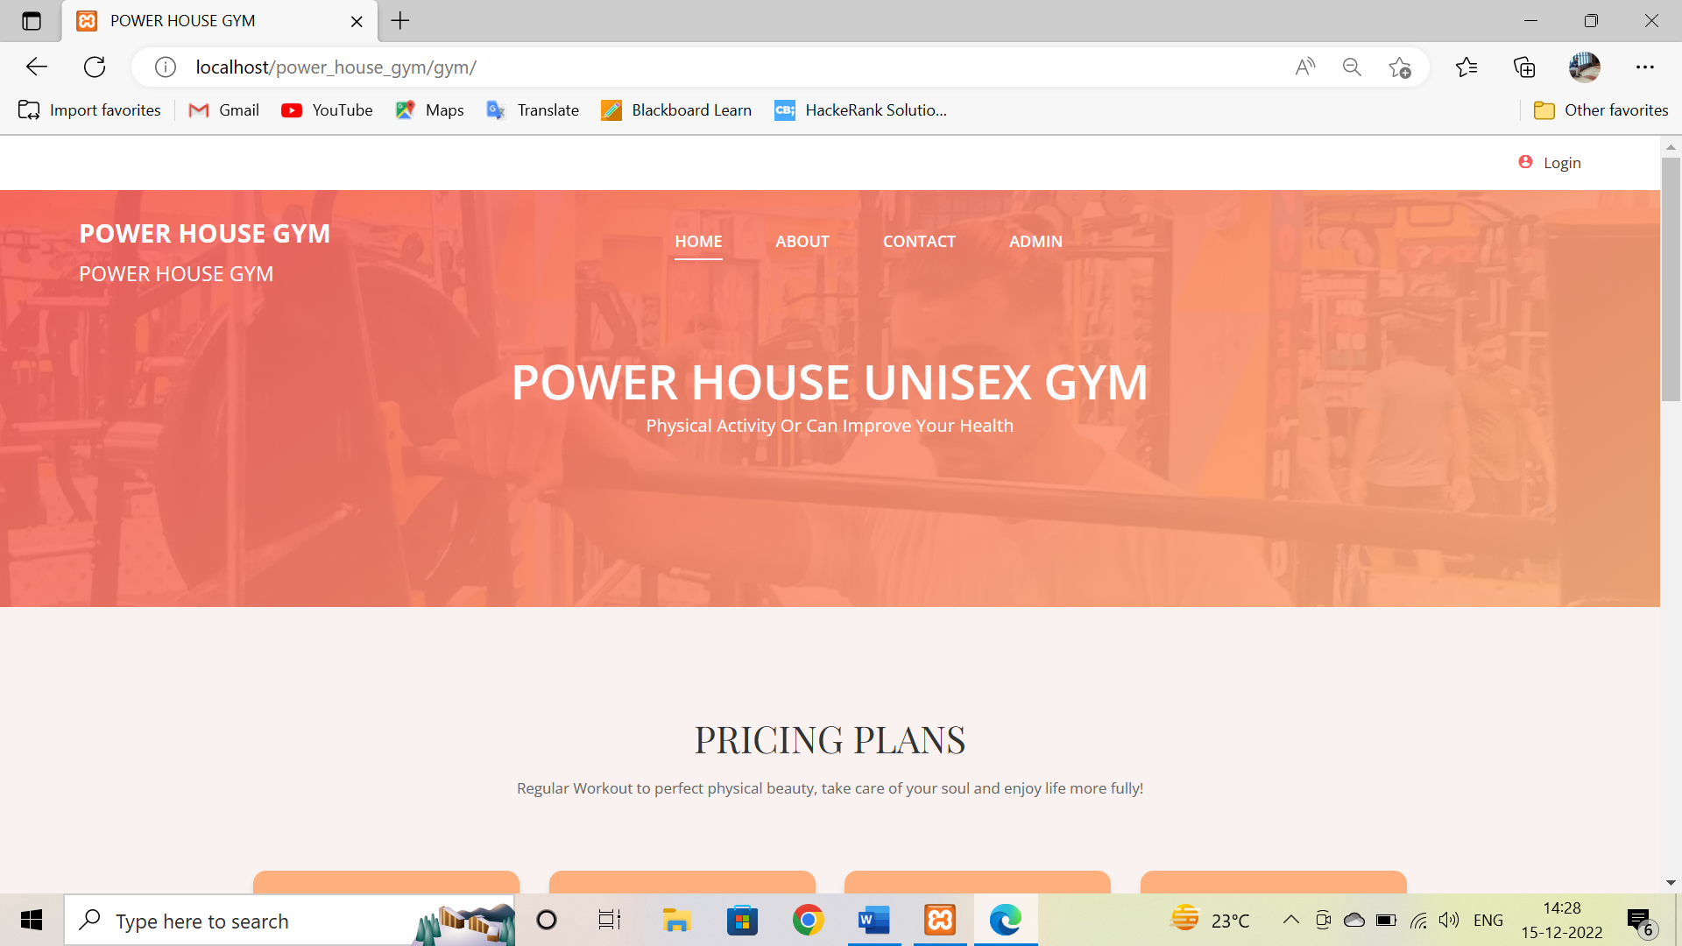

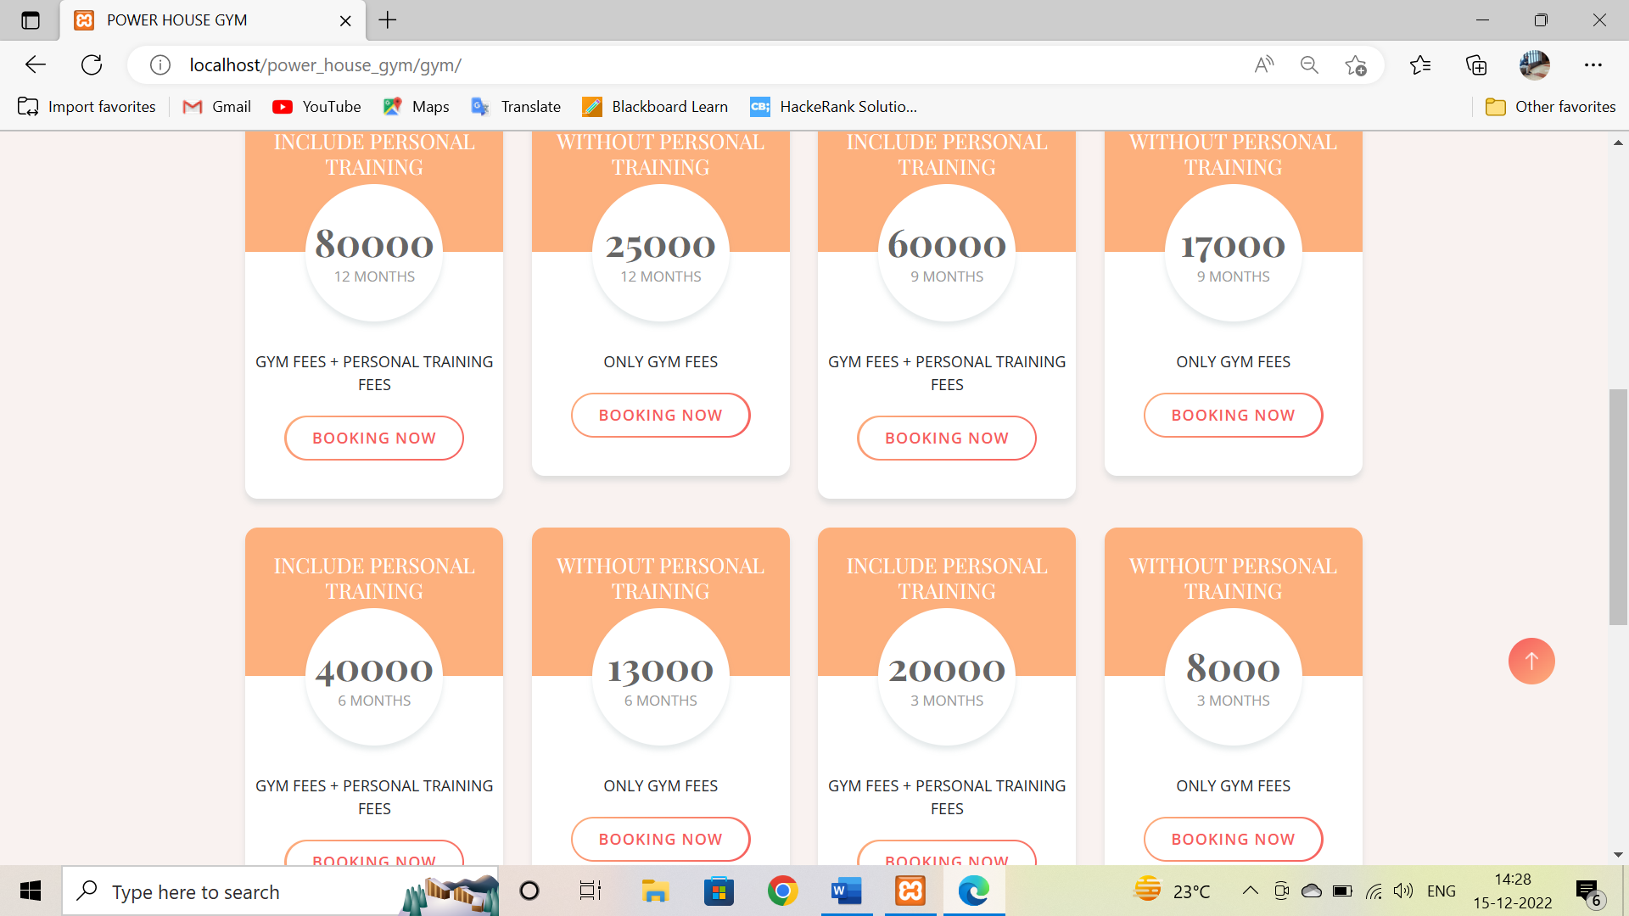

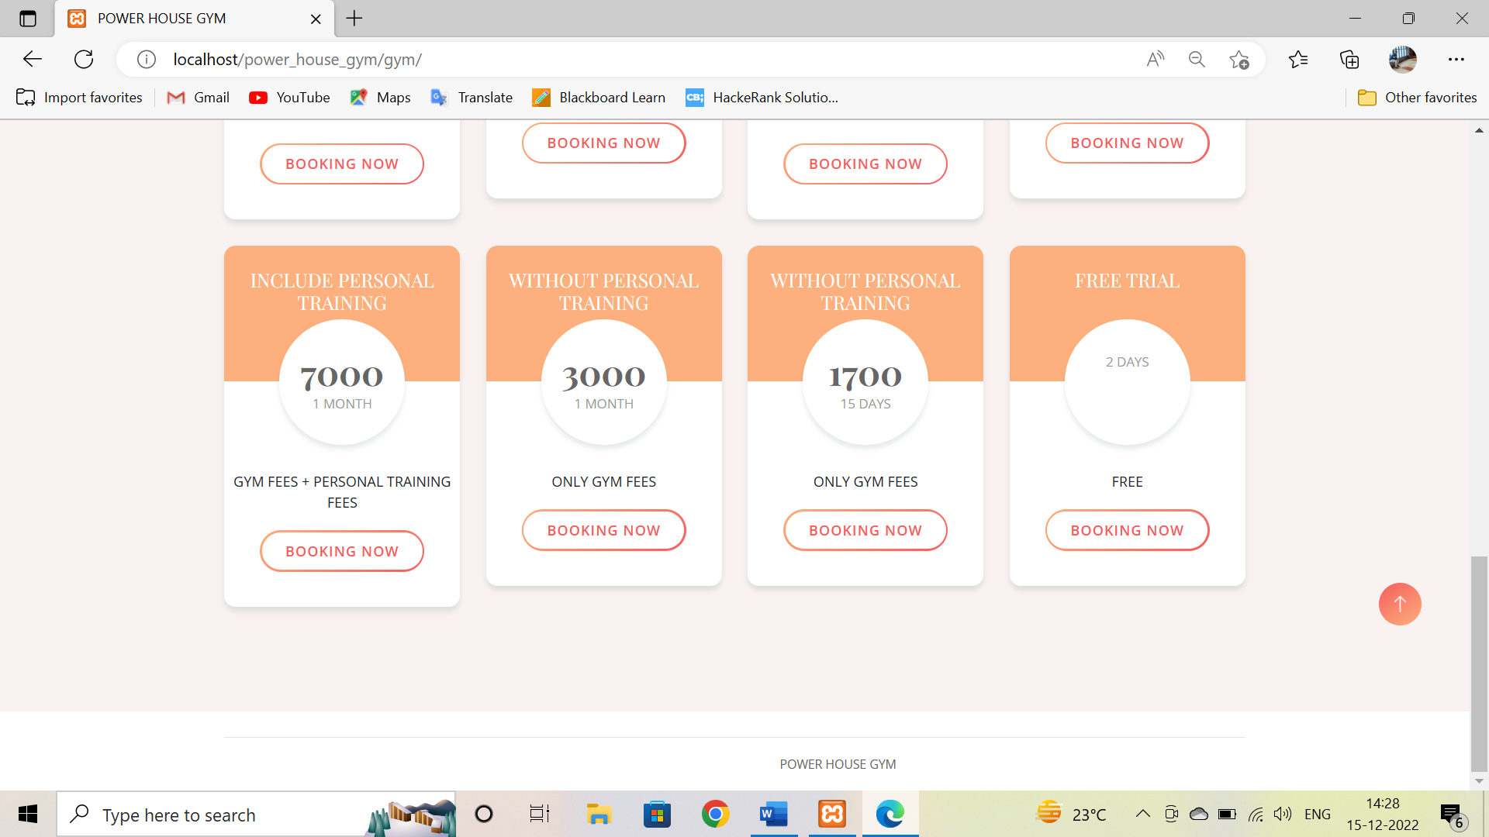

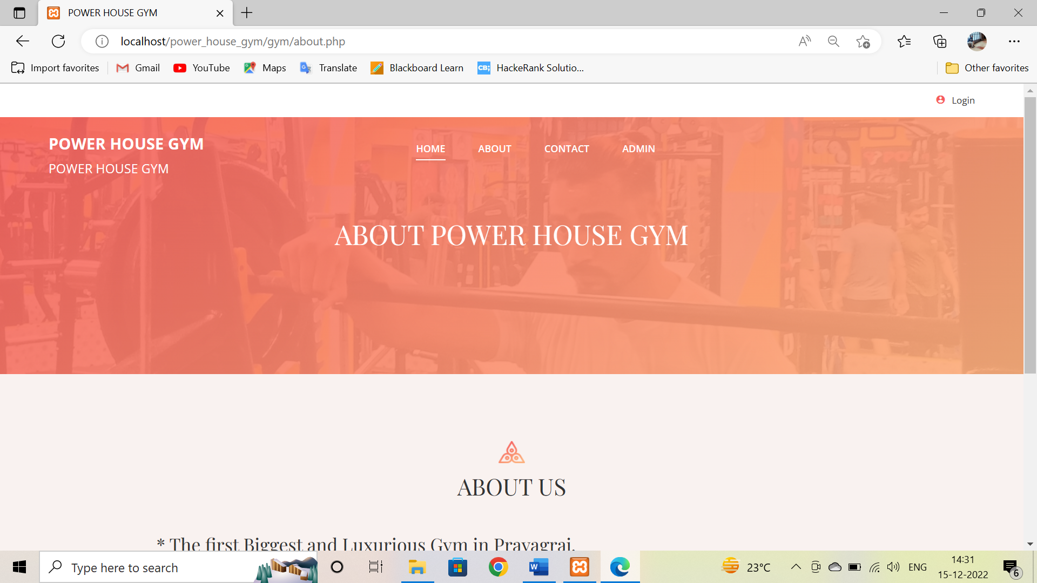

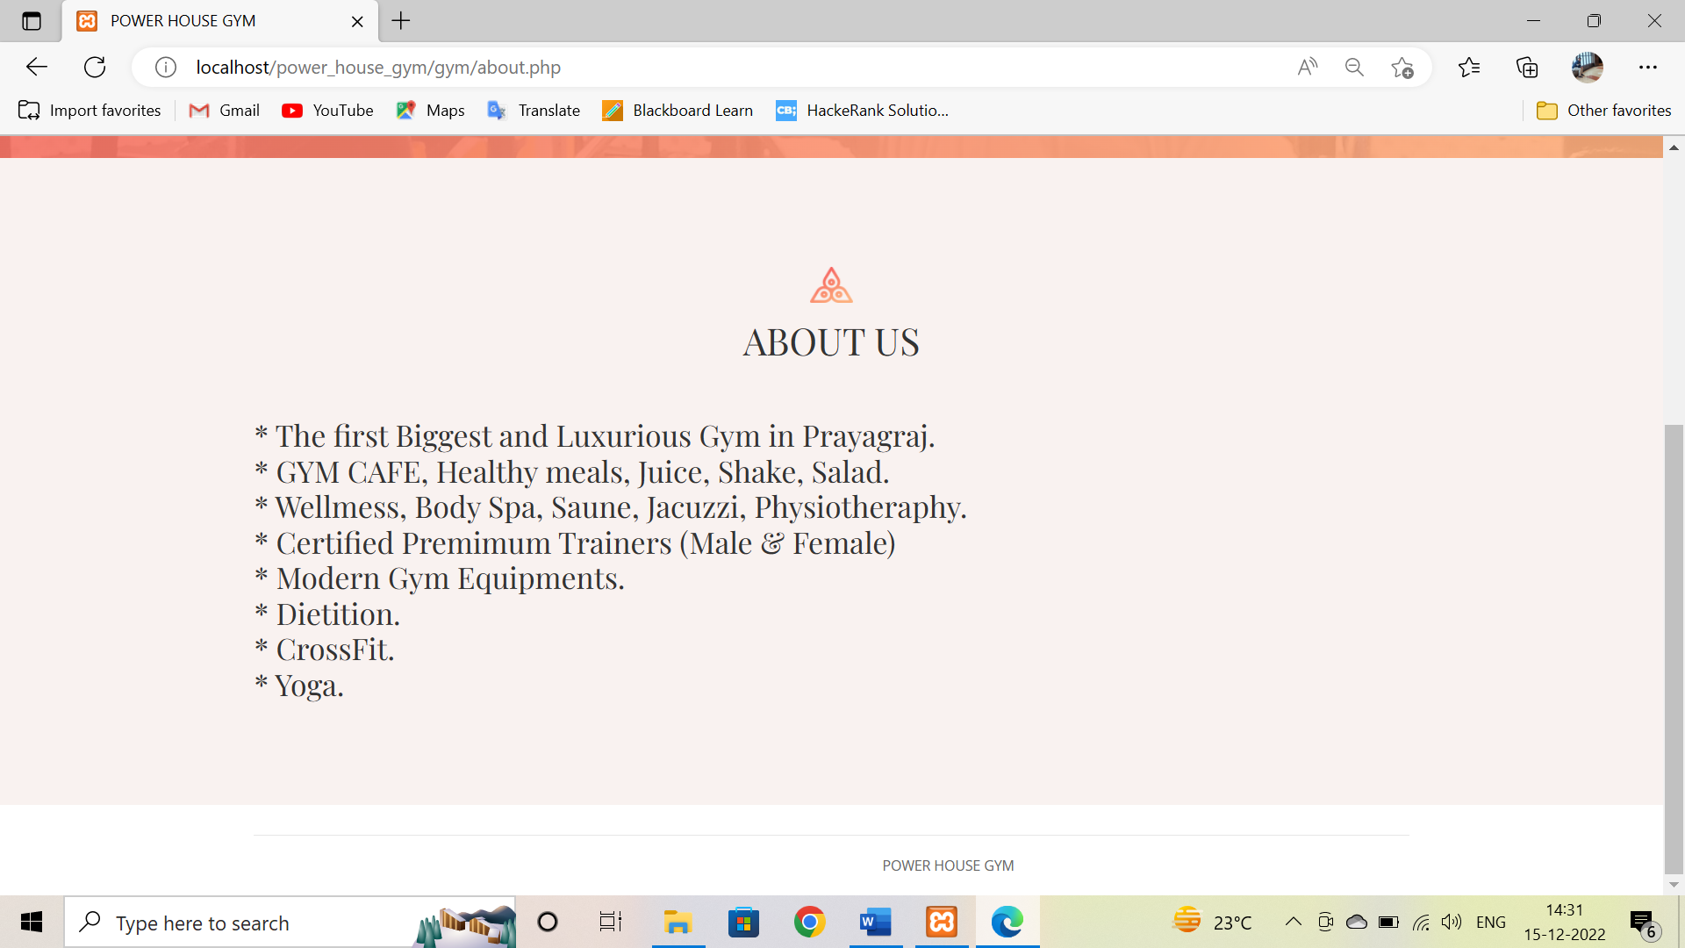

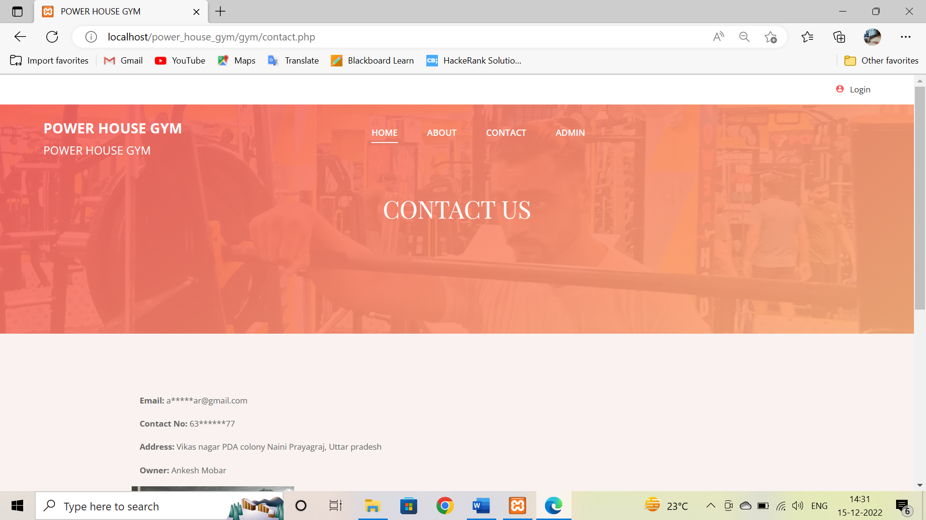

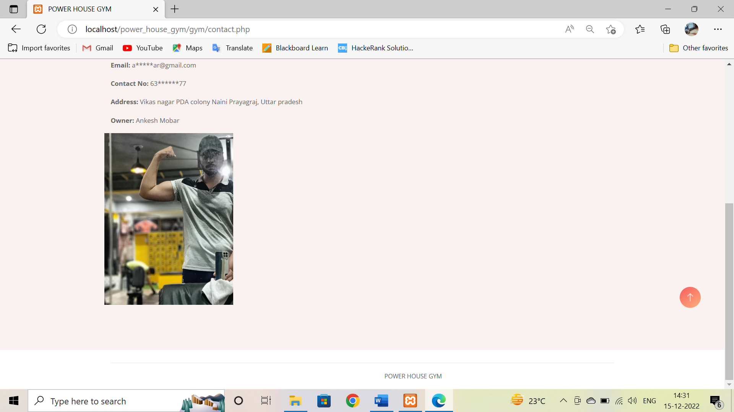

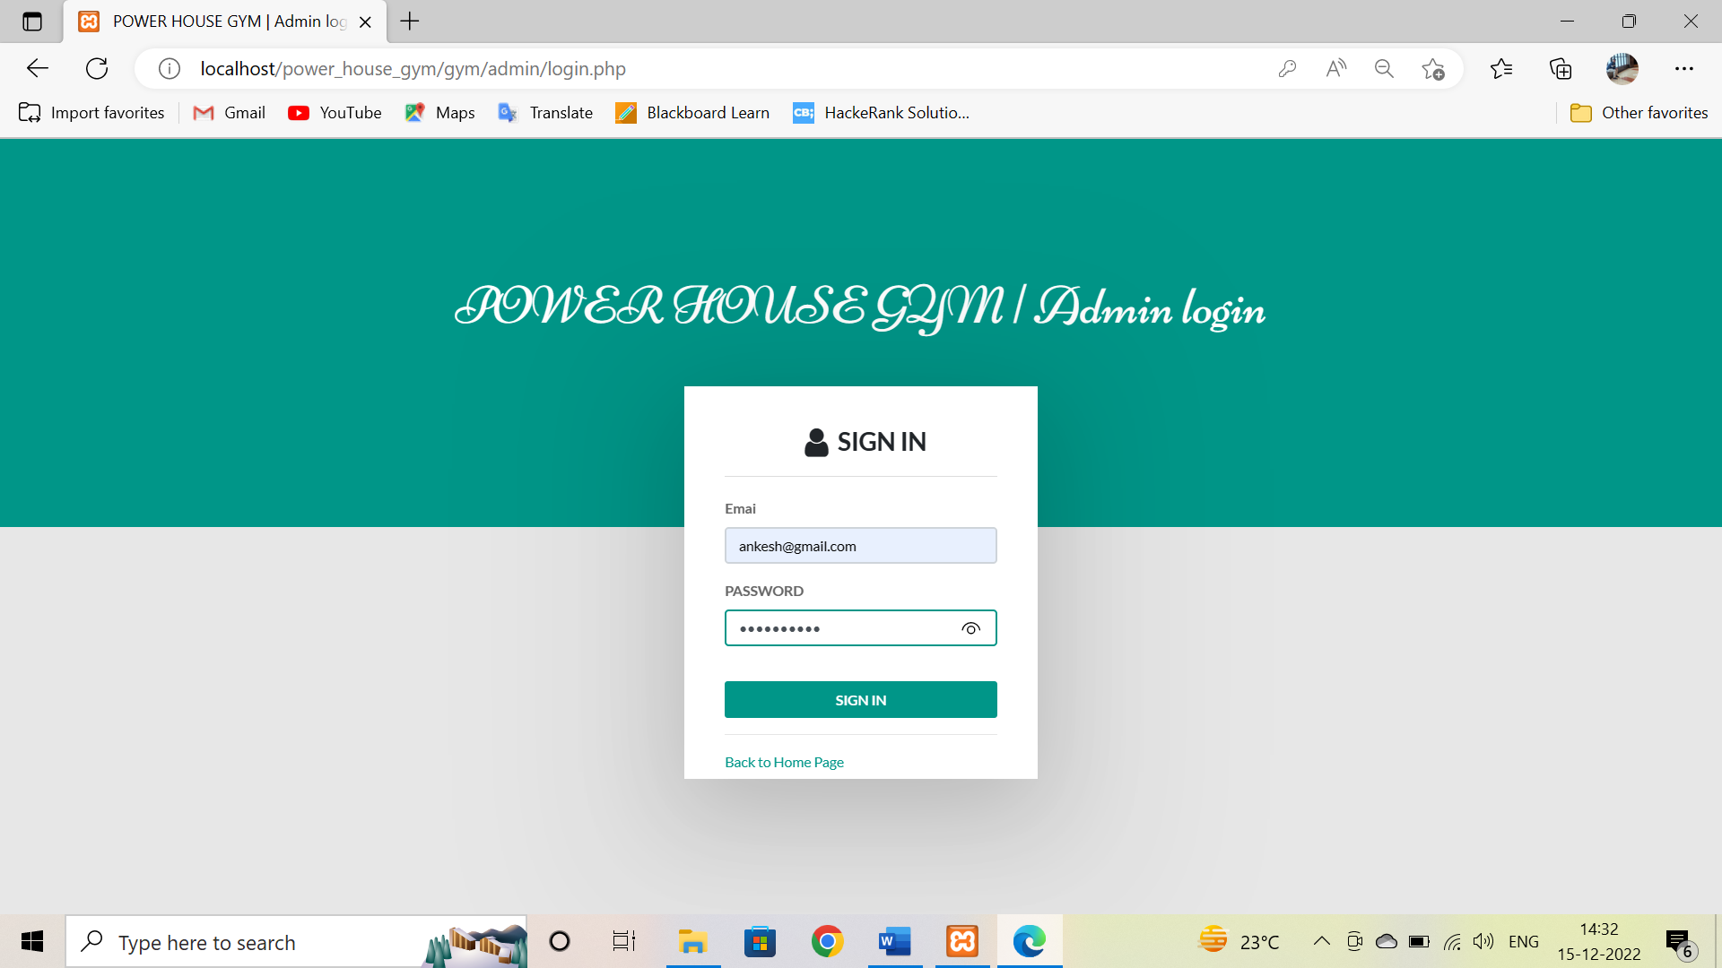

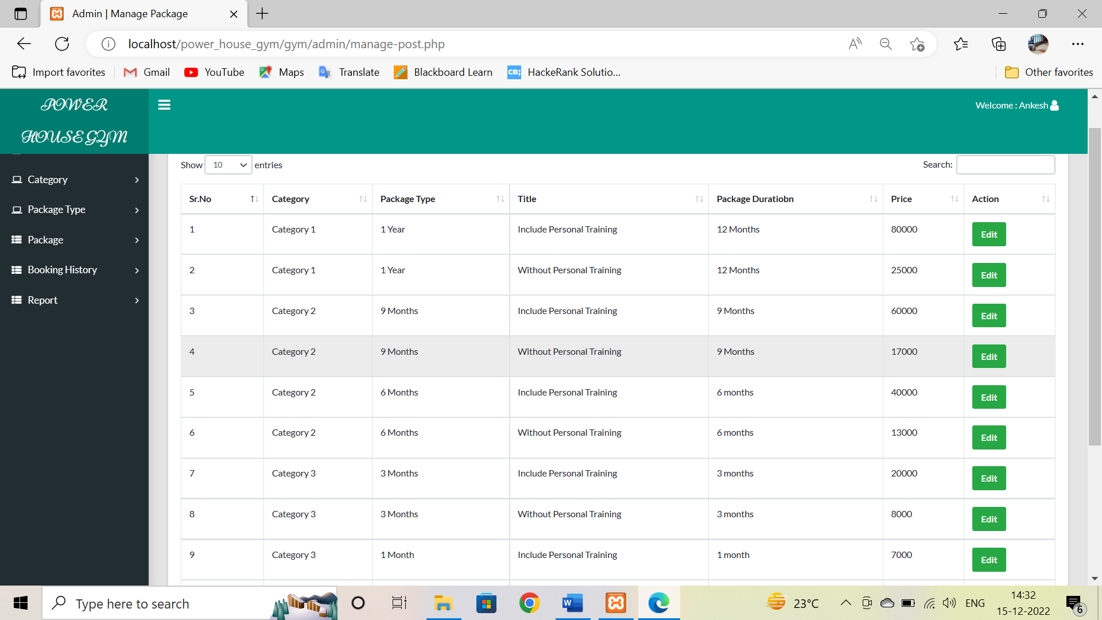

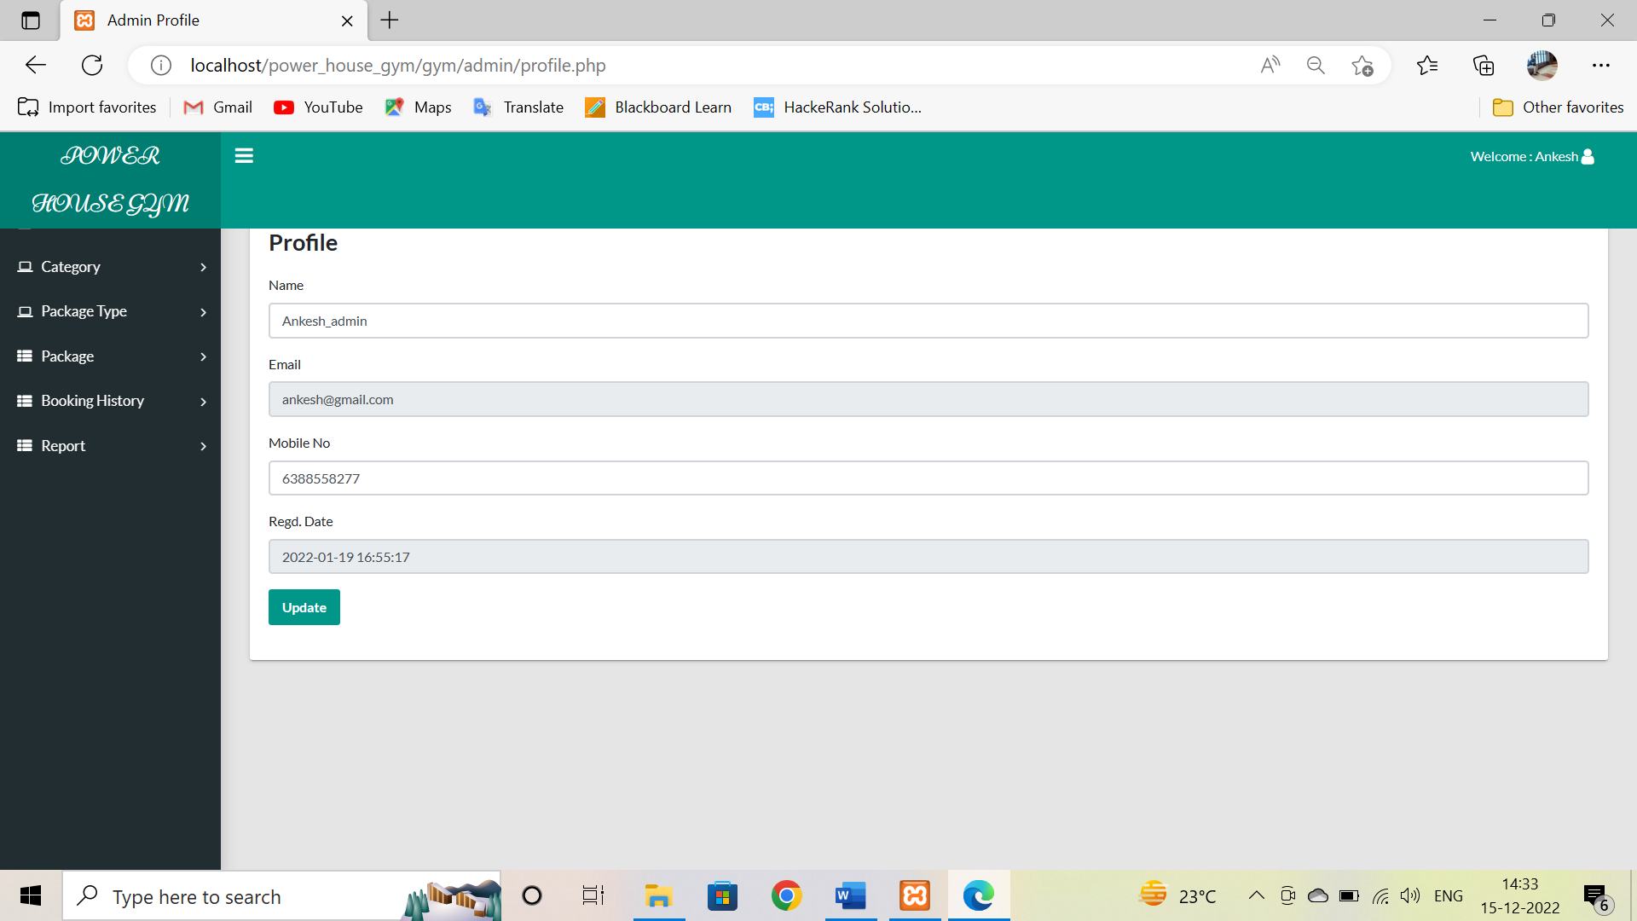

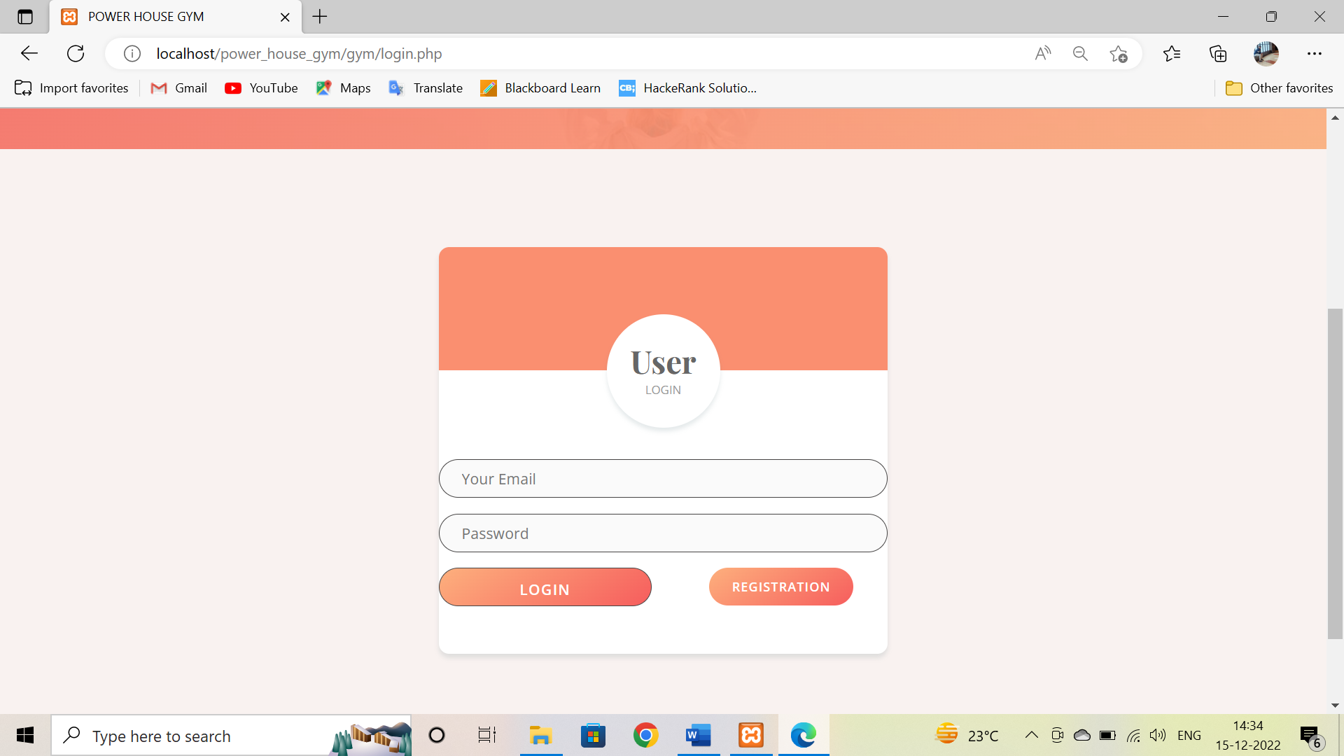

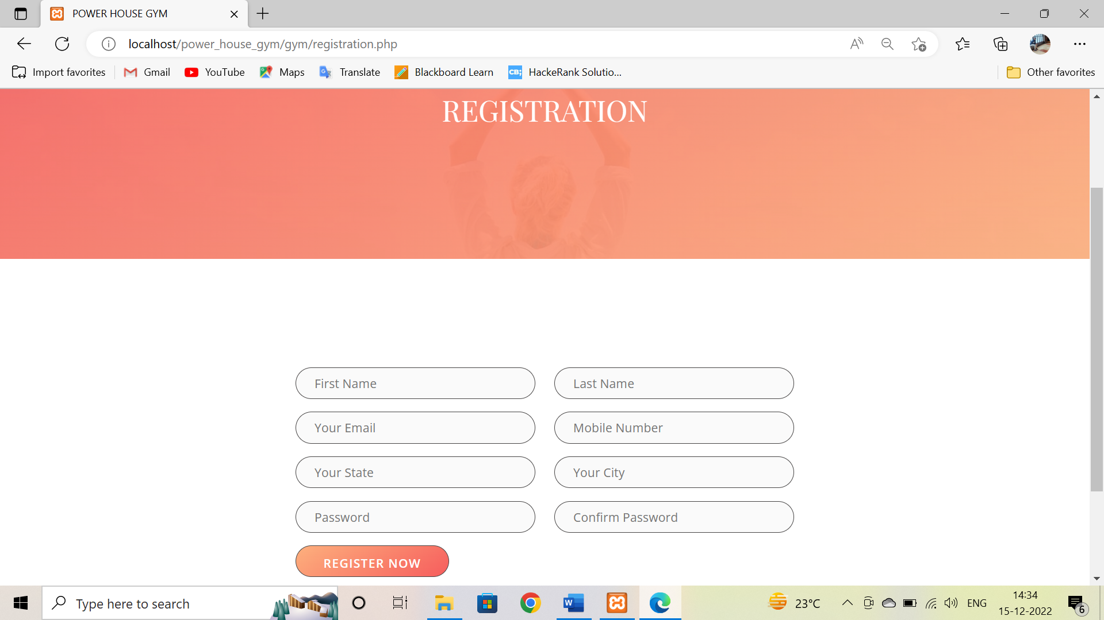

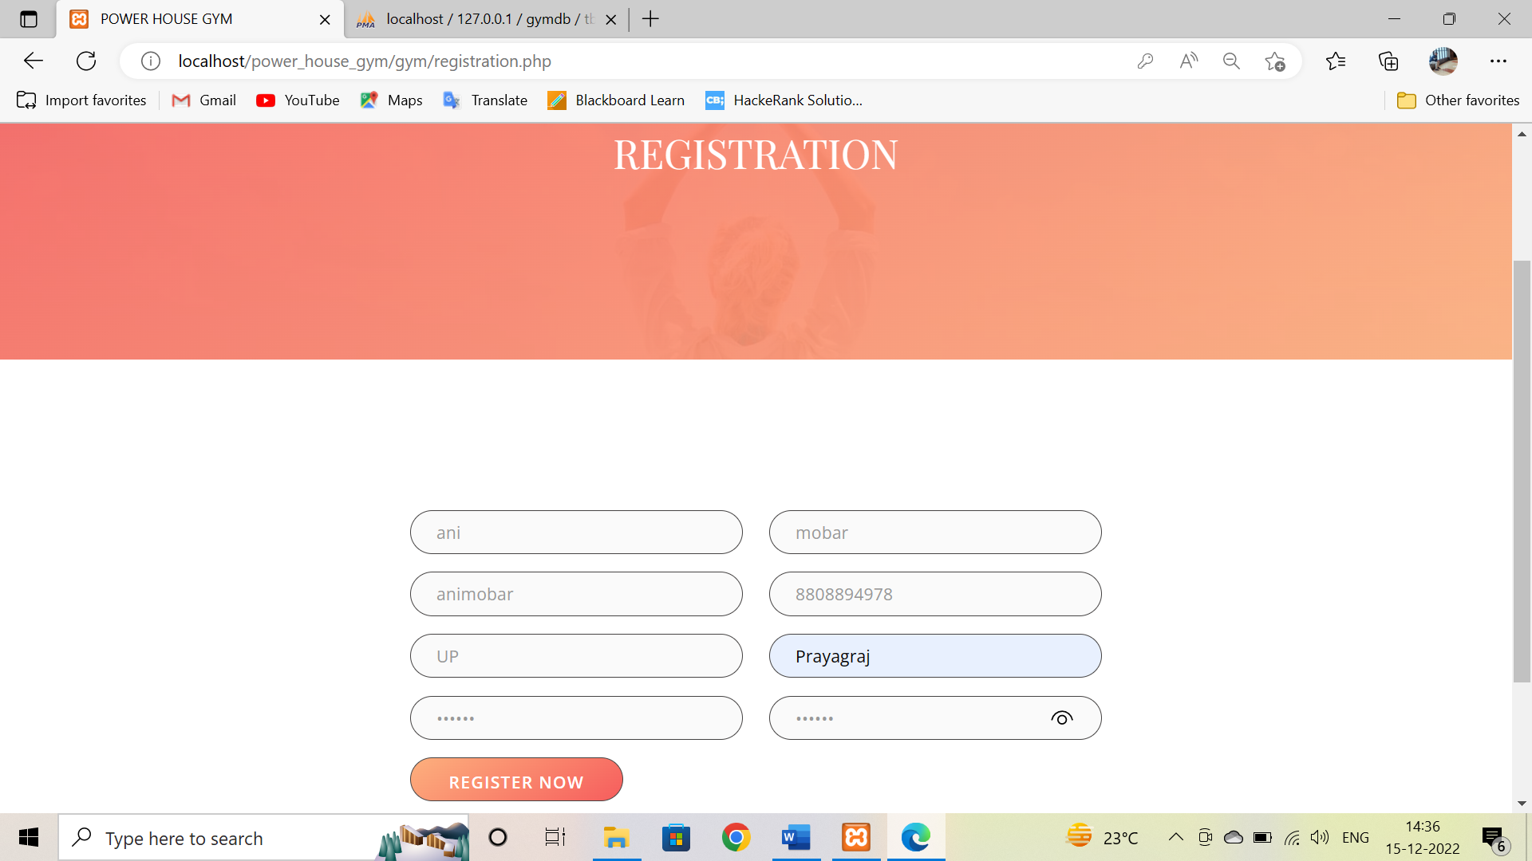

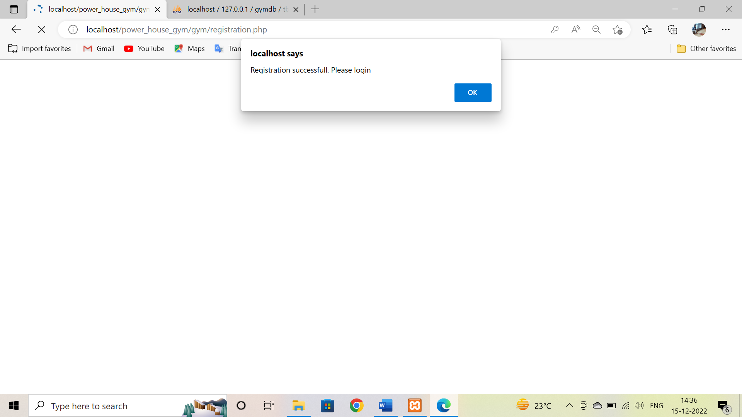

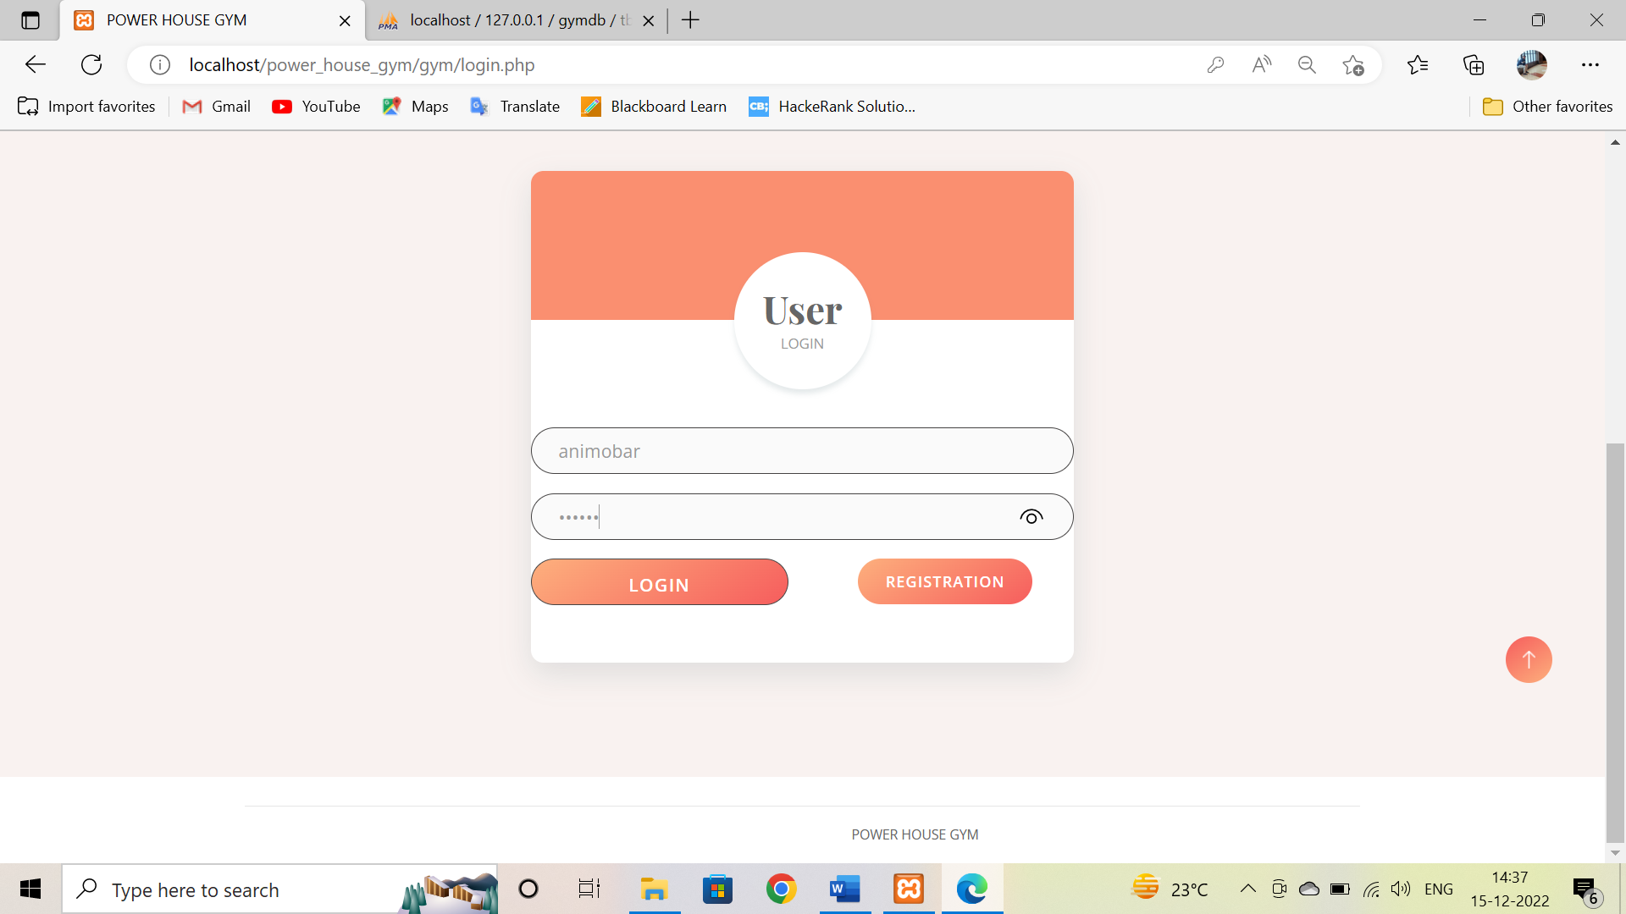

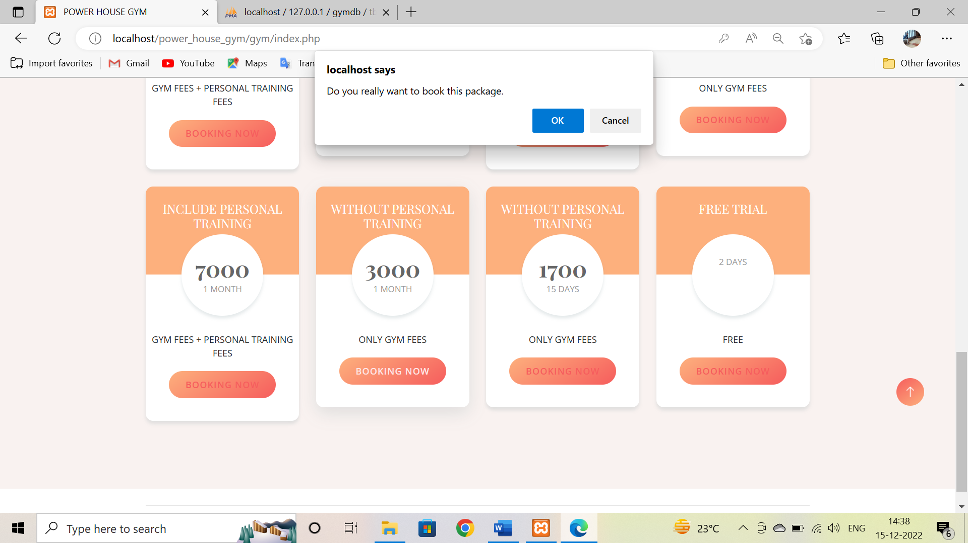

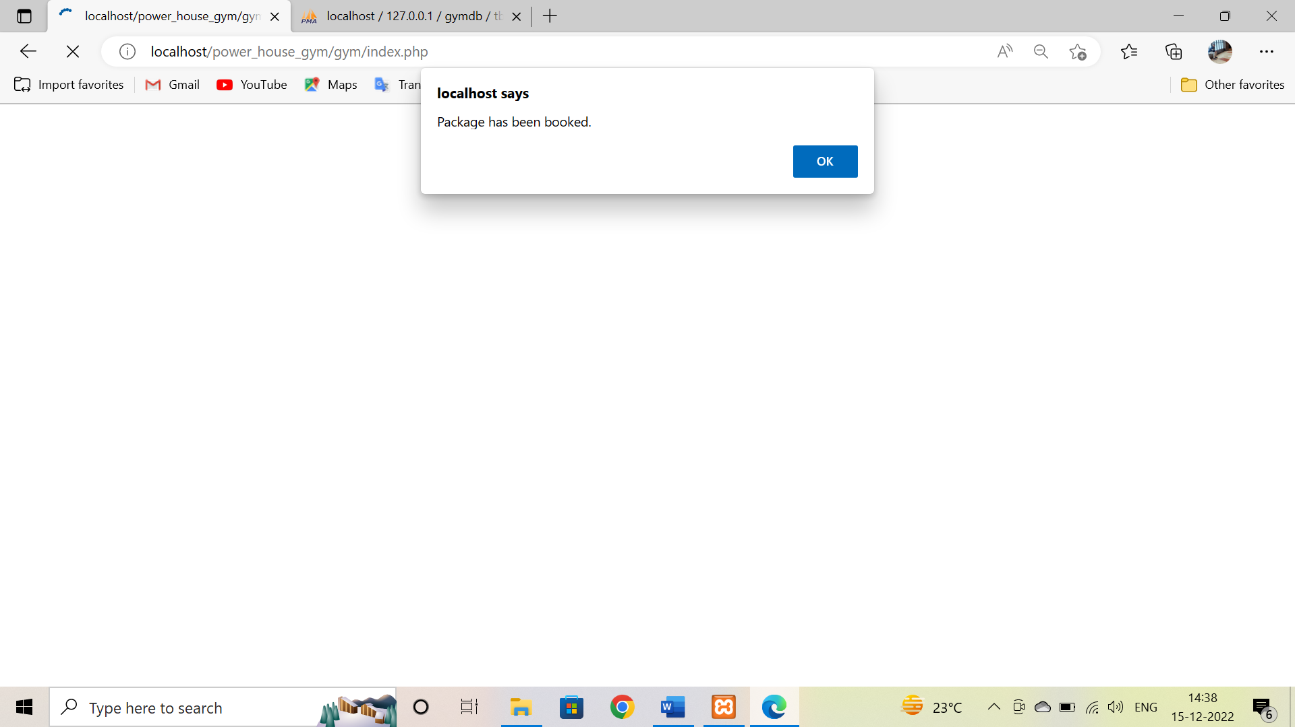

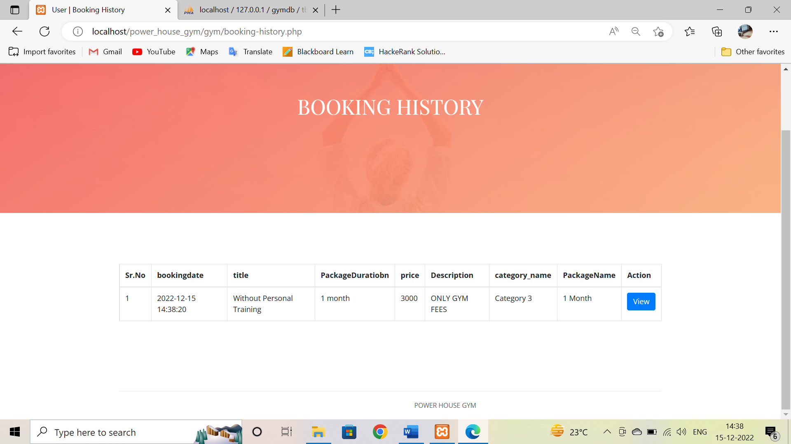

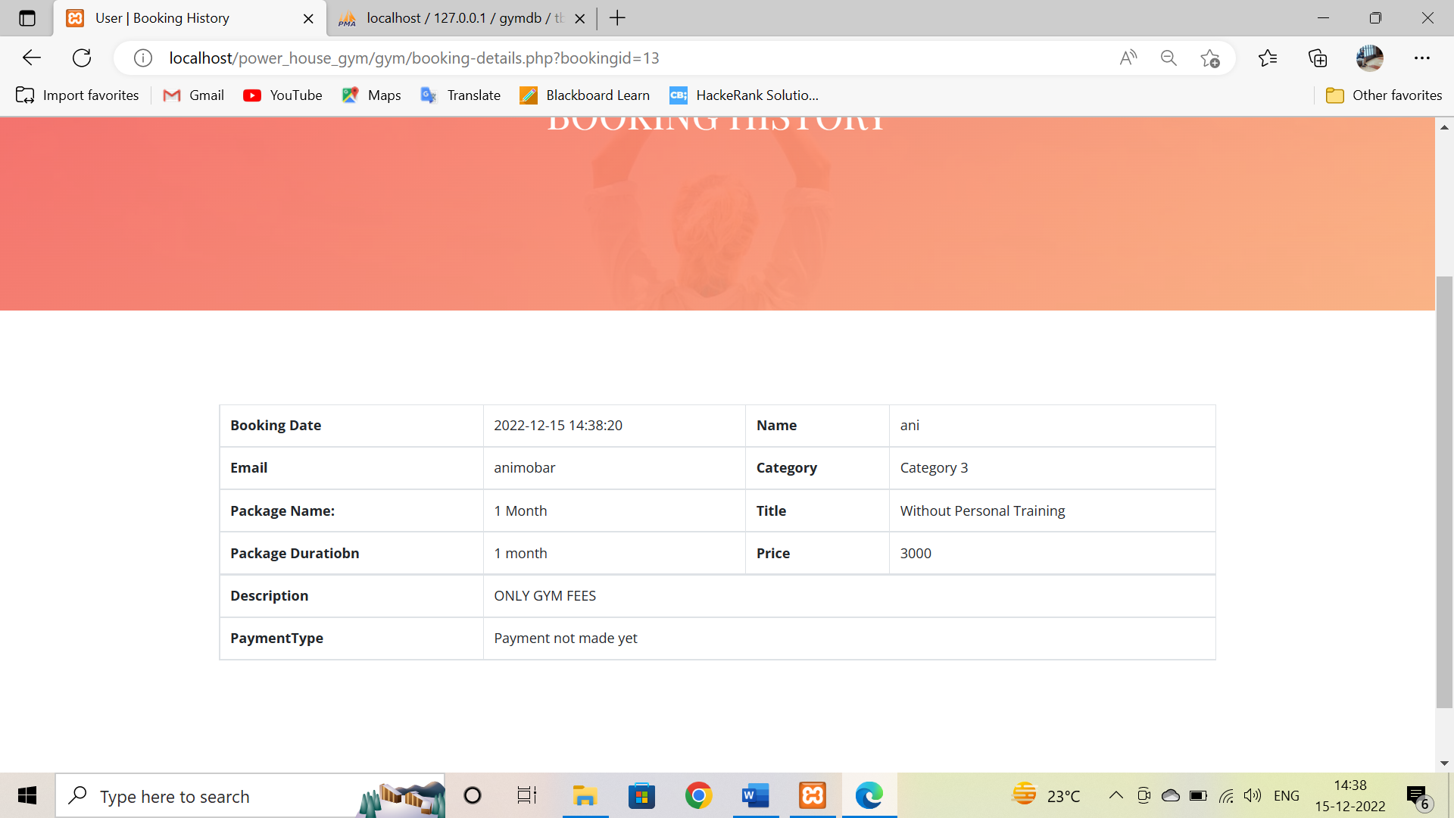

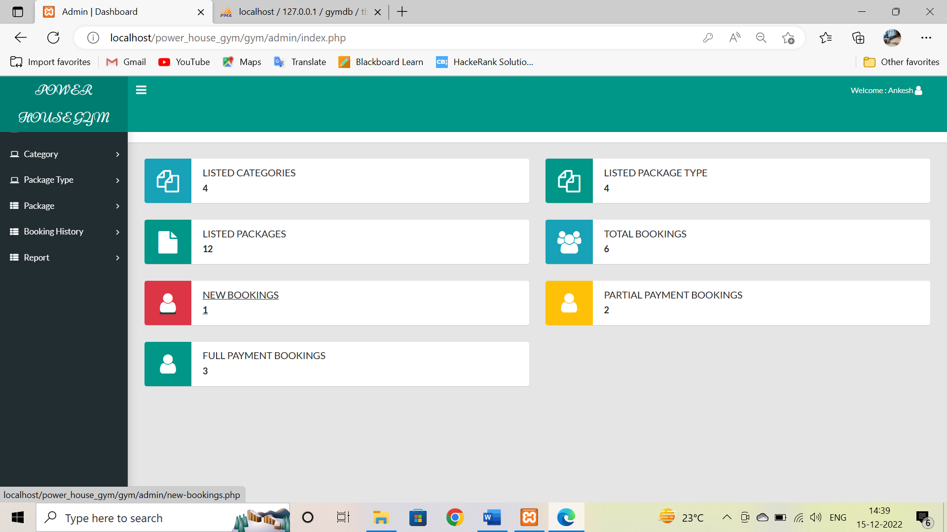

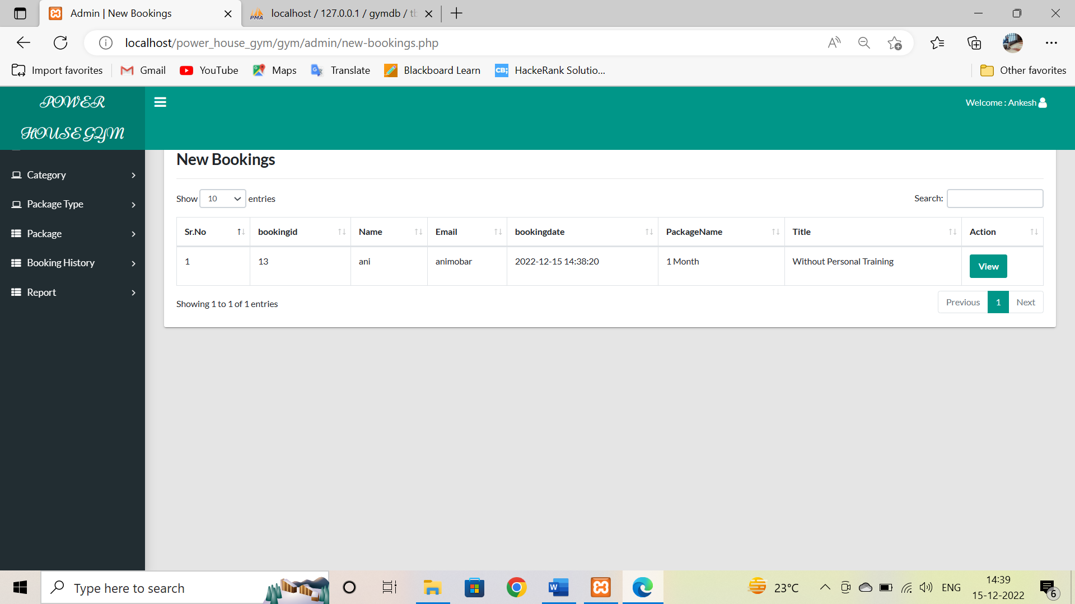

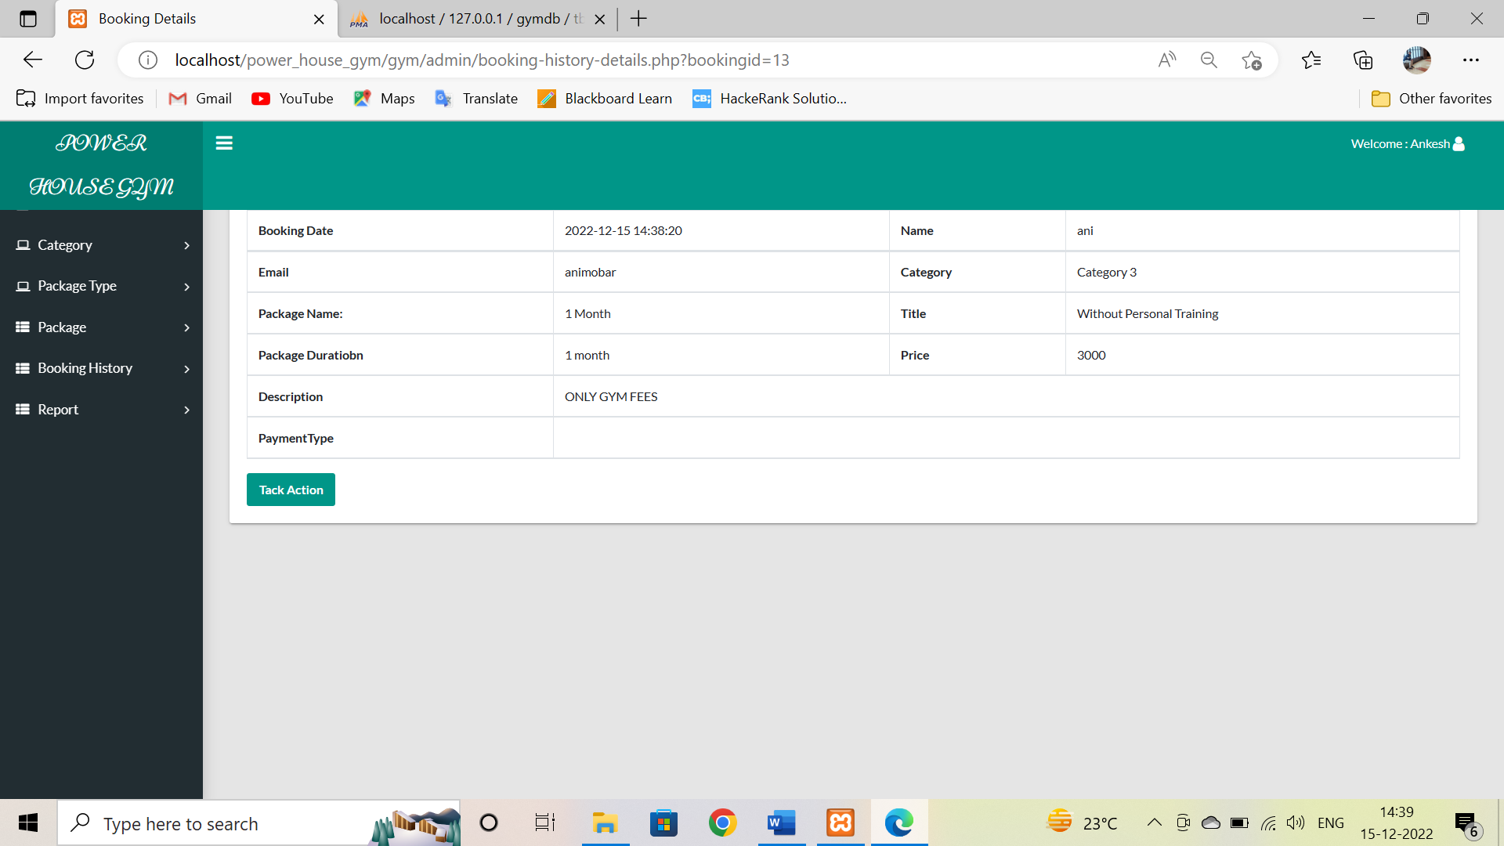

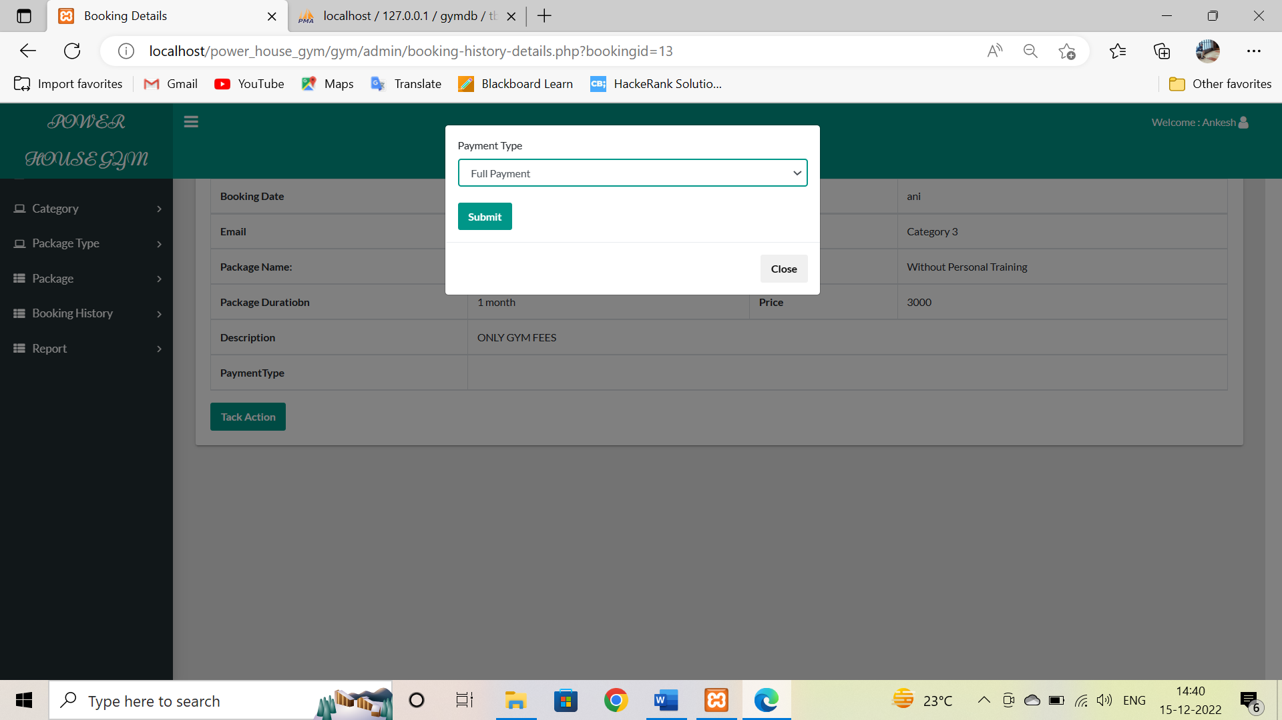

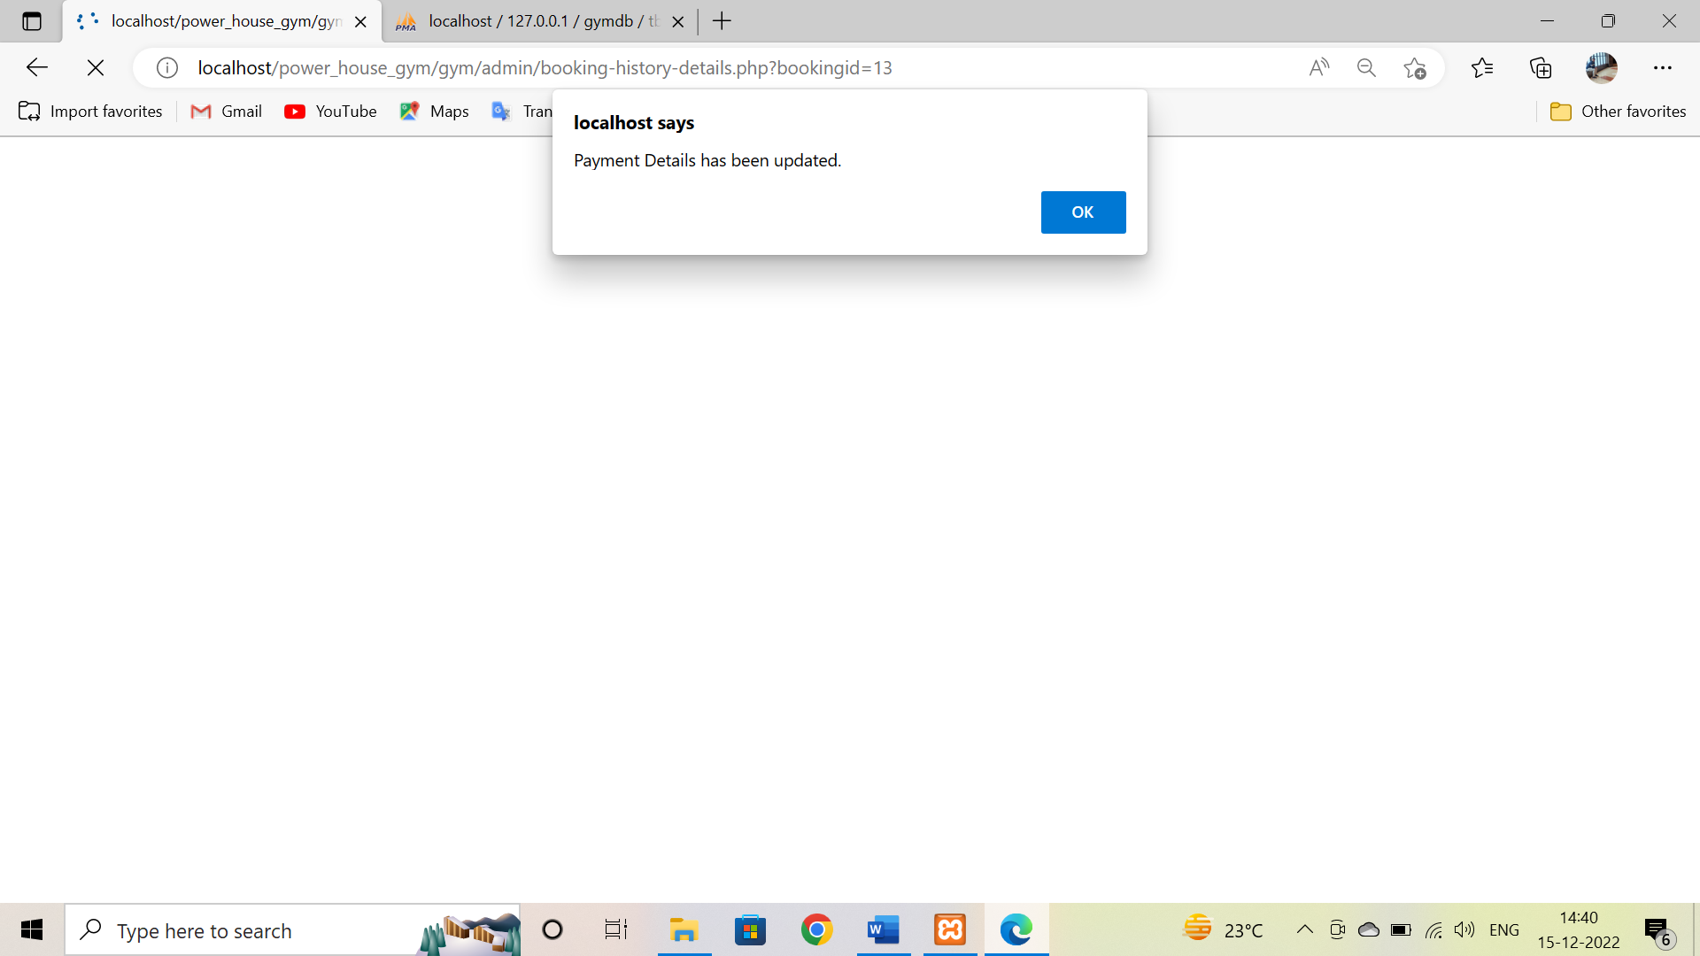

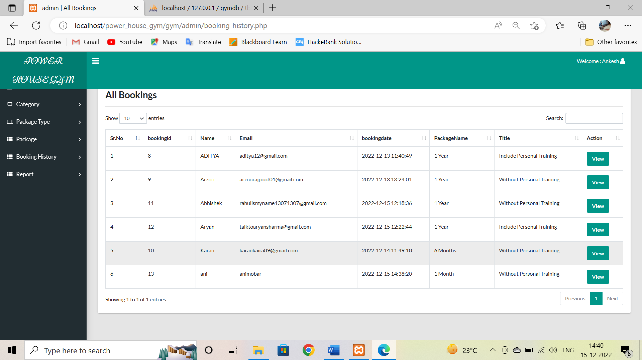

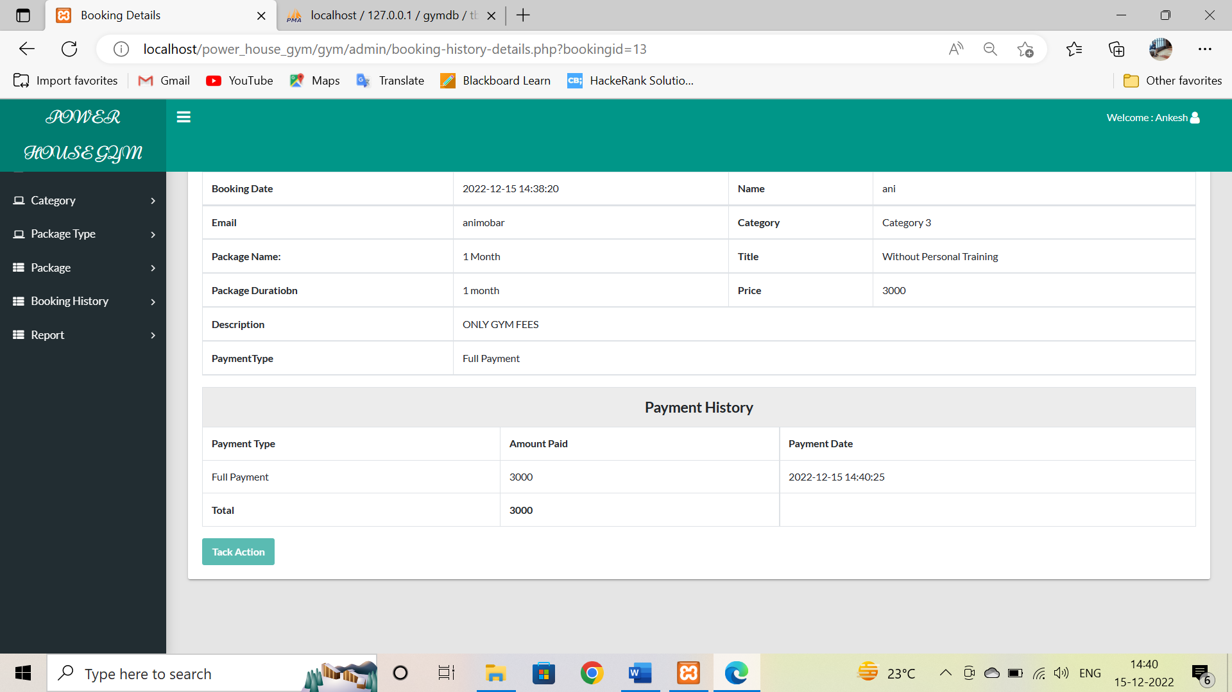

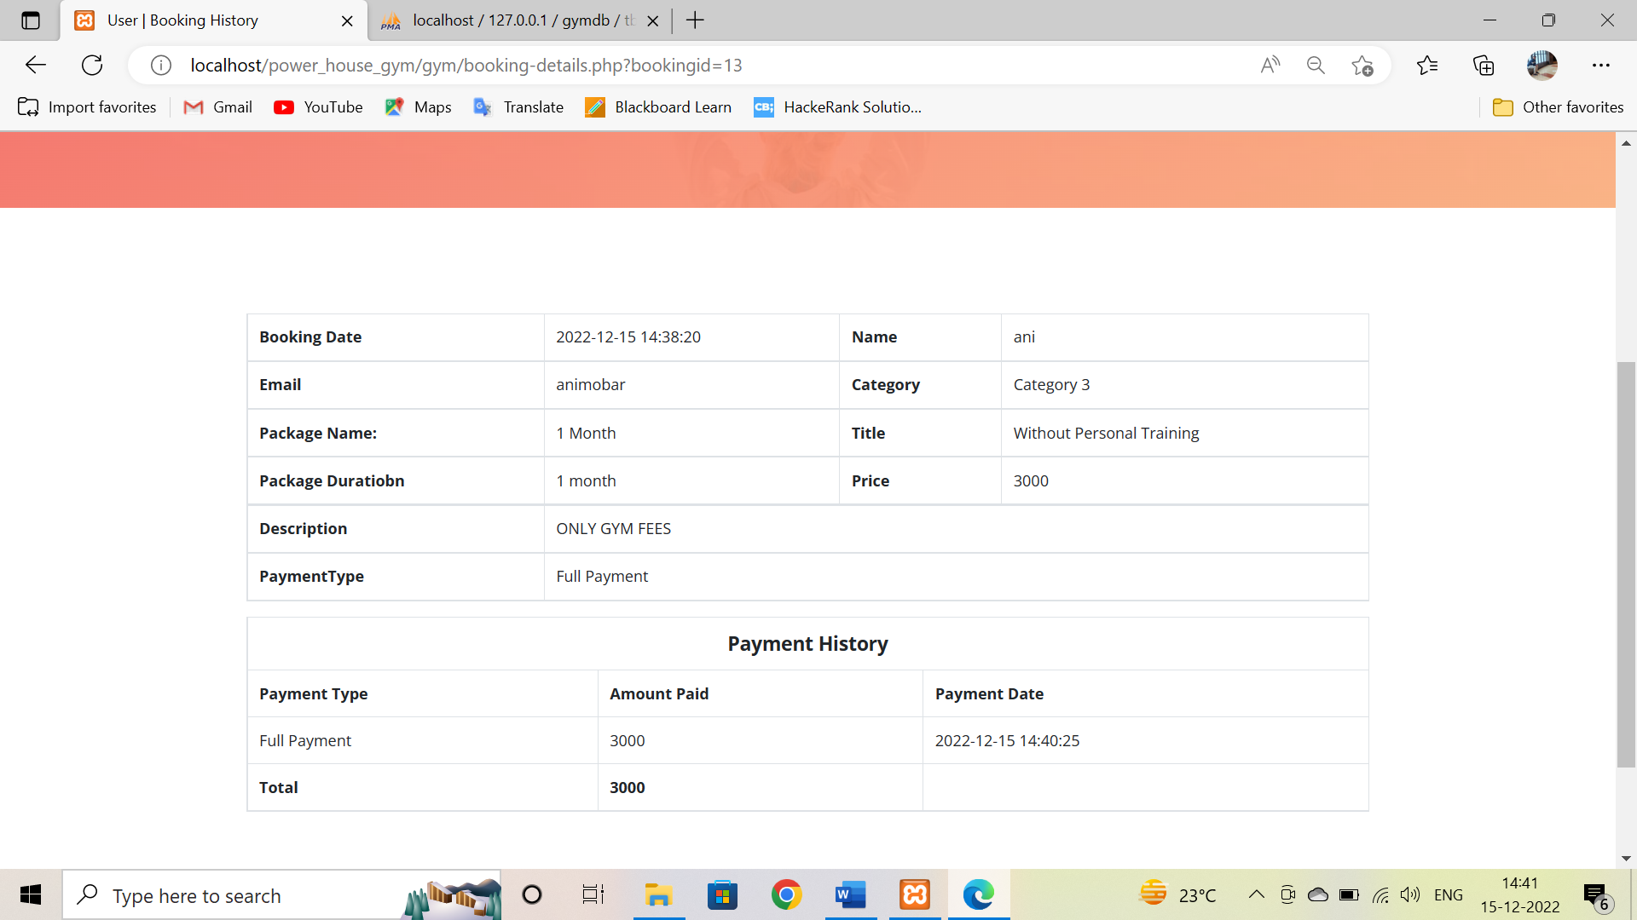

1. **Backend Output Screenshot:**

